

Technical Specification

MEF XXX

Requirements for Service
Protection Across External Interfaces

Draft 0.4

January 2011

Disclaimer
The information in this publication is freely available for reproduction and use by any recipient and is believed to be accurate as of its publication date. Such information is subject to change without notice and the Metro Ethernet Forum (MEF) is not responsible for any errors. The MEF does not assume responsibility to update or correct any information in this publication. No representation or warranty, expressed or implied, is made by the MEF concerning the completeness, accuracy, or applicability of any information contained herein and no liability of any kind shall be assumed by the MEF as a result of reliance upon such information.
The information contained herein is intended to be used without modification by the recipient or user of this document. The MEF is not responsible or liable for any modifications to this document made by any other party.
The receipt or any use of this document or its contents does not in any way create, by implication or otherwise:
any express or implied license or right to or under any patent, copyright, trademark or trade secret rights held or claimed by any MEF member company which are or may be associated with the ideas, techniques, concepts or expressions contained herein; nor
any warranty or representation that any MEF member companies will announce any product(s) and/or service(s) related thereto, or if such announcements are made, that such announced product(s) and/or service(s) embody any or all of the ideas, technologies, or concepts contained herein; nor
any form of relationship between any MEF member companies and the recipient or user of this document.
Implementation or use of specific Metro Ethernet standards or recommendations and MEF specifications will be voluntary, and no company shall be obliged to implement them by virtue of participation in the Metro Ethernet Forum. The MEF is a non-profit international organization accelerating industry cooperation on Metro Ethernet technology. The MEF does not, expressly or otherwise, endorse or promote any specific products or services.
© The Metro Ethernet Forum 2010. All Rights Reserved.

Editor | Company | Telephone | Email
Yoav Cohen | Nokia Siemens Networks |  | Yoav.cohen@nsn.com
Contributors | Company | Telephone | Email
Michael Bugenhagen | CenturyLink
Bill Bjorkman | Verizon
Steve Haddock | Extreme Networks
Bob Klessig | MEF
Raghu Ranganathan | Ciena
Cherng Yeh | Tata Communications
Lionel Florit | Cisco
Enrique Hernandez-Valencia | Alcatel-Lucent
Shobhan Ayyadevara | Vitesse
Michael Waldo | Adva
Norman Finn | Cisco
David Allan | Ericsson
Jack Pugaczewski | Qwest

To be removed when LB approved.

Table of Contents
1. Abstract 1
2. Abbreviations 1
3. Introduction 2
4. Scope and definitions 2
4.1 Definitions 2
4.1.1 Service End Point (EP) 2
4.1.2 Link Connection 3
4.1.3 Working Link 3
4.1.4 Protection Link 3
4.1.5 Active and Standby Links 3
4.1.6 Protection Switching 3
4.1.7 Failure 4
4.1.8 Interconnection Zone 4
4.2 Reference model 4
4.3 In Scope for Phase I 5
4.4 Out of Scope for Phase I 6
5. Compliance Levels 6
6. Requirements 6
6.1 General Requirements 7
6.2 Requirements addressing Ethernet Layer 8
6.3 Requirements addressing triggers for recovery actions 9
6.3.1 Requirements addressing operator manual commands 9
6.4 Requirements addressing configuration aspects 9
6.5 Requirements for scalability and performance 10
7. References 11
8. Appendix A – Several Operator Networks and their Associated Interconnection Zones (Informative) 12

List of Figures
Figure 1: A Reference Model of the Interconnection Zones 4
Figure 2 : Example of an EVC traversing several Operators' Networks and Interconnection Zones 12

List of Tables
Table 1: Abbreviations 2

Abstract
The requirements listed in this specification address a gap in the industry specifications that does not define a protection mechanism without single point of failure for protecting services at External Interfaces (EIs). That is, there is currently no standard way of protecting the services at the External Interfaces in case of node failure.
This specification specifies requirements for protecting any MEF Service by protecting its Service End Points, which associate services with External Interfaces. The requirements specified in this specification address potential impact on MEF services. MEF would like these requirements to be considered when designing a mechanism for Service Protection across an External Interface. The mechanism is assumed to be developed outside MEF by SDOs such as IEEE 802.1, ITU-T, IETF, etc.
The current MEF standardized External Interfaces are the UNI and ENNI. These requirements aim to cover a wide range of MEF Ethernet service types as well as a wide range of packet network deployments in which the EIs are MEF defined EIs.
- Editor's notes:
- 1. Protection vs. Resiliency: During the Q1/2011 meeting, the Technical Committee agreed to use the term "Resiliency" instead of "Protection". This change would be reflected in the next draft version.
- 2. Number of Service End Points per EVC/OVC at an EIs: Single logical view vs. 2 physical location view of the External Interface. This topic is under discussion. A resolution must be reached until the next MEF meeting (Q2/2011).

Abbreviations
Abbreviation | Definition | Reference
BW | Bandwidth
CE | Customer Edge | [5]
CEN | Carrier Ethernet Network
CoS | Class of Service | [4]
EI | External Interface | [10]
EP | End Point | [10]
EPL | Ethernet Private Line | [4]
EVC | Ethernet Virtual Connection | [4]
EVPL | Ethernet Virtual Private Line | [4]
EP-LAN | Ethernet Private LAN | [4]
EVP-LAN | Ethernet Virtual Private LAN | [4]
EP-Tree | Ethernet Private Tree | [4]
EVP-Tree | Ethernet Virtual Private Tree | [4]
FD | Frame Delay | [5]
FDV | Frame Delay Variation | [5]
FLR | Frame Loss Ratio | [5]
MEN | Metro Ethernet Network | [3]
OVC | Operator Virtual Connection | [10]
SLA | Service Level Agreement | [5]
SDO | Standard Development Organization
SP | Service Providers | [5]
UNI | User Network Interface | [5]
VLAN | Virtual LAN | [5]
Table 1: Abbreviations

Introduction
Reliability, in terms of availability, is a key attribute of a Carrier Ethernet service. High Availability commitments in SLAs require a resilient network that can rapidly detect interface failure, node failure and performance degradation, and can rapidly restore service operation. Network survivability plays a critical factor in the delivery of reliable services.

This specification specifies requirements for protecting any MEF Service by protecting its Service End Points, which associate services with External Interfaces. The requirements specified in this specification address potential impact on MEF services. MEF would like these requirements to be considered when designing a mechanism for Service Protection across an External Interface. The mechanism is assumed to be developed outside MEF by SDOs such as IEEE 802.1, ITU-T, IETF, etc.
Many protection switching schemes are deployed to date. Those include linear schemes such as 1:1, 1+1, 1:N as well as protection schemes that operate over Mesh and Ring topologies. Each of the schemes has its pros and cons. The choice of protection scheme is left to the discretion of the SDO developing the protection switching mechanism.

Scope and definitions
The scope of this specification reflects the ambitions for specifying requirements for Service End Point protection across External Interfaces. The requirements for protection address only the Interconnection Zone (see definition below).

Definitions
Networks are connected to each other at demarcation points. In many cases the resources supporting the connections, i.e., nodes and Link Connections (see definition below) are redundant, providing improved protection for Service End Points.
This specification defines requirements for protection of Ethernet Service End Points that would only be performed at the External Interfaces.

Service End Point (EP)
In this specification, a Service End Point is an association of a service or a service constructs (EVC or OVC) to an External Interface (a UNI or ENNI in the context of this specification). Note that the End Point normative definition, as specified in the ENNI specification [10], allows the association of End Points only with OVCs. However, since a given OVC can associate at most one OVC End Point at a given UNI, this specification extends the definition of an End Point, as specified in the ENNI specification [10], to implicitly assume association of a single End Point with an EVC at a given UNI [5], as well. Hence the term Service End Point.

Link Connection
A Link Connection as defined in [3] denotes the connectivity supporting the exchange of Ethernet Service Frames or ENNI Frames as defined in [5] and [10], respectively, between EI peers. The transport layer could be an Ethernet phy sub-layer, Link Aggregation [14] or any other transport, e.g., MPLS/PW.

Working Link
The designated Link Connection configured to exchange Ethernet frames between Service End Points under normal condition (i.e., where there is no failure).

Protection Link
The designated Link Connection configured to exchange Ethernet frames between Service End Points when the Working Link Connection fails.

Active and Standby Links
Active Link Connection is a dynamic status of a Link Connections indicating that the Link Connection exchanges Ethernet frames.
Standby Link Connection is a dynamic status of a Link Connections indicating that the Link Connection blocks Ethernet frames.

Note that the Working Link Connection and the Protection Link Connection can each have a status of Active or Standby.

Protection Switching
A Protection Switching event occurs when a failure of the Active Link Connection is detected, and as a result, traffic is switched (i.e., redirected) from the failed Link Connection to the Standby Link Connection (which now becomes the Active Link Connection).
Typically, the Protection Switching is performed by a Protection Switching Mechanism.

Failure
Throughout this specification the term failure means any event that affects an SLA. Examples of such events are: link failure, node failure, link degradation.

Interconnection Zone
The area between External Interface peers containing a collection of nodes and Link Connections, which are assigned to a specific instance of the protection switching mechanism. The Interconnection Zones currently supported by MEF Specifications are: UNI, i.e., between UNI-C and UNI-N, and ENNI, between adjacent ENNI-Ns.
Note that other nodes and Link Connections supporting External Interfaces may be assigned to other Interconnection Zones or not assigned to any Interconnection Zone.

Reference model
The network reference model is illustrated in Figure 1 below. Several adjacent MENs/CENs for which protection requirements may be defined, are illustrated in the figure. The Interconnection Zones currently supported by MEF Specifications are: UNI i.e., between UNI-C and UNI-N and ENNI between adjacent ENNI-Ns. This reference model is used when defining requirements for Service End Point protection and related terminology.

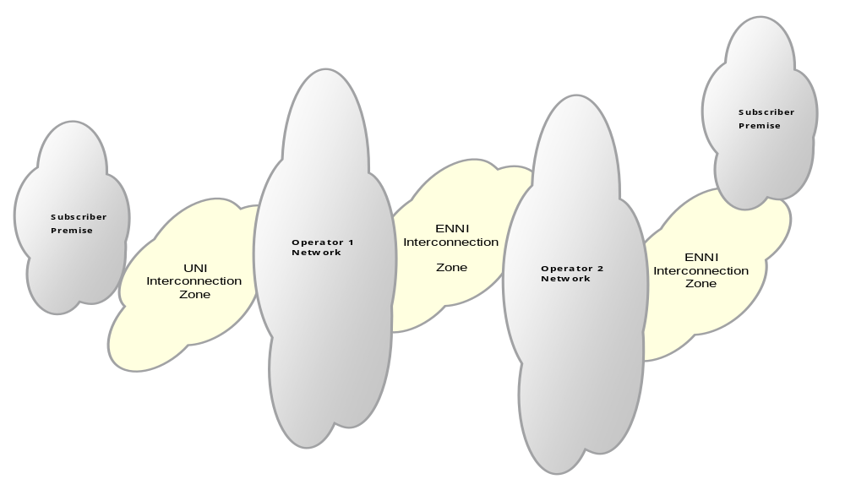
Figure 1: A Reference Model of the Interconnection Zones

Several MENs/CENs and subscriber premises are depicted in Figure 1. An Interconnection Zone may be defined between two adjacent networks supporting MEF defined ENNI External Interfaces or between a MEN and a subscriber premise supporting MEF defined UNI External Interfaces.

Appendix A depicts a typical use case where an EVC traverses several networks which are interconnected at Interconnection Zones. Each Interconnection Zone provides protection only within its Zone.

In Scope for Phase I
The following items highlight the scope of this specification for Phase I:
- ENNI Interconnection Zone
- UNI Interconnection Zone

Out of Scope for Phase I
The following are out of scope of this specification for Phase I, but are candidates for inclusion in Phase II:
- Explore requirements for UTA Service protection across ENNI Interconnection Zone
- Explore requirements for NID to MEN Interconnection Zone
- The requirements listed in this specification assume that the protection schemes are not based on 1+1. The 1+1 scheme is currently Out Of Scope of this specification.

Compliance Levels
The key words "MUST", "MUST NOT", "REQUIRED", "SHALL", "SHALL NOT", "SHOULD", "SHOULD NOT", "RECOMMENDED", "MAY", and "OPTIONAL" in this specification are to be interpreted as described in IETF RFC 2119 [1].

Items that are REQUIRED (contain the words MUST or MUST NOT) will be labeled as [Rx] for required. Items that are RECOMMENDED (contain the words SHOULD or SHOULD NOT) will be labeled as [Dx] for desirable. Items that are OPTIONAL (contain the words MAY or OPTIONAL) will be labeled as [Ox] for optional.

Requirements
In addressing the reliability requirements for Carrier Ethernet services at the Interconnection Zone, it is essential that the Interconnection Zone be equipped with a protection mechanism that is capable of rapidly detecting a failure or facility degradation (node or interface) and of restoring traffic without impacting EVC SLA provided to the end user. The mechanism should provide a means to avoid a potential single point failure or an SLA violation such as high FLR or FD (node or interface).

The designed protection mechanism used in an Interconnection Zone should be robust enough to ensure a service is protected against various types of failures such as:
- An interface failure between two nodes, each residing on a different Operator networks
- A node failure supporting the service in the Interconnection Zone. Note that as a corollary another Service End Point may be required to protect the failed Service End Point.
- Service performance degradation, i.e., where the network performance violates the SLA, across the Interconnection Zone.

This specification defines requirements for protecting Service End Points (EPs) in the Interconnection Zone following the topics depicted below:

General Requirements
This section details general requirements.
- The protection switching mechanism MUST be able to operate at a UNI.
- The protection switching mechanism MUST be able to operate at an ENNI.
- The protection switching mechanism MUST support protection switching granularity per Service End Point.
- Each Service End Point traffic MUST NOT be split between Link Connections in the Interconnection Zone.
Note that this requirement is designed to prevent services from being split into "streams" (or "conversation", as defined in the IEEE 802.3 specification).
- If node protection is required, the protection switching mechanism MUST be able to support at least two nodes on one side of the UNI reference point at the Interconnection Zone.

Note that a typical deployment would create a "dual homing" connectivity between a UNI-C and e.g. 2 UNI-Ns, each residing on a separate node.

- The protection switching mechanism MUST support automatic protection switching from the Working Link Connection to the Protection Link Connection and from the Protection Link Connection to the Working Link Connection, in the Interconnection Zone, in case of a failure.
- If node protection is required, the protection switching mechanism MUST be able to support at least two nodes on each side of the ENNI reference point at the Interconnection Zone.
- Each protected Service End Point MUST be supported by exactly one Working Link Connection and at least one Protection Link Connection across the Interconnection Zone.
- The protection switching mechanism MUST provide indication of the protection state to a Management Entity, i.e., which Link Connection is Active for each Service End Point at any given time.
- The protection switching mechanism MUST perform protection switching at both ends of the Link Connection such that the traffic MUST ingress and egress through the same Service End Points.
- In the absence of any other failure, the protection switching mechanism MUST be capable of protecting at least against a single node failure within the Interconnection Zone.

Note that a typical deployment at the ENNI Interconnection Zone would be symmetrical between the two adjacent MENs/CENs while at the UNI one possible deployment scenario is for the CE to have two Link Connections, each to a different node supporting the UNI-N functionality (Dual Home configuration). The requirement only defines the capability to support node failure when two or more nodes protect a particular network in the Interconnection Zone, while the actual deployment of this requirement is not mandated.
- In the absence of any other failure, the protection switching mechanism MUST protect at least against a single Link Connection failure within the Interconnection Zone.
- The protection switching mechanism MUST be decoupled from the networks it is adjacent to and SHOULD be able to perform all its functionality independent of the adjacent networks' internal functionality.
- The protection switching mechanism MUST support Service Frames (comprising C-Tags, priority tag and untagged Ethernet frames) at the UNI reference point, as defined in the MEF 10.2, “Ethernet Services Attributes - Phase 2” [10].
- The protection switching mechanism MUST provide indication of the protection state to it local adjacent network.

Requirements addressing Ethernet Layer
This section details the requirements addressing frame formats.
- The protection switching mechanism MUST support ENNI Frames, containing Service Frames encapsulated by S-Tags, as defined in the ENNI specification [10].
- The protection switching mechanism MUST NOT modify Ethernet frames delivered by a Service End Point to the Link Connections in the Interconnection Zone. These frames currently include Service Frames, containing the payload and optionally C-Tags, or ENNI Frames, containing Service Frames encapsulated by S-Tag.
Note that this requirement is designed to support the “preservation” Service Attributes. Note also that this requirement does not preclude encapsulation inside the Interconnection Zone, as long as the frames will enter the adjacent network unmodified.
- The protection switching mechanism MUST ensure that Ethernet Frames (unicast, multicast and broadcast frames) of a single Service End Point are delivered once and only once to the adjacent network beyond the Interconnection Zone.
Note that frames may not be delivered to the adjacent network during the protection switching time.

Requirements addressing triggers for recovery actions

Requirements addressing operator manual commands
- The protection mechanism MUST support Operator manual commands to switch Service End Points from Active Link Connection to Standby Protection Link Connection in the Interconnection Zone.

Requirements addressing configuration aspects
- The protection switching mechanism MUST support the ability to manually map Service End Points to specific Link Connections in the UNI Interconnection Zone.
- The protection switching mechanism MUST support the ability to manually map Service End Points to specific Link Connections in the ENNI Interconnection Zone.
Note that there is no requirement to map all End Points of the same service to a single Link Connection. This decision is left to the discretion of the Operators. An example of multiple End Points for a single service is the case of Hairpin.
- The protection switching mechanism MUST support the ability to configure a Service End Point as 'unprotected'.
Note that in this case when a failure occurs, the Service End Point will not participate in protection switching. This requirement addresses cases where Service End Points are for example, protected end-to-end by another mechanism and hence do not require local protection at the Interconnection Zone.
- The protection switching mechanism MUST support a Management Entity's ability to retrieve the mapping configuration of Service End Points to Link Connections during normal and failure conditions in the Interconnection Zone.
- The protection switching mechanism MUST support a Management Entity's ability to retrieve the protection state, as defined in [R9], of each Service End Point in the Interconnection Zone.
- The protection switching mechanism MUST support the ability to operate in a Non-Revertive Mode per Service End Point in the Interconnection Zone.

This means that after the failure causing the protection switching is repaired, the protection mechanism will not switch back the repaired Working Link Connection.

  - The protection switching mechanism SHOULD support the ability to operate in a Revertive Mode per Service End Point in the Interconnection Zone. The mechanism MUST have a configurable time to wait before reverting back to the repaired Working Connection Link

This means that after the failure causing the protection switching is repaired, the protection switching mechanism will switch back to the repaired Working Link Connection.
- The protection mechanism MAY support both Service End Points that operate in Revertive Mode together with other Service End Points that operate in Non-Revertive Mode in the same Link Connection in the Interconnection Zone.

Requirements for scalability and performance
- The protection switching mechanism MUST support at least 4095 Services in the UNI Interconnection Zone.
- The protection switching mechanism MUST support at least 4095 Services in the ENNI Interconnection Zone.
- The protection switching mechanism MUST support at least 4095 Service End Points in the UNI Interconnection Zone.
- The protection switching mechanism MUST support at least 4095 Service End Points in the ENNI Interconnection Zone.
- The automatic and manual protection switching MUST perform the protection switching in not more than 50 ms between Active and Standby Link Connections in the Interconnection Zone.
- The manual protection switching SHOULD be hitless (i.e., zero frame loss).

References
- RFC 2119, “Key words for use in RFCs to Indicate Requirement Levels”, S. Bradner
- MEF Technical Specification MEF 2, “Requirements and Framework for Ethernet Service Protection in Metro Ethernet Networks”
- MEF Technical Specification MEF 4, Metro Ethernet Network Architecture Framework - Part 1: Generic Framework
- MEF Technical Specification MEF 6.1, “Ethernet Services Definitions - Phase 2”
- MEF Technical Specification, MEF 10.2, “Ethernet Services Attributes - Phase 2”
- MEF Technical Specification, MEF 11 “User Network Interface (UNI) Requirements and Framework”
- MEF Technical Specification, MEF 13 “User Network Interface (UNI) Type 1 Implementation Agreement”
- MEF Technical Specification, MEF 17 “Service OAM Requirements & Framework”
- MEF Technical Specification, MEF 20, “User Network Interface (UNI) Type 2 Implementation Agreement”
- MEF Technical Specification, MEF 26, “Error: Reference source not found”
- IEEE 802.1D-2004, “Part 3: Media Access Control (MAC) Bridges”
- IEEE 802.1Q – 2005, “Virtual Bridged Local Area Networks”
- IEEE 802.3-2008, “Part 3: Carrier sense multiple access with collision detection (CSMA/CD) access method and physical layer specifications”
- IEEE802.1AX -2008, "Standard for Local and Metropolitan Area Networks – Link Aggregation"

Appendix A – Several Operator Networks and their Associated Interconnection Zones (Informative)
This Appendix provides an informative description of one model for protecting services across several Interconnection Zones.
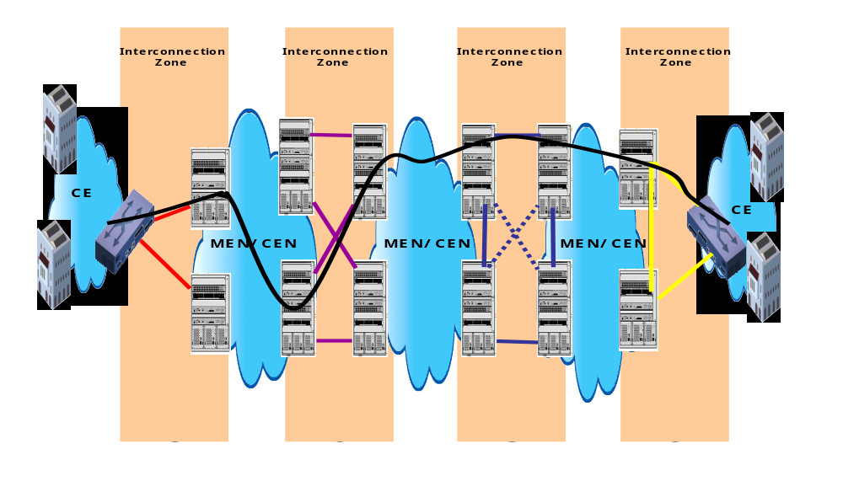
Figure 2 : Example of an EVC traversing several Operators' Networks and Interconnection Zones
The figure illustrates various possible interconnection topologies between the Subscriber premises and MENs/CENs as well as between the MENs/CENs themselves. The dashed lines denote optional Link Connections. Note that the interconnection topologies shown in this figure are just for illustration

- Editor's Note 9: { add more text ….}

