INTERNATIONAL TELECOMMUNICATION UNION |  | STUDY GROUP 15
TELECOMMUNICATION  STANDARDIZATION SECTOR  STUDY PERIOD 2005-2008 |  | TD 212 Rev1 (PLEN/15)
English only
Original: English
Question(s): | 12, 14/15 | Geneva, 6-17 February 2006
TEMPORARY DOCUMENT
(Ref. : TD 112 (WP 3/15))
Source: | Editor Recommendation G.8080
Title: | Draft revised Recommendation G.8080/Y.1304 (for consent)

Abstract
At the December 2004 meeting of SG-15, Amendment 2 to G.8080 was consented and recently approved through AAP. This contribution contains the combined version of G.8080 incorporating changes as a result of the AAP. This document is intended for the use of SG-15 in preparation of a new revised version of this Recommendation. Version 0.5.03 contains text from the Chicago meeting in November 2005. Version 0.5.04 contains edits made after the Chicago meeting in preparation for Geneva meeting. Version 0.5.05 was produced based on drafting activity February 8,9, 2006 in Geneva. Version 0.5.06 was produced based on drafting February 13, 2006. Version 0.5.07 contains edits following final review in Q12.

Note: Text is colour coded to indicate origin of text:
Original G.8080 text is black:
Amendment 1 text is blue:
Amendment 2 text is green.
Text from G.807 is orange.
New text is indicated with change bars or Highlighted text (Note: sections that have been moved are indicated with change marks in MSword. Changes to moved sections are not automatically generated and in these cases, highlighted text is used in this case.

New Draft ITU-T Recommendation G.8080/Y.1304 (Draft Version 0.5.07)
Architecture for the automatically switched optical network (ASON)

Summary
This Recommendation describes the reference architecture for the control plane of the Automatically Switched Optical Network as applicable to SDH transport networks, as defined in ITU-T Recommendation G.803 and Optical Transport Networks, as defined in ITU-T Recommendation G.872. This reference architecture is described in terms of the key functional components and the interactions between them..

Version history: (ED: to be removed following consent. For revision history prior to Version 0.5.03, See TD212(Plen).)
0.5.03 | Nov 2005 | Drafting version (Chicago), contains combined text from drafting activity. Note: requires editorial cleanup after the meeting.
0.5.04 | Dec, 2005 | Version produced in preparation for Geneva meeting.  Main changes:  - Global change: Transport Network Name to Transport Network Identifier (done)  -Addition of text as per SP9 (Sections 5, 5.1)  -Removed “server layer” from call segment definition as per SP8  -added section 6.7 from living list (SP9) as per editors note  - Figures 28, 29 of Chicago draft changed as per SP11 (note: figure numbers will change)  -Editorial “may” to “is” in Section 5.1 to align with Section 8.3.  -added note that call and connection coincide at domain boundaries (Section 5.1.5).  -updated figures 19, 20 to coincide with table  -Renumbered tables  -Reordered appendices
0.5.05 | February 2006 | First drafting version produced in Geneva after editing February 8,9, 2006.  File: G.8080 V0.5.05 drafting version 1.doc  -Added modified definitions from D.518  -updated Appendix VI as per D.659 and D.539  -updated text on NCC based on D.560  -added text on directory server in NCC.  -Clarified call control at inter domain boundaries (7.3.5)  -Added new section 10.3 as per TD213(WP3)  -corrected figure 31 as per SP11 (needs confirmation)
0.5.06 | February 2006 | Second draft version produced during drafting after editing Februrary 13, 2006  Changes::  -global change of “routing controller” to “routing domain controller”  -Added definitions from G.807 (new definitions 3.36-3.50)  -modified definitions 3.16, 3.28, 3.31 3.33  -updated 6.5 on multilayer aspects.  -made corrections to Figure A-2  -Modified Tables A2, A3  -Renamed Annex A to Connection Services  -Modified Figure 41 (changed name to identifier)  -added definition of TRI (definition 3.35 in this version)  -new title to figure 15  -Deleted text on “interfaces” from G.807 (old text, not needed), including figure 39  -renumbered figures 40-44 to onwards to 39-43.  -Modified figure 23 (changed route query interface, now bidirectional, aligned input interface names with table.)  -modified appendix V-1 to clarify application to mapped server.
0.5.07 | February 2006 | Third draft following review by Q12/15. submitted for consent as revision of TD212(WP3)  Summary of changes:  -Minor editorial  -updated definitions of routing domain and rerouting domain (definitions 3.37 and 3.39 (new numbers) (reviewed during Q12/15)  -updated figures 23, 30 and 31,  -deletion of appendix IV (renumbering of Appendix V onward has not been done in this version. This will be done following consent.  -Renumbering of Definitions and addition of editors note to TSB Re; G.8081

CONTENTS
Page

Abstract 1
1 Scope 8
2 References 8
3 Definitions 9
4 Abbreviations 15
5 Overview 16
5.1 Call and connection control 18
5.1.1 Call control 19
5.1.2 Call admission control 19
5.1.3 Connection control 20
5.1.4 Connection admission control 20
5.1.5 Relationship between call state and connection state 20
5.2. Interaction between control, transport and management planes 20
5.2.1 Management - Transport interaction 20
5.2.2 Control - Transport interaction 21
5.2.3 Management - Control interaction. 21
6 Transport resources and their organization 22
6.1 Transport entities 22
6.2 Routing areas 25
6.2.1 Aggregation of links and Routing Areas 26
6.2.2 Relationship to Links and Link Aggregation 27
6.3 Topology and discovery 30
6.4 Domains 31
6.4.1 Relationship between control domains and control plane resources 33
6.4.2 Relationship between control domains, interfaces and reference points 33
6.5 Multi-layer aspects 33
6.6 Interlayer Client Support 36
7 Control plane architecture 38
7.1 Notation 39
7.2 Policy and federations 40
7.2.1 General model of policy 40
7.2.2 General model of federation 42
7.3 Interlayer Client Support 43
7.3 Architectural components 44
7.3.1 Connection controller (CC) component 44
7.3.2 Routing Controller (RC) component 46
7.3.3 Link resource manager (LRMA and LRMZ) component 48
7.3.4 Traffic Policing (TP) component 51
7.3.5 Call controller components 51
7.3.6 Discovery Agent (DA) 61
7.3.7 Termination and adaptation performers 62
7.4 Protocol controller (PC) components 65
7.5 Component interactions for connection setup 67
7.5.1 Hierarchical Routing 68
7.5.2 Source and step-by-step routing 70
8 Reference points 73
8.1 UNI 74
8.2 I-NNI 75
8.3 E-NNI 75
8.4 User Architecture 75
9 Network management of control plane entities 78
10 Addresses 79
10.1 Name Spaces 79
10.2 Names and Addresses 79
11 Connection availability enhancement techniques 81
11.1 Protection 82
11.2 Restoration 82
12 Resilience 86
12.1 Principles of control and transport plane interactions 86
12.2 Principles of Protocol Controller Communication 87
12.3 Control and Management Plane Interactions 87

1 Scope
This Recommendation specifies the architecture and requirements for the automatic switched transport network as applicable to SDH transport networks, as defined in ITU-T Rec. G.803, and Optical Transport Networks, as defined in ITU-T Rec. G.872.
This Recommendation describes the set of control plane components that are used to manipulate transport network resources in order to provide the functionality of setting up, maintaining and releasing connections. The use of components allows for the separation of call control from connection control and the separation of routing and signalling.
For the purposes of this Recommendation, components are used to represent abstract entities rather than instances of implementable software. UML-like notation is used to describe components of the architecture of the Automatically Switched Optical Network.
.

2 References
The following ITU-T Recommendations and other references contain provisions which, through reference in this text, constitute provisions of this Recommendation. At the time of publication, the editions indicated were valid. All Recommendations and other references are subject to revision; users of this Recommendation are therefore encouraged to investigate the possibility of applying the most recent edition of the Recommendations and other references listed below. A list of the currently valid ITU-T Recommendations is regularly published.
− ITU-T Recommendation G.705 (2000), Characteristics of plesiochronous digital hierarchy (PDH) equipment functional blocks.
− ITU-T Recommendation G.707/Y.1322 (2000), Network node interface for the synchronous digital hierarchy (SDH).
− ITU-T Recommendation G.709/Y.1331 (2001), Interfaces for the optical transport network (OTN).
− ITU-T Recommendation G.783 (2000), Characteristics of synchronous digital hierarchy (SDH) equipment functional blocks.
− ITU-T Recommendation G.798 (2002), Characteristics of optical transport network (OTN) hierarchy equipment functional blocks.
− ITU-T Recommendation G.803 (2000), Architecture of transport networks based on the synchronous digital hierarchy (SDH).
− ITU-T Recommendation G.805 (2000), Generic functional architecture of transport networks.
−
− ITU-T Recommendation G.872 (2001), Architecture of optical transport networks.
− ITU-T Recommendation M.3010 (2000), Principles for a telecommunications management network.
− ITU-T Recommendation M.3000 (2000), Overview of TMN Recommendations.
- ITU-T Recommendation M.3100 (1995), Generic network information model.
- ITU-T Recommendation X.25 (1996), Interface between Data Terminal Equipment (DTE) and Data Circuit-terminating Equipment (DCE) for terminals operating in the packet mode and connected to public data networks by dedicated circuit.
- ITU-T Recommendation Y.1311 (2002), Network-based VPNs – Generic architecture and service requirements.
– ITU-T Recommendation Y.1312 (2003), Layer 1 virtual private network generic requirements and architecture.
– ITU-T Recommendation Y.1313 (consented 2004), Layer 1 Virtual Private Network service and network architectures

3 Definitions
This Recommendation defines the following terms:
[Ed: The following definitions have been re-ordered. Changes to previous definitions from original definitions in G.8080, AM1, AM2 and G.807 as a result of drafting are indicated with highlighted text. ]
This Recommendation defines the following terms:
3.1 Access Group (AG): See ITU-T Rec. G.805.
3.2 Adaptation: See ITU-T Rec. G.805.
3.3 Administrative domain: See ITU-T Rec. G.805.
3.4 trail: See ITU-T Rec. G.805.
3.5 Closed user group: See ITU-T Rec. X.25.

3.6 Link: See ITU-T Rec. G.805.
3.7 Link Connection: See ITU-T Rec. G.805.
3.8 Virtual Private Network: See ITU-T Rec. Y.1311
3.9 layer network: See ITU-T G.805.

[Note to TSB: Replace the following definitions with references to G.8081 after G.8081 is approved. (ie. “Agent: See ITU-T Rec. G.8081”)]

3.10 Agent: Within this Recommendation, the term agent is used to describe the entity that represents certain attributes and behaviour of a resource. The agent allows interaction between various resources and management and control functions. More than one agent may represent a resource.
3.11 Call: An association between two or more users and one or more domains that supports an instance of a service through one or more domains. Within domains, the association is supported by network entities that contain call state. Between a user and a network call control entity and between network call control entities, there are call segments. The call consists of a set of concatenated call segments.
3.12 Call segment: An association between two call control entities (as per Q.2982, which is equivalent to G.8080 call controllers). Each call segment has zero or more associated connections. Call segments between network call control entities have zero or more supporting calls.

3.13 Component: An abstract representation of a functional entity. In this Recommendation, components do not represent instances of implementation code. They are used to construct scenarios to explain the operation of the architecture.
3.14 Connection: A connection is a concatenation of link connections and subnetwork connections (as described in ITU-T Rec. G.805) that allows the transport of user information between the ingress and egress points of a subnetwork.
3.15 Connection Point (CP): For the purposes of this Recommendation, a connection point represents the north input port of an Adaptation function. (Note that in ITU-T Rec. G.805 the CP refers to the binding between two points).
3.16 Connection Termination Point (CTP): See ITU-T Rec. M.3100, Amendment 1. A connection Termination point represents the signal state at the CP.
3.17 Control Plane: The control plane performs the call control and connection control functions. Through signalling, the control plane sets up and releases connections, and may restore a connection in case of a failure. The control plane also performs other functions in support of call and connection control, such as routing information dissemination.

3.18 Management Plane: The management plane performs management functions for the transport plane, the control plane and the system as a whole. It also provides coordination between all the planes. The following management functional areas identified in ITU-T Rec. M.3010 are performed in the management plane:
– performance management;
– fault management;
– configuration management;
– accounting management;
– security management
The TMN architecture is described in ITU-T Rec. M.3010, additional details of the management plane are provided by the M-series Recommendations.
3.19 Multi-homed: A user is considered to be multi-homed when there are two or more SNPP links connecting the access group container to the network. SNPP links associated with the same UNI reference point if on the network side, they are within the scope of a common network call controller component. Further, there is also a service agreement between the user and the network such that the network offers reliability, diversity, or other service characteristic between connections on different multi-homed SNPP links.
3.20 Policy: The set of rules applied to interfaces at the system boundary, which filter messages into an allowed set. Policy is implemented by "Port Controller" components.
3.21 Port Controller: A class of component that implements the set of rules applied to a system.
3.22 Route: a sequence of SNP names, SNPP names, routing area names, and/or transport resource identifiers that are used by the control plane to create a network connection
3.23 Routing Area: A routing area is defined by a set of subnetworks, the SNPP links that interconnect them, and the SNPPs representing the ends of the SNPP links exiting that routing area. A routing area may contain smaller routing areas interconnected by SNPP links. The limit of subdivision results in a routing area that contains a subnetwork.
3.24 Routing level: A routing level is a relationship between an RA and a containing RA or contained RAs. The containment hierarchy of routing areas creates routing levels.
3.25 Subnetwork: A topological component used to effect routing of a specific characteristic information. For the purposes of this Recommendation, a subnetwork is bounded by subnetwork points.
3.26 Subnetwork Connection (SNC): A subnetwork connection is a dynamic relation between two (or more in the case of broadcast connections) subnetwork points at the boundary of the same subnetwork.
3.27 Subnetwork Point (SNP): The SNP is an abstraction that represents an actual or potential underlying CP (or CTP) or an actual or potential TCP (or TTP). Several SNPs (in different subnetwork partitions) may represent the same TCP or CP.
3.28 Subnetwork Point Pool (SNPP): A set of subnetwork points that are grouped together for the purposes of routing. An SNP pool has a strong relationship to Link Ends (See ITU-T Rec. G.852.2).
3.29 Subnetwork Point Pool link (SNPP link): An association between SNPPs on different subnetworks.
3.30 Termination Connection Point (TCP): For the purposes of this Recommendation, a termination connection point represents the output of a trail termination function or the input to a trail termination sink function. (Note that in ITU-T Rec. G.805 the TCP refers to the binding between two points).
3.31 Trail Termination Point (TTP): See ITU-T Rec. M.3100. A trail termination point represents the signal state at a TCP.
3.32 Transport Plane: The transport plane provides bidirectional or unidirectional transfer of user information, from one location to another. It can also provide transfer of some control and network management information. The transport plane is layered; it is equivalent to the transport network defined in ITU-T Rec. G.805.
3.33 Control Domain: A type of transport domain where the criterion for membership is the scope of a control plane component that is responsible for the transport resources within the transport domain.
3.34 Transport Domain: A transport domain is a set of transport resources that are grouped as a result of some criteria. This grouping is established by operator policies. An example is the G.805 administrative domain.
3.35 Hard Rerouting: A failure recovery function in a rerouting domain that attempts to create another connection to the destination at the edge of the rerouting domain. This is performed in response to the failure of an existing connection, and the rerouted connection replaces the connection that contained the failure.
3.36 Control Plane Configured Protection: Control Plane Configured Protection refers to the configuration and use of transport plane protection capabilities. Configuration of protection is done by the control plane as opposed to the management plane. Control plane components associated with a protected connection are responsible for use of the protected connection. In the event of a failure, the control plane protection action does not involve rerouting or additional connection setup.
3.37 Rerouting Domain:. A type of routing control domain whose control components at the edge of the domain coordinate rerouting operations for all calls/connections that traverse the rerouting domain. .
3.38 Restoration: Restoration is the action of replacing a connection in a call by rerouting the connection.
3.39 Routing Control Domain:. A type of control domain where the criterion for membership is a common routing capability. It may contain zero or more routing domains.
3.40 Soft Rerouting: Soft rerouting is a function that reroutes a connection for administrative purposes. The original connection is not taken out of service until the rerouted connection is established.
3.41 Transport Resource Identifier: Transport resource identifiers are used by control plane components to refer to transport plane resources. This name space is operator assigned and is independent of SNPP identifier spaces.
3.42 Address: An address is a string of symbols that is valid regardless of the location of the source but changes if the destination moves. An address is used for the purpose of routeing. Source and destination addresses must be globally unique.
3.43 E-NNI: A bidirectional signalling interface between control plane entities belonging to different domains. (See also clause 8.)
3.44 Interface: In the context of this Recommendation, interfaces represent logical relationships between ASTN control plane entities and are defined by the information flow between these entities. Such a relationship allows distribution of these entities in support of different equipment implementations and network architectures.
3.45 I-NNI: A bidirectional signalling interface between control plane entities belonging to one or more domains having a trusted relationship. (See also clause 8.)
3.46 Name: A name, or identifier, is a location independent string with respect to both a source and a destination. If a string is the name of a destination, it remains unchanged if the destination moves. It is valid regardless of the source attempting communication with the destination.
3.47 Permanent connection : A permanent connection is a connection type that is provisioned by manual action or via the management system.
3.48 Switched Connection (SC): An switched connection is any connection that is established, as a result of a request from the end user, between connection end-points using a signalling/control plane and involves the dynamic exchange of signalling information between signalling elements within the control plane(s).
3.49 Soft Permanent Connection (SPC): An Soft Permanent Connection is a user-to-user connection where by the user-to-network portion of the end-to-end connection is established by the network management system as a permanent connection. The network portion of the end-to-end connection is established as a switched connection using the control plane. In the network portion of the connection, requests for establishment of the connection are initiated by the management plane and set-up by the control plane.
3.50 Service level agreement: A service level agreement is a contract between two parties such as a service provider and a customer. It defines the services available to the customer, and the grade of service of those services as offered to the customer. It also usually describes the service guarantee and potential penalties in case of service degradation or failure. Service level agreements and related policies are out side the scope of standardization”
3.51 Supplementary services: Within a transport network, supplementary services are considered to be the set of services that are provided to end users over and above connection management.
3.52 Third party signalling: A party that acts on behalf of a user and exchanges information between the user and the control plane for the purpose of connection supervision.
3.53 User-Network Interface for the control plane (UNI): A bidirectional signalling interface between service requester and service provider control plane entities. (See also clause 8.)

4 Abbreviations
This Recommendation uses the following abbreviations:
AG Access Group
AGC Access Group Container
CC Connection Controller
CCC Calling party Call Controller
CP Connection Point
CPS Connection Point Status
CTP Connection Termination Point
DCN Data Communications Network
DA Discovery Agent
E-NNI External Network-Network Interface (reference point)
HOVC Higher Order Virtual Container
id identifier
I-NNI Internal Network-Network Interface (reference point)
LOVC Lower Order Virtual Container
LRM Link Resource Manager
MI Management Information
MO Managed Object
NCC Network Call Controller
PC Protocol Controller
RC Routing Controller
SNC Subnetwork Connection
SNP Subnetwork Point
SNPP Subnetwork Point Pool
TAP Termination and Adaptation Performer
TCP Termination Connection Point
TTP Trail Termination Point
UML Unified Modelling Language
UNI User-Network Interface (reference point)
VPN Virtual Private Network

5 Overview
The purpose of the Automatic Switched Optical Network (ASON) control plane is to:
− Facilitate fast and efficient configuration of connections within a transport layer network to support both switched and soft permanent connections.
− Reconfigure or modify connections that support calls that have previously been set up.
− Perform a restoration function.
A well-designed control plane architecture should give service providers control of their network, while providing fast and reliable call setup. The control plane itself should be reliable, scalable, and efficient. It should be sufficiently generic to support different technologies, differing business needs and different distribution of functions by vendors (i.e. different packaging of the control plane components).
The ASON control plane is composed of different components that provide specific functions including that of route determination and signalling. The control plane components are described in terms that place no restrictions regarding how these functions are combined and packaged. Interactions among these components, and the information flow required for communication between components, are achieved via interfaces.
This Recommendation deals with the control plane architectural components and the interaction between the control plane, management plane and transport plane. The management and transport planes are specified in other ITU-T Recommendations and are outside the scope of this Recommendation.
Figure 1/G.8080/Y.1304 provides a high level view of the interactions of the control, management and transport planes for the support of switched connections of a layer network. Also included on this figure is the DCN, which provides the communication paths to carry signalling and management information. The details of the DCN, management plane and the transport plane are outside the scope of this Recommendation. Functions pertaining to the control plane are described in this Recommendation.
Control plane deployment will occur within the context of commercial operator business practices and the multi-dimensional heterogeneity of transport networks. These business and operational considerations lead to the need for architectural support of, for example, strong abstraction barriers to protect commercial business operating practices, segmenting transport networks into domains according to managerial and/or policy considerations, and inherent transport network heterogeneity (including control and management). The domain notion embodied in the G.805 definition of administrative domain and the Internet administrative regions (e.g., Autonomous Systems) has been generalized in the control plane architecture to express differing administrative and/or managerial responsibilities, trust relationships, addressing schemes, infrastructure capabilities, survivability techniques, distributions of control functionality, etc. Domains are established by operator policies and have a range of membership criteria, as exemplified above.
The control plane supports connection services (See Annex A) through the automatic provisioning of end-to-end transport connections across one or more domains. This involves both a service and connection perspective:
- The service (call) perspective is to support the provisioning of end-to-end services while preserving the independent nature of the various businesses involved.
- The connection perspective is to automatically provision “path layer” connections (in support of a service) that span one or more domains.
Connection state information (e.g. fault and signal quality) is detected by the transport plane and provided to the control plane.
The control plane carries (distributes) link status (e.g. adjacency, available capacity and failure) information to support connection setup/release and restoration.
Detailed fault management information or performance monitoring information is transported within the transport plane (via the overhead/OAM) and via the management plane (including the DCN).
The interconnection between and within domains is described in terms of reference points. As domains are established via operator policies, inter-domain reference points are service demarcation points for a single service layer (i.e., points where call control is provided). The exchange of information across these reference points is described by the multiple abstract interfaces between control components. A physical interface is provided by mapping one or more abstract component interfaces to a protocol. Multiple abstract interfaces may be multiplexed over a single physical interface. The reference point between a user and a provider domain is the UNI, which represents a user-provider service demarcation point. . The reference point between domains is the E-NNI, which represents a service demarcation point supporting multi-domain connection establishment. The reference point within a domain is an I-NNI, which represents a connection point supporting intra-domain connection establishment. The information flows across these reference points are further described in clause 8.
The control plane may also be subdivided to allow the segregation of resources for example between Virtual Private Networks (VPN). If the resources are dedicated to independent domains then no reference points are provided between these domains. The case where a portion of the resources are dynamically shared is for further study.

Separate descriptions are provided for the interactions between the:
Control plane and transport plane layer networks, and
Management plane and transport planes resulting from the addition of the control plane for connection management and connection monitor configuration

This recommendation version encompasses the control of transport layer network connections , including inter-layer interactions arising from requests for capacity in server layers.
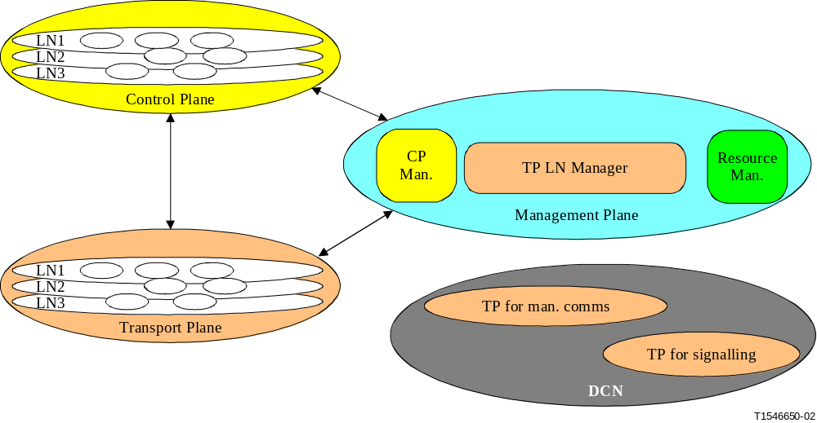
Figure 1/G.8080/Y.1304 – Relationship between architectural components

5.1 Call and connection control
This Recommendation separates the treatment of call and connection control, as call control is only needed at domain boundaries (e.g. UNI, E-NNI). Thus, within a domain (i.e., I-NNI) it is only necessary to support procedures for connection control.
Additionally, call control is provided at interlayer NCC boundaries . The functions performed by the call controllers at domain boundaries are defined by the policies associated by the interactions allowed between the domains. Policies are established by the operator. As such, an end-to-end call is considered to consist of multiple call segments, depending on whether the call traverses multiple domains. This allows for flexibility in the choice of signalling, routing and recovery paradigms in different domains.
It should be noted that the call is the representation of the service offered to the user of a network layer, while the connections are one of the means by which networks deliver said services. There may be other entities used in supporting calls, such as service specific processes.

5.1.1 Call control
Call control is a signalling association between one or more user applications and the network to control the setup, release, modification and maintenance of sets of connections. Call control is used to maintain the association between parties and a call may embody any number of underlying connections, including zero, at any instant of time.
Call control may be realized by one of the following methods:
− Separation of the call information into parameters carried by a single call/connection protocol.
− Separation of the state machines for call control and connection control, whilst signalling information in a single call/connection protocol.
− Separation of information and state machines by providing separate signalling protocols for call control and connection control.
Call control must provide coordination of connections (in a multi-connection call) and the coordination of parties (multiparty calls). To coordinate multiple connections, the following actions need to take place in the network:
− All connections must be routed so that they can be monitored by at least one coordinating (call control) entity.
− Call control associations must be completed before connections are setup. A call may exist without any connections (facilitating complex connection rearrangements).
A call can be considered to have three phases:
Establishment
During this phase, signalling messages are exchanged between users and the network to negotiate the call characteristics. The exchange of signalling messages between the calling party and the network is known as an outgoing call. The exchange of signalling messages between the network and the called party is referred to as an incoming call.
Active
During this phase, data can be exchanged on the associated connections and call parameters may also be modified (e.g. the addition of new parties in a point-to-multi-point call, where this type of call is supported).
Release
During this phase, signalling messages are exchanged between calling and called parties and the network to terminate the call. A call may be released by either the calling or called terminals or by proxy or network management.

5.1.2 Call admission control
Call admission control is a policy function invoked by an originating role in a network and may involve cooperation with the terminating role in the network. Note that a call being allowed to proceed only indicates that the call may proceed to request one or more connections. It does not imply that any of those connection requests will succeed. Call admission control may also be invoked at other network boundaries.
The originating call admission function is responsible for checking that a valid called user name and parameters has been provided. The service parameters are checked against a service level specification (a set of parameters and values agreed between network operator and customer for a particular service indicating the 'scope' of the service). If necessary, these parameters may need to be renegotiated with the originating user. The scope of this negotiation is determined by policies derived from the original service level specification, which itself is derived from the service level agreement (the service contract between a network operator and a customer that defines global responsibilities between them).
The terminating call admission function is responsible for checking that the called party is entitled to accept the call, based on the calling party and called party service contracts. For example, a caller address may be screened.

5.1.3 Connection control
Connection control is responsible for the overall control of individual connections. Connection control may also be considered to be associated with link control. The overall control of a connection is performed by the protocol undertaking the setup and release procedures associated with a connection and the maintenance of the state of the connection.

5.1.4 Connection admission control
Connection admission control is essentially a process that determines if there are sufficient resources to admit a connection (or re-negotiates resources during a call). This is usually performed on a link-by-link basis, based on local conditions and policy. For a circuit switched network, this may simply devolve to whether there are free resources available. In contrast, for packet switched networks such as ATM, where there are multiple quality of service parameters, connection admission control needs to ensure that admission of new connections is compatible with existing quality of service agreements for existing connections. Connection admission control may refuse the connection request.

5.1.5 Relationship between call state and connection state
The call state has dependency upon the state of the associated connections. This dependency is related to call type and policy. For example, where there is a single connection and it fails, the call may be immediately released, or alternatively, may be released after a period of time if no alternative connection can be obtained using mechanisms such as protection or restoration. Note that call and connection coincide at domain boundaries.

5.2. Interaction between control, transport and management planes
Figure 1/G.8080/Y.1304 illustrates the general relationships between the control, management and transport planes. Each plane is autonomous, but some interaction will occur. The following provides further details on the interactions between the various planes.

5.2.1 Management - Transport interaction
The management plane interacts with transport resources by operating on a suitable information model, which presents a management view of the underlying resource. The objects of the information model are physically located with the transport resource, and interact with that resource via the Management Information (MI) interfaces of the layer specific functional model. These interfaces should be collocated with the managed object and the control component.

5.2.2 Control - Transport interaction
Only two architectural components have a strong relationship to a physical transport resource.
At the lower limit of recursion, the Connection Controller (CC) provides a signalling interface to control a connection function. This component is physically located with the connection function and all further hardware details are hidden. However, given the limited information flow a new protocol may be useful to optimise this communication. The Termination and Adaptation Performer (TAP) is physically located with the equipment that provides adaptation and termination functions, and provides a control plane view of link connections. The TAP hides the interaction with the hardware.

5.2.3 Management - Control interaction.
G.8080/Y.1304, Clause 7.1 states that each component has a set of special interfaces to allow for monitoring of the component operation, and dynamically setting policies and affecting internal behavior. These interfaces are equivalent to the MI interface of the transport functional model, and allow the component to present a view to a management system and to be configured by a management system. This is discussed further in Section 7.1.
The management plane interacts with control components by operating on a suitable information model, which presents a management view of the underlying component. The objects of the information model are physically located with a control component, and interact with that component via the monitor and configuration interfaces of that component. These interfaces should be collocated with the managed object and the control component.
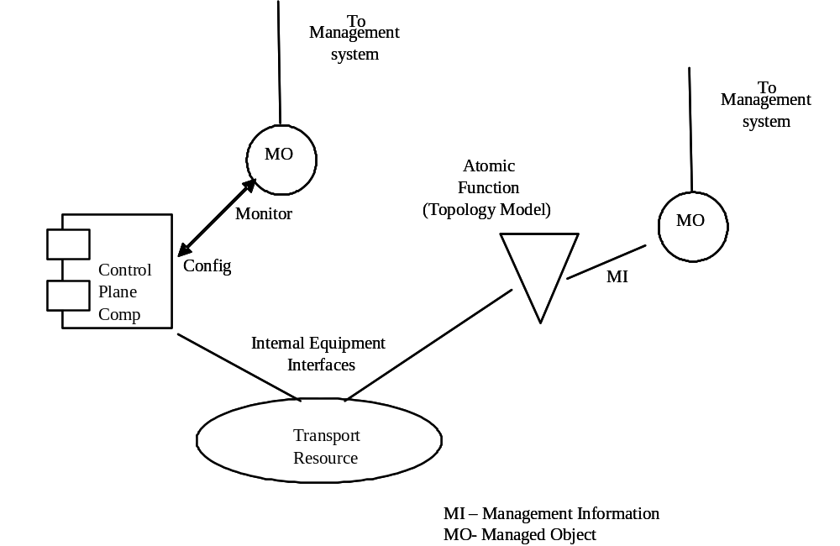

Figure 2/G.8080/Y.1304: Management/transport plane interactions with transport resources
The physical transport resources, which represent the physical reality of the equipment, are described in terms of G.805 atomic functions. Managed objects (MO), which represent the external management view of the equipment, interact with the functional model specified in equipment recommendations via the MI reference points, which are also completely within the equipment. Note that the managed object represents the management view regardless of the management protocol used. The information is independent of the protocol used.
From the control plane view, control plane components operate directly on the transport resources, so control plane operation appears autonomous to the management plane. Likewise, management plane operations appear autonomous to the control plane. This is exactly the same situation we have when multiple managers manage equipment. Each manager is unaware of each other's existence, and simply sees autonomous equipment behaviour. Although the information presented to the control plane is similar to that presented to management, it is not identical to the MI information. Control plane information overlaps the MI data because the control plane requires some but not all management information. For example, restoration is likely to be triggered by the same conditions that normally trigger protection actions.
Component specific managed objects present a management view of control plane components via the monitor interfaces on the component. It is critical to realise that this is the view of the manageable aspects of the component, and not a view of the transport resource, which is obtained via the management view.
5.2.4 Resource Management [Ed: text from G.807 Section 12]
Network resources may be partitioned between those under the authority of the management plane and those under the authority of the control plane. It shall not be possible for the control plane to modify resources that are under the authority of the management plane. This includes network resources not currently in use, but reserved for future use (e.g. by network planners). As such, resource management is performed by the management plane and is outside the scope of this Recommendation.

6 Transport resources and their organization
The functional architecture of the transport network describes the way that the transport resources are used to perform the basic transport functions in a manner that makes no reference to the control and management of those functions. For the purposes of control and management each transport resource has a closely coupled agent that represents the role it has to play. These agents interact with other functions that are participating in the control and management through interfaces, and present information or execute operations as required. The transport resources are organized into routing areas and subnetworks for the purposes of control and management.

6.1 Transport entities
For the purpose of managing connections within a layer network, the underlying transport plane resources are represented by a number of entities in the control plane. Figure 3 illustrates the relationship between the transport resources described in ITU-T Rec. G.805, the entities that represent these resources for the purposes of network management (as described in ITU-T Rec. M.3100) and the view of the transport resources as seen by the control plane.
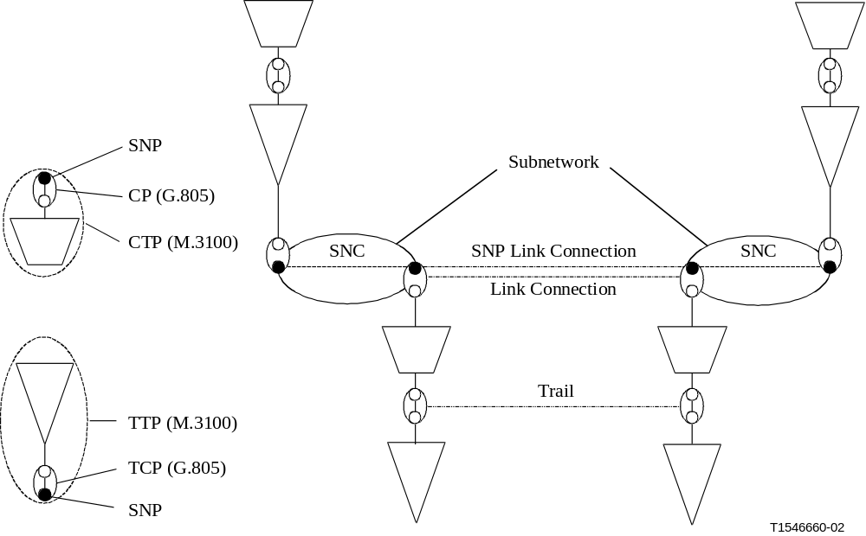
Figure 3/G.8080/Y.1304 – Relationship between architectural entities in the transport plane, management plane and the control plane
An SNP has a number of relationships with other SNPs:
− A static relationship between two SNPs in different subnetworks. This is referred to as an SNP link connection.
− A dynamic relationship between two (or more in the case of broadcast connections) subnetwork points at the boundary of the same subnetwork. This is referred to as a subnetwork connection.
A subnetwork point may also be grouped with other SNPs for the purpose of routing. This is a subnetwork point pool (SNPP) and has a strong relationship with Link Ends (as defined in ITU-T Rec. G.852.2), however, this relationship is more flexible than the link end. An SNPP may be further subdivided into smaller pools. One use of this sub-structuring is to describe different degrees of route diversity. For example, all the SNPs in one subnetwork that have a relationship to a similar group on another subnetwork may be grouped into a single SNPP. This SNPP may be further sub-divided to represent diverse routes and further subdivided to represent, for example, individual wavelengths.
The association between SNPPs on different subnetworks is an SNPP link.
The SNP and SNP link connection states of interest to the control plane are described in sections 7.3.7 (Termination and adaptation performers), and section 7.3.3 (Link resource manager respectively).
Variable adaptation functions
A number of transport systems support variable adaptation, whereby a single server layer trail may dynamically support different multiplexing structures.
This situation is modelled by assigning SNPs for each CP in the various structures, and placing those SNPs in their respective layer subnetworks. When a particular SNP instance is allocated, this causes the relevant client specific process in the adaptation function to be activated and creates the associated CTP. SNPs in other layer networks that use the same resources become busy.
Figure 4 shows an example of a STM-1 trail that can support either a single VC-4 or 3 VC-3s.
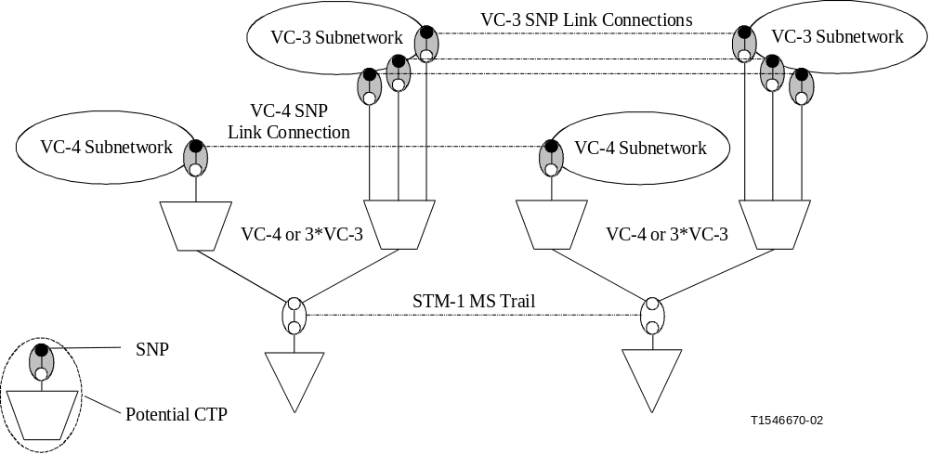
Figure 4/G.8080/Y.1304 – Example of variable adaptation
(STM-1 trail supporting both 3 × VC-3 or 1 × VC-4)
Link resources shared between VPNs
Y.1313 defines several basic service models through which Layer One VPNs (L1VPNs) may be provided through the ASON architecture.
A VPN is a closed user group that can use a defined set of network resources. In the control plane, a SNPP can be public, that is, not associated with any VPN, or private, that is, associated with exactly one VPN. Connection routing in a VPN can only use the SNPPs associated with that VPN. In the transport plane, a CP can be assigned to a SNP in multiple SNPPs, public or private. Connectivity on a link that is shared between VPNs can be modelled by creating an SNP for each of the shared CPs in each VPN. When a CP is allocated to a particular SNP in one VPN, the SNPs representing the same resources in other VPNs become Busy. Figure 5 shows an example of two VPNs, each with two SNPs in the control plane. In the transport plane, the first CP is assigned and allocated to the second SNP in VPN 2, the third CP is assigned and allocated to the second SNP in VPN 1, and the second CP is assigned to both the first SNP in VPN 1 and the first SNP in VPN 2. If the second CP is allocated to the first SNP in VPN 1, this SNP becomes Available while the first SNP in VPN 2 becomes Busy.

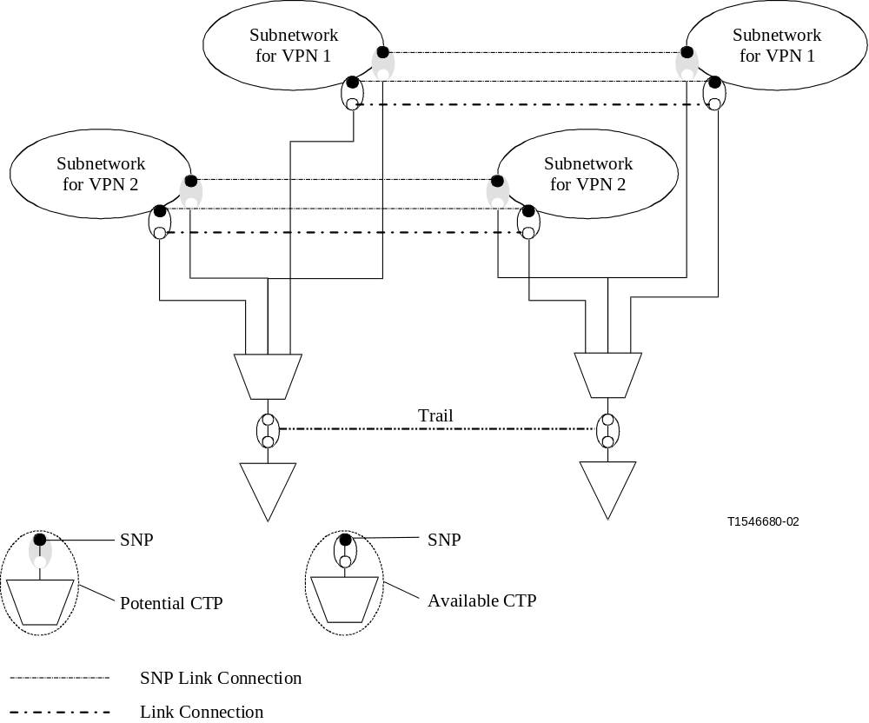
Figure 5/G.8080/Y.1304 – Allocation of link resources between VPNs

6.2 Routing areas
Within the context of this Recommendation a routing area exists within a single layer network. A routing area is defined by a set of subnetworks, the SNPP links that interconnect them, and the SNPPs representing the ends of the SNPP links exiting that routing area. A routing area may contain smaller routing areas interconnected by SNPP links. The limit of subdivision results in a routing area that contains one subnetwork.
Routing Areas and subnetworks are very closely related as both provide an identical function in partitioning a network. The critical distinction is that at the boundary, the link ends are visible from inside a routing area, whereas inside a subnetwork only connection points can be seen. Seen from the outside, subnetworks and RAs are identical, and the terms subnetwork and RA can be used almost synonymously. The distinction between the two is usually obvious from the context, though the term node is often used to denote either a subnetwork or RA. Also note that from the outside of both subnetworks and routing areas, it is not possible to see any internal details, and both subnetworks and routing areas appear as points in the network topology graph.
Where an SNPP link crosses the boundary of a routing area, all the routing areas sharing that common boundary have contained co-incident SNPP links. This is illustrated in Figure 6.
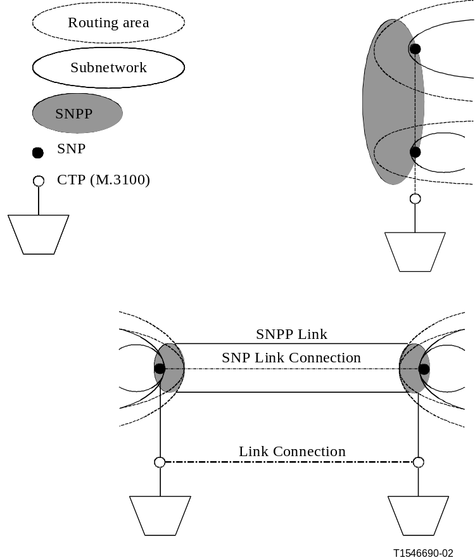
Figure 6/G.8080/Y.1304 – Relationship between routing areas, subnetworks, SNPs and SNPP

6.2.1 Aggregation of links and Routing Areas
Figure 7 illustrates the relationships between routing areas, SNPPs, and SNPP links. Routing areas and SNPP links may be related hierarchically. In the example routing area A is partitioned to create a lower level of routing areas, B, C, D, E, F, G and interconnecting SNPP links. This recursion can continue as many times as necessary. For example, routing area E is further partitioned to reveal routing areas H and I. In the example given there is a single top level routing area. In creating a hierarchical routing area structure based upon "containment" (in which the lower level routing areas are completely contained within a single higher level routing area), only a subset of lower level routing areas, and a subset of their SNPP links are on the boundary of the higher level routing area. The internal structure of the lower level is visible to the higher level when viewed from inside of A, but not from outside of A. Consequently only the SNPP links at the boundary between a higher and lower level are visible to the higher level when viewed from outside of A. Hence the outermost SNPP links of B and C and F and G are visible from outside of A but not the internal SNPP links associated with D and E or those between B and D, C and D, C and E or between E and F or E and G. The same visibility applies between E and its subordinates H and I. This visibility of the boundary between levels is recursive. SNPP link hierarchies are therefore only created at the points where higher level routing areas are bounded by SNPP links in lower level routing areas.
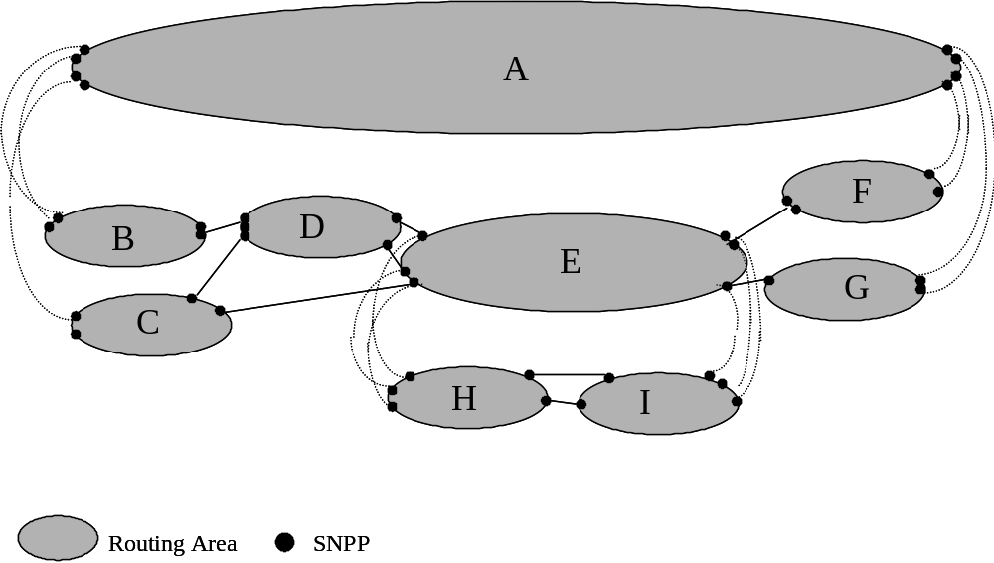
Figure 7/G.8080/Y.1304 Example of a Routing Area Hierarchy and SNPP link Relationships
Subnetwork points are allocated to an SNPP link at the lowest level of the routing hierarchy and can only be allocated to a single subnetwork point pool at that level. At the routing area hierarchy boundaries the SNPP link pool at a lower level is fully contained by an SNPP link at a higher level. A higher level SNPP link pool may contain one or more lower level SNPP links. In any level of this hierarchy an SNPP link is associated with only one routing area. As such routing areas do not overlap at any level of the hierarchy. SNPP links within a level of the routing area hierarchy that are not at the boundary of a higher level may be at the boundary with a lower level thereby creating an SNPP link hierarchy from that point (e.g. routing area E). This provides for the creation of a containment hierarchy for SNPP links.
A routing area may have an SNPP name space that is independent from those used in other routing areas. Note, an SNPP name is routable in the RA whose SNPP name space it belongs to.

6.2.2 Relationship to Links and Link Aggregation
A number of SNP link connections within a routing area can be assigned to the same SNPP link if and only if they go between the same two subnetworks. This is illustrated in Figure 8. Four subnetworks, SNa, SNb, SNc and SNd and SNPP links 1, 2 and 3 are within a single routing area. SNP link connections A and B are in the SNPP link 1. SNP link connections B and C cannot be in the same SNPP link because they do not connect the same two subnetworks. Similar behaviour also applies to the grouping of SNPs between routing areas.
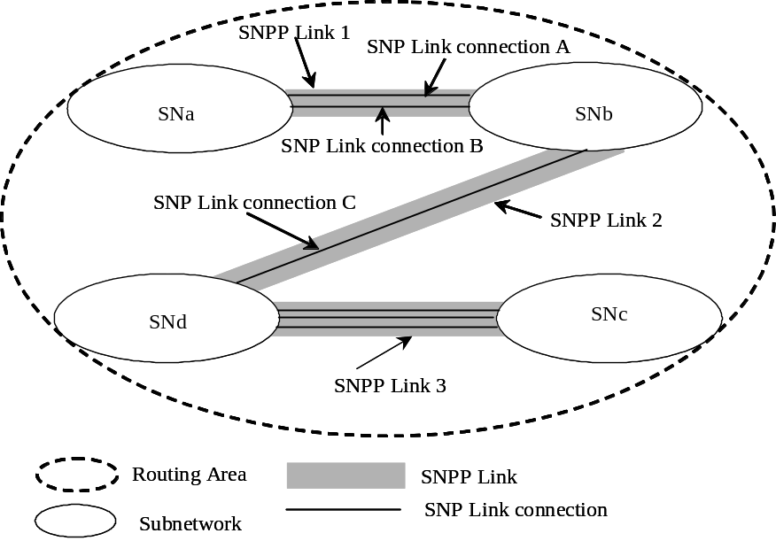
Figure 8/G.8080/Y.1304 SNPP link Relationship to Subnetworks
Figure 9 shows three routing areas, RA-1, RA-2 and RA-3 and SNPP links 1 and 2. SNP link connections A, B, and C cannot be in the same SNPP link because more than two routing areas are found in their endpoints. SNP link connections A&B are not equivalent to SNP link connection C for routing from Routing Area 3 (RA-3).
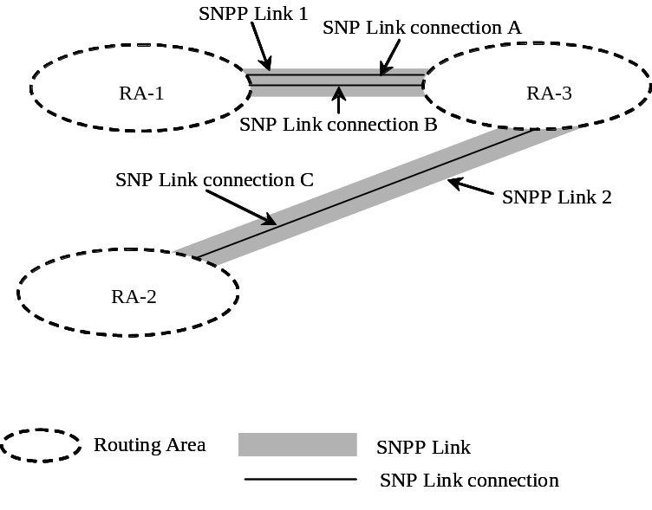
Figure 9/G.8080/Y.1304: SNPP link Relationships to Routing Areas

SNP link connections between two routing areas, or subnetworks, can be grouped into one or more SNPP links. Grouping into multiple SNPP links may be required:
- if they are not equivalent for routing purposes with respect to the routing areas they are attached to, or to the containing routing area
- if smaller groupings are required for administrative purposes.
There may be more than one routing scope to consider when organizing SNP link connections into SNPP links. In Figure 10, there are two SNP link connections between routing areas 1 and 3. If those two routing areas are at the top of the routing hierarchy (there is therefore no single top level routing area), then the routing scope of RA-1 and RA-3 is used to determine if the SNP link connections are equivalent for the purpose of routing.
The situation may however be as shown in Figure 10. Here RA-0 is a containing routing area. From RA-0's point of view, SNP link connections A&B could be in one (a) or two (b)SNPP links. An example of when one SNPP link suffices is if the routing paradigm for RA-0 is step-by-step. Path computation sees no distinction between SNP link connection A and B as a next step to get from say RA-1 to RA-2.

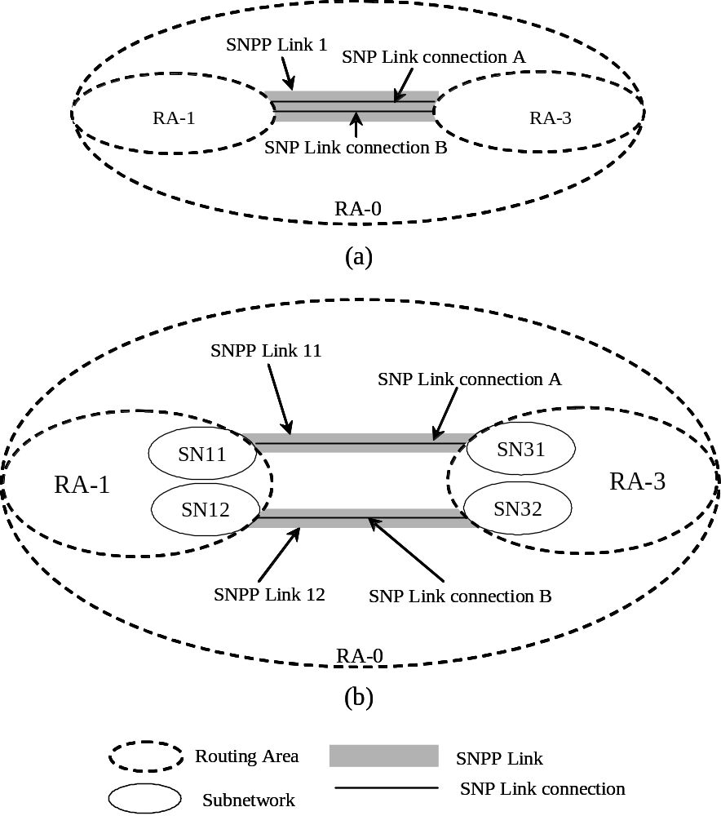
Figure 10/G.8080/Y.1304: Routing scope

From RA-1 and RA-3's point of view though, the SNP link connections may be quite distinct from a routing point of view as choosing SNP link connection A may be more desirable than SNP link connection B for cost, protection or other reason. In this case, placing each SNP link connection into its own SNPP link meets the requirement of "equivalent for the purpose of routing". Note that in Figure 10, SNPP link 11, Link 12 and Link 1 can all coexist.
Another reason for choosing SNPP link 11 (Figure 10b) over SNPP link 12 could be because the cost of crossing RA-3 is different from SNPP link 11 than from SNPP link 12. This suggests that a mechanism to determine the relative cost of crossing RA-3 from link 11 and from link 12 would be useful. Such a mechanism could be used recursively to determine the relative cost of crossing RA-0. Note that this does not imply exposing the internal topology of any routing area outside of its scope. A query function could be invoked to return the cost of a particular route choice. The costs returned by such a query would be determined by policy applied to each routing area. A common policy should be used in all the routing areas, resulting in comparable costs. Such a query could also be generalized to apply routing constraints before calculating the cost.

6.3 Topology and discovery
The routing function understands topology in terms of SNPP links. Before SNPP links can be created, the underlying transport topology, i.e. the link connection relationships between CPs, must be established. These relationships may be discovered (or confirmed against a network plan) using a number of different techniques; for example, use of a test signal or derived from a trail trace in the server layer. They may also be provided by a management system based on a network plan. The capability of the transport equipment to support flexible adaptation functions (and thus link connections for multiple client layer networks) may also be discovered or reported.
Link connections that are equivalent for routing purposes are then grouped into links. This grouping is based on parameters, such as link cost, delay, quality or diversity. Some of these parameters may be derived from the server layer but in general they will be provisioned by the management plane.
Separate links may be created (i.e. link connections that are equivalent for routing purposes may be placed in different links) to allow the division of resources between different ASON networks (e.g. different VPNs) or between resources controlled by ASON and the management plane.
The link information (e.g. the constituent link connections and the names of the CP pairs) is then used to configure the LRM instances (as described in 7.3.3) associated with the SNPP link. Additional characteristics of the link, based on parameters of the link connections, may also be provided. The LRMs at each end of the link must establish a control plane adjacency that corresponds to the SNPP link. The interface SNPP ids may be negotiated during adjacency discovery or may be provided as part of the LRM configuration. The link connections and CP names are then mapped to interface SNP ids (and SNP Link Connection names). In the case where both ends of the link are within the same routing area the local and interface SNPP id and the local and interface SNP ids may be identical. Otherwise, at each end of the link the interface SNPP id is mapped to a local SNPP id and the interface SNP ids are mapped to local SNP ids. This is shown in Figure 11.
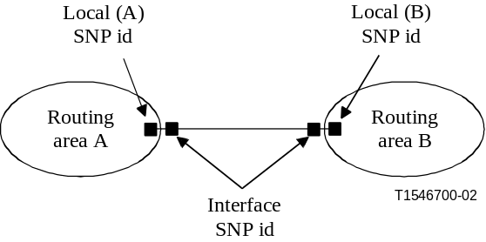
Figure 11/G.8080/Y.1304 – Relationship between local and interface ids
The resulting SNP link connections may then be validated by a discovery process. The degree of validation required at this stage is dependent on integrity of the Link Connection relationships initially provided by the transport plane or management plane and the integrity of the process used to map CPs to SNPs.
Validation may be derived from a trail trace in the server layer or by using a test signal and test connections. If test connections are used, the discovery process may setup and release these connections using either the management plane or the control plane. If the control plane is used, the Link must be made temporarily available to routing and connection control, for test connections only.
Once the SNPP link validation is completed the LRMs informs the RC component (see 7.3.2) of the SNPP Link adjacency and the link characteristics e.g. cost, performance, quality and diversity.

6.4 Domains
As introduced in Section 5, we have generalized the domain notion embodied in the G.805 definition of administrative and management domains, along with the notion of Internet administrative regions, to express differing administrative and/or managerial responsibilities, trust relationships, addressing schemes infrastructure capabilities, survivability techniques, distributions of control functionality, etc. A domain thus represents a collection of entities that are grouped for a particular purpose.
A control domain is comprised of a collection of control plane components, and provides an architectural construct that encapsulates and hides the detail of a distributed implementation of a particular group of architectural component of one or more types. It allows for the description of a group of distributed components in such a way that the group can be represented by distribution interfaces on a single entity, the domain, that has identical characteristics to that of the interfaces of the original component distribution interfaces. The nature of the information exchanged between control domains captures the common semantics of the information exchanged between component distribution interfaces, while allowing for different representations inside the domain.
Generally a control domain is derived from a particular component type, or types, that interact for a particular purpose. For example, routing (control) domains are derived from routing controller components whilst a rerouting domain is derived from a set of connection controller and network call controller components that share responsibility for the rerouting/restoration of connections/calls that traverse that domain. In both examples the operation that occurs, routing or rerouting, is contained entirely within the domain. In this Recommendation control domains are described in relation to components associated with a layer network.
As a domain is defined in terms of a purpose it is evident that domains defined for one purpose need not coincide with domains defined for another purpose. Domains of the same type are restricted in that they may:
- fully contain other domains of the same type, but do not overlap,
- border each other
- be isolated from each other
An example of the relationships between components, domains and reference points is provided in Figure 12 which shows a domain, B, and its relationship to domains A, C and D. Each domain is derived from a component of type Z. The internal structure and interactions may be different in each domain, e.g. they may use different federation models.
The same example is shown in Figure 13 with the relationships between components, domains and interfaces. The components interact via their protocol controllers, using protocol I on the I-PCs and protocol E on the E-PCs. It is also possible for the protocol used internal to A, for example, to be different to that used in B, and the protocol used between B and C to be different to that between A and B. The I-NNI interfaces are located between protocol controllers within domains whilst E-NNI interfaces are located on protocol controllers between domains.
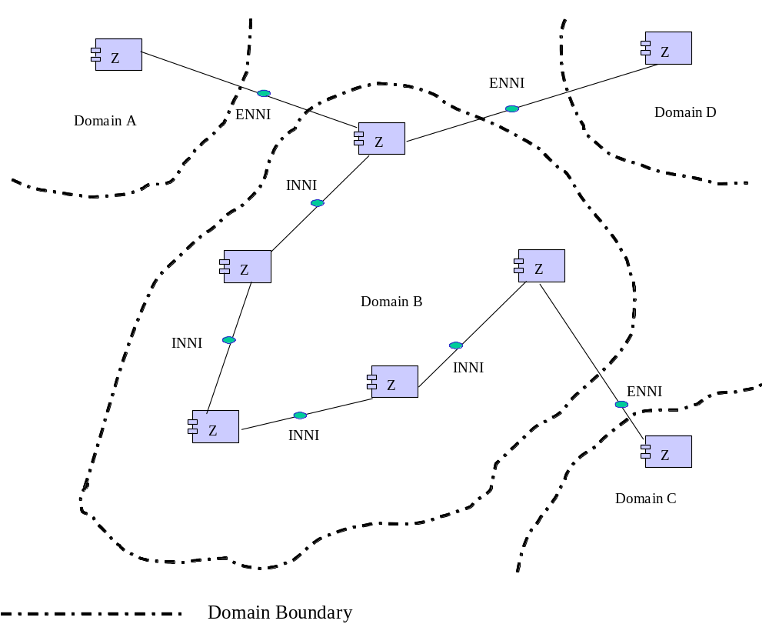
Figure 12/G.8080/Y.1304:Relationship between domains, protocol controllers and reference points

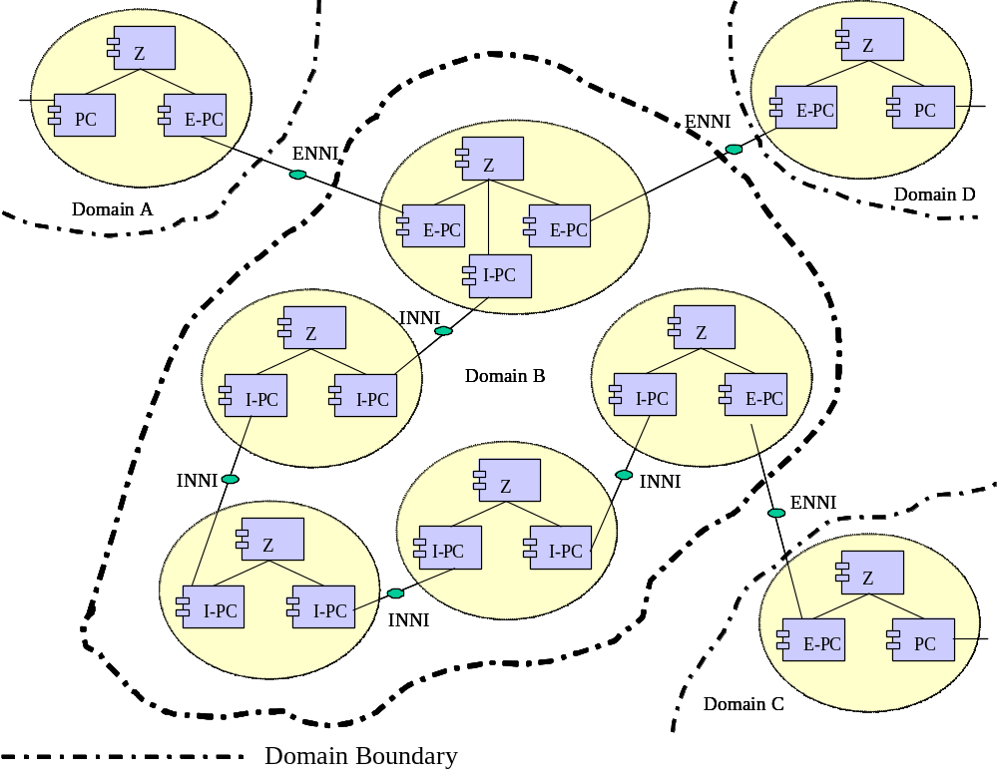
Figure 13/G.8080/Y.1304: Relationship between domains, protocol controllers and interfaces

6.4.1 Relationship between control domains and control plane resources
The components of a domain may, depending on purpose, reflect the underlying transport network resources. A routing control domain may, for example, contain components that represent one or more routing areas at one or more levels of aggregation, depending upon the routing method/protocol used throughout the domain.

6.4.2 Relationship between control domains, interfaces and reference points
I-NNI and E-NNI interfaces are always between protocol controllers. The protocols running between protocol controllers may or may not use SNPP links in the transport network under control and as such it is incorrect to show I-NNI and E-NNI interfaces on SNPP links.
I-NNI and E-NNI reference points are between components of the same type, where the component type is not a protocol controller, and represents primitive message flows (see Clause 7 of Recommendation G.8080/Y.1304).
In a diagram showing only domains and the relationships between them (and not revealing the internal structure of the domains) the information transfer is assumed to be over a reference point.

6.5 Multi-layer aspects
The description of the control plane can be divided into those aspects related to a single layer network, such as routing, creation and deletion of connections, etc., and those that relate to multiple layers. The relationship between the client and server layer networks is managed by means of the Termination and Adaptation Performers (see Clause 7.3.7, below ). The topology and connectivity of the underlying server layer is not explicitly visible to the client layer, rather aspects of the server layer are encapsulated and presented to the client layer network. The server layer may be represented as a client layer SNPP link, or as client layer subnetworks interconnected by SNPP links. This abstraction of the server layer topology for the purpose of path computation in the client layer has similar properties to the hierarchical containment relationships described in clause 6.2.1. Thus the results of path computation in the client layer may not result in the optimum use of the server layer resources. If the resources available to the client layer network are insufficient to support a connection request, additional resources may be provided by activating or creating new connections in one or more server layer networks. Operator policies will govern the availability of underlying server layer resources to the client layer.

When the server layer is represented to the client layer as an SNPP link, this can be achieved by modifying SNPs from potential to available. If the server layer is represented as a set of SNPP links and subnetworks then a new server layer connection must be requested directly by the control plane depending on operator policies. In the case where the capacity of the resulting server layer network connection is greater than the capacity required to support the client layer connection, a new SNPP link will be created as a side effect of this operation. The mechanism to add this new SNPP link to the topology of the client layer is not within the scope of this Recommendation.
Alternatively, the server layer topology may not be made visible to the client layer. In this case the decision to add new server layer network connections may be made by a planning process. The use of a planning system to invoke the configuration of the server layer network to provide additional resources for the client layer network may result in more optimum use of the server layer resources. Details of the planning process and its interaction with the client and the server control planes is outside the scope of this Recommendation. The decision to create/remove the server layer connections is a business decision that may be represented in operator policy.
As described above, there are two different ways to represent server layer resources in the client layer. The representation used is dependent on whether server layer resources have already been selected to provide connectivity to the client layer. A control plane instance for a layer network may use one or both of these approaches at a time. Other representations of server layer resources are for further study.

Representation as SNP link connections
A planning process may cause a pair of access points in the server layer to be connected, this creates a client layer SNPP link that contains multiple SNP link connections for the supported client layers. These SNP link connections may initially be either active or potential, as the underlying resource may or may not be allocated for the exclusive use of the client layer. (See Clause 6.1)
This process may be applied recursively in multiple client/server layer networks. Thus the connection between the pair of access points may be supported by potential link connections. The connection of the access points in the server-layer is not activated until a request to use one of the potential client-layer SNP link connections is received by the control plane. At this time, the client-layer request is “suspended” while the server-layer connections are established. Once the server-layer connections are in-place, the client-layer SNP link connections are made active, allowing the client layer signalling to resume. If a connection in the server layer cannot be established, the client layer SNP link connections cannot be made active, causing the client layer connection attempt to fail due to lack of resources.
When the SNP link connection is removed, the underlying resources that supported the connection are freed, allowing them to return to the potential state if allowed by policy. When all SNP link connections supported by a server trail return to the potential state, the server trail may be changed to potential if allowed by policy.
It should be noted that the SNPP link containing these SNP link connections can be represented using existing components and states as described in clause 6.1.

Representation as a set of SNPP links and subnetworks
A planning process may also allow the client layer control plane more flexibility in the selection of the of the server layer resources to satisfy a connection request. To accomplish the some of the server layer resources are represented to the client layer as SNPP links and subnetworks with the appropriate client layer control plane components. This representation is possible if the server layer provides flexibility which allows client layer subnetworks to be interconnected. The server layer flexibility and its corresponding client layer flexibility are shown in Figure 14. This enables the routing controller to know that a set of client layer SNPs can be reachable through a common server layer. That is, in Figure 14, absence of the server layer representation would not allow paths to be computed between all of the client layer SNPs.
The adaptation and termination functions used to transition from the client layer to the server layer are represented as SNPP links in the client layer. In this figure, we used dashed elements to distinguish this representation of the server layer resources to the client layer from other client layer resources. Additionally, client and server layer SNPs are represented as solid and open dots, repectively, However, to the client layer routing controller, there is no distinction between there repreented elements and the other client layer elements.

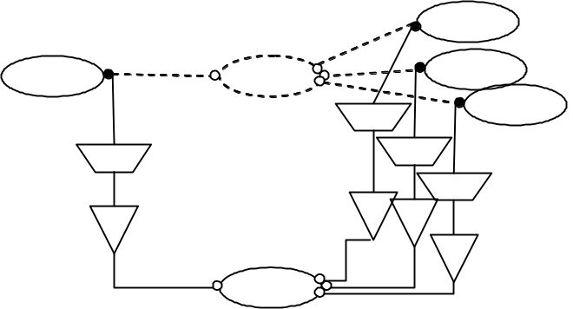
Figure 14/G.8080/Y.1304: Relationship between client and server architectural elements

As in the SNPP link representation, the SNP link connections connecting the client layer subnetwork to the server layer are potential, as the server layer resources have not been allocated for exclusive use to the client layer. When a connection request is received that utilizes a potential resource, a path through the server layer is calculated identifying the specific resources to be used. As a result of identifying these resources, client layer SNP link connections are created, and processing continues as above.

6.6 Interlayer Client Support

In transport networks, network elements may support more than a single layer. For example at the edge of a multi-layer transport network, a network element may support client layer networks that are directly supported in the core of a multilayer transport network. For example the edge network element may support the adaptation of service into a lower order VC whilst the core network elements may only provide flexibility at the high order VC layer; or the edge network element may adapt an Ethernet service into high order VCs. A general problem faced is how to transfer client characteristic information (CI) when a continuous/connected client layer network is not present between two client AGCs.
There are two solutions to this problem. Either, client layer topology may be created from server layer connections as described in clause 6.5 or, the client CI could be adapted, possibly multiple times, onto server layer connections. This would not be visible to the client routing controller.
Interfaces between Network Call Controllers (NCCs, See Clause 7.3.5.1) in different layer networks are used to apply ASON functions to the second solution. This inter-layer interface enables an association between calls in a client/server layer relationship. This association can recurse to mirror a set of “stacked” adaptations. That is, the NCCs recurse with G.805 layers. NCCs at different layers may still be instantiated differently from each other. For example an NCC could be distributed at a client layer and centralized at a server layer. A server layer CC creates the connection(s). The client CI is mapped to the server layer connection and this association is maintained by the client/server NCC relationship. In this situation, a client layer link connection is created as a result of the server layer connection and CI mapping, but the client layer CC is not involved in this. This recurses upward and creates a link connection at each of the affected client layers.
Appendix V illustrates this capability with an example.
The interlayer NCC relationship may occur at points other than where access group containers is attached to the client layer network. In Figure 14 (above), a call traverses a client subnetwork first before being supported by a server layer subnetwork. In Figure 15 (below), the call may also be supported by connections in a client layer subnetwork that is not contiguous with client layer subnetworks at the ingress or egress. Here, interlayer NCCs relationships are found between client subnetwork C2 and server subnetworks S1 and S1.
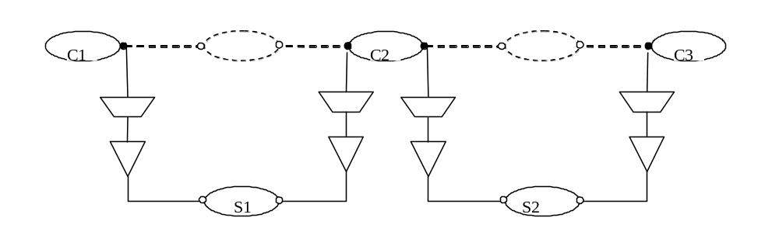
Figure 15/G.8080/Y.1304: Non-contiguous client layer sub-networks

6.7 Calls Supported by Calls at same Layer
Similar to the arrangement of NCCs in an interlayer relationship, a call segment may be supported by a separate call at the same layer but not over an E-NNI. In this arrangement, an NCC to NCC call segment is supported by a complete call with calling/called party call controllers. Figure 16 illustrates this in a carrier’s carrier business scenario. Here, a call between two clients associated with Carrier A is supported in two subnetworks that belong to Carrier A. Between those two subnetworks, the call is supported by a separate SPC within Carrier B. The connection returned by Carrier B is joined with the connections established in the Carrier A subnetworks.
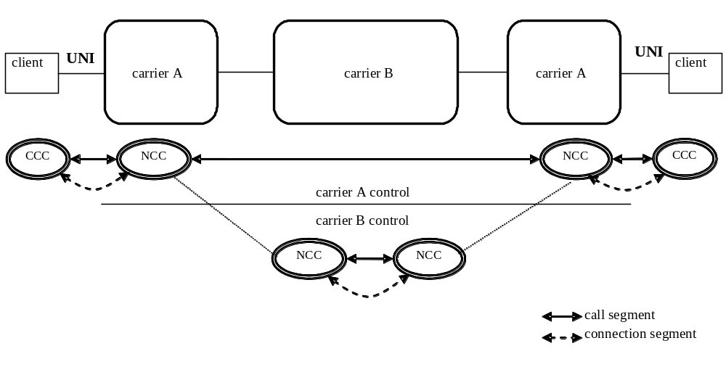
Figure 16/G.8080/Y.1403: Calls supported by calls in the same layer

7 Control plane architecture
This clause describes a reference architecture for the control plane that supports the requirements in this Recommendation, identifying its key functional components and how they interact. This flexible reference architecture is intended to enable operators to support their internal business and managerial practices, as well as to bill for service usage. The control plane architecture should have the following characteristics:
− Support various transport infrastructures, such as the SONET/SDH transport network, as defined in ITU-T Rec. G.803, and the Optical Transport Network (OTN), as defined in ITU-T Rec. G.872.
− Be applicable regardless of the particular choice of control protocol (i.e. employ a protocol neutral approach that is independent of the particular connection control protocols used).
− Be applicable regardless of how the control plane has been subdivided into domains and routing areas, and how the transport resources have been partitioned into subnetworks.
− Be applicable regardless of the implementation of connection control that may range from a fully distributed to a centralized control architecture.
This reference architecture describes the:
− functional components of the control plane, including abstract interfaces and primitives;
− interactions between call controller components;
− interactions among components during connection setup;
− functional component that transforms the abstract component interfaces into protocols on external interfaces.
Special components are defined in G.8080/Y.1304 and are provided to allow for implementation flexibility. These components are Protocol Controllers and Port Controllers. The detail of the interfaces of these and other components are provided in other technology specific recommendations.
Protocol Controllers are provided to take the primitive interface supplied by one or more architectural components, and multiplex those interfaces into a single instance of a protocol. This is described in Clause 7.4 and illustrated in Figure 34. In this way, a Protocol Controller absorbs variations among various protocol choices, and the architecture remains invariant. One, or more, protocol controllers are responsible for managing the information flows across a reference point.
Port Controllers are provided to apply rules to system interfaces. Their purpose is to provide a secure environment for the architectural components to execute in, thereby isolating the architectural components from security considerations. In particular, they isolate the architecture from distribution decisions made involving security issues. This is described in clause 7.2.1 and Figure 15.

7.1 Notation
In this clause we consider the component architectural notation based upon some simple building blocks from the vocabulary of the unified modelling language, UML.
Interface: An interface supports a collection of operations that specify a service of a component, and is specified independently from the components that use or provide that service. Operations specify the information passed in or out together with any applicable constraints. Interface definitions are presented in the form of a table, an example of which is presented in Table 1. Each interface has an interface name that identifies the role. Input interfaces represent services provided by the component; the basic input parameters are required for the specific role and basic return parameters are a result of the action on the input parameters. Output interfaces represent services used by the component; the basic output parameters define the information provided, the basic return parameters (if identified) are those required in response to the output parameters. Notification interfaces represent unsolicited output actions by the component, and are represented by an output interface with no return parameters. These three interface types are described separately in interface specifications.
Table 1/G.8080/Y.1304 – Generic interface descriptions table format
Input interface | Basic input parameters | Basic return parameters
Interface name | Input parameters | Returned parameters
Output interface | Basic output parameters | Basic return parameters
Interface name | Output parameters | Returned parameters
Transaction semantics associated with a particular transaction are assumed to be handled transparently, and there is no need to explicitly mention separate parameters for this purpose in interface description.
Role: A role is the behaviour of an entity when it is participating in a particular context. Roles allow for the possibility that different entities participate at different times, and are denoted by annotating a relationship with the name of an interface.
Component: In this Recommendation, components are used to represent abstract entities, rather than instances of implementation code. They are used to construct scenarios to explain the operation of the architecture. This component is represented as a rectangle with tabs. This is illustrated in Figure 14.
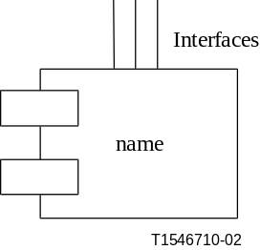
Figure 17/G.8080/Y.1304 – Representation of a component
Generically, every component has a set of special interfaces to allow for monitoring of the component operation, and dynamically setting policies and affecting internal behaviour. These interfaces are not mandatory, and are provided on specific components only where necessary. Where appropriate, the use of the monitor interface is described in individual component descriptions. Components are not assumed to be statically distributed.
When interfaces on components are described, only the different interface types are specified. All components have the property of supporting multiple callers and multiple providers, and resolution of concurrent requests is not mentioned explicitly.
As components are used in an abstract way, this specification is extendable by the techniques of component subclassing and composition.

7.2 Policy and federations

7.2.1 General model of policy
For the purposes of this policy model, systems represent collections of components, and a system boundary provides a point where policy may be applied. Policy is defined as the set of rules applied to interfaces at the system boundary, and implemented by port controller components. Policy ports are used to simplify the modelling of policies that are applied to multiple ports. System boundaries are nested to allow for correct modelling of shared policies applied to any scope (full system, any set of components, individual components, etc.). Note that the order of policy application is that which is specified by the nesting.
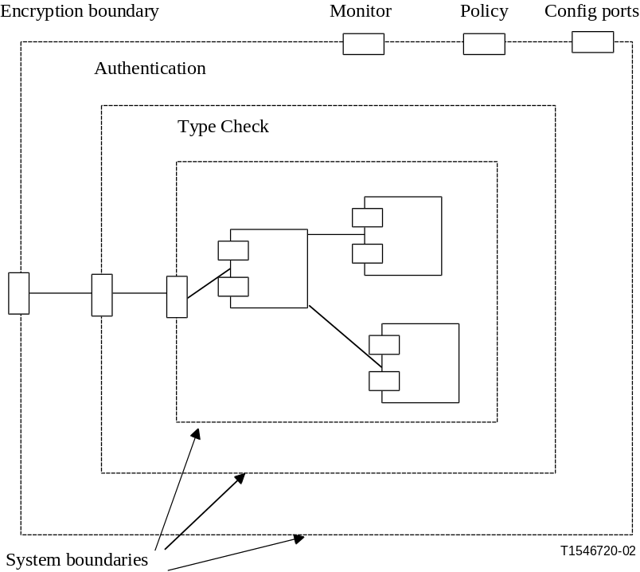
Figure 18/G.8080/Y.1304 – Example of System boundaries related to policy control
In Figure 18, the dashed boxes represent system boundaries, while the closed rectangles on the boundary, called ports, represent port controller components.
The monitor, policy, and configuration ports may be available on every system (and component) without further architectural specification. The monitor port allows management information to pass through the boundary relating to performance degradations, trouble events, failures, etc., for components, subject to policy constraints. The policy port allows for the exchange of policy information relating to components. The configuration port allows for the exchange of configuration, provisioning and administration information relating to components (subject to policy constraints) that may dynamically adjust the internal behaviour of the system.
Figure 18 shows an example of how encryption, authentication and type checking may be implemented as a set of three nested port controllers, where the policy application order follows the nesting order. The components inside the authentication boundary do not specify encryption or authentication requirements, as these are properties of the component environment. Port controllers are defined for each independent aspect of port policy, and combined policy is achieved by composition of port controllers. This allows the creation of reusable components, which are distinguished by a descriptive prefix. Policy violations are reported via the monitoring port.
The policy port may be seen as a filter of incoming messages, where messages that are rejected have violated the policy. Policies may be dynamically changed via the system policy port, and in this way, dynamic behavioural changes may be described.
It is common to discuss how policy is applied at a reference point, but policy can only be applied to the individual interfaces crossing the reference point. A method of combining several interfaces into a single implementation interface is described later in the clause on protocol controllers.
Other aspects of policy have to do with variable behaviour of the components (such as schedules, access rights, etc.) and these aspects are specified and implemented by the components. Component behaviour may also be dynamically changed, and the ability to do this may be controlled by policy. This allows us to determine which aspects of system behaviour are specified where.
Policy, as other aspects of the system, may be distributed. An example of a suitable model for distribution could be the COPS protocol model of RFC 2753. The Policy Enforcement Point (PEP) (the point where the policy decisions are enforced) of that model corresponds to the Port in this model. The Policy Decision Point (PDP) is the point where policy decisions are made. This can be done within the port, though it may be distributed to a different system. This distribution decision depends on many factors that in turn depend on the actual policy. As an example, performance reasons may force the PDP to be within the port (encryption), while security reasons may force the PDP to be elsewhere (password lookup).
When the PEP and PDP are not collocated, cooperation is required.

7.2.2 General model of federation
The creation, maintenance, and deletion of connections across multiple domains is required. This is achieved by cooperation between controllers in different domains. For the purposes of this Recommendation, a federation is considered a community of domains that co-operate for the purposes of connection management, and is illustrated using the cooperation between connection controllers. (connection controllers are described in 7.3.1.)
There are two types of federation:
− Joint federation model.
− Cooperative model.
In the joint federation case one connection controller, the parent connection controller, has authority over connection controllers that reside in different domains. Where a connection is required that crosses multiple domains the highest-level connection controller (the parent) acts as the coordinator. This connection controller has knowledge of the highest-level connection controllers in each domain. The parent connection controller divides the responsibility for the network connection between the next level connection controllers, with each responsible for its part of the connection. This is illustrated in Figure 19. This model is recursive with a parent connection controller at one level being a child to a parent at a higher level.
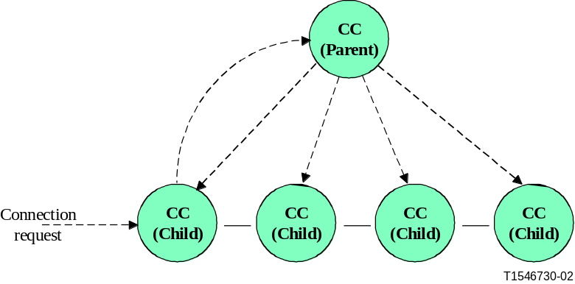
Figure 19/G.8080/Y.1304 – Joint federation model
In the cooperative model, there is no concept of a parent connection controller. Instead when a connection request is made the originating connection controller contacts each of the connection controllers associated with domains of its own volition and there is no overall coordination. The simplest method of achieving this is for the originating connection controller to contact the next connection controller in the chain. This is illustrated in Figure 20, where each connection controller calculates what part of the connection it can provide and what the next connection controller will be. This continues until the connection is provided.
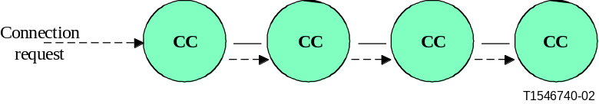
Figure 20/G.8080/Y.1304 – Cooperative federation model
Federation between administrative domains is by means of the cooperative model. In this case all administrative domains are expected to have the capability to federate with other administrative domains. Parent connection controllers within an administrative domain may federate with other parent connection controllers in other administrative domains by means of the cooperative model. An administrative domain may also be subdivided and the choice of federation model employed between domains within an administrative domain can be independent of what happens in another administrative domain. It is therefore possible to combine both federation models to construct large networks as illustrated in Figure 21. The principle described above can also be applied to federations of call controllers.
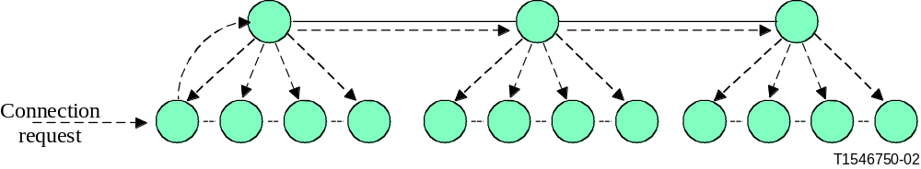
Figure 21/G.8080/Y.1304 – Combined federation model

7.3 Architectural components
The components of the control plane architecture are described in this clause. Components can be combined in different ways, depending upon the required functionality. Appendix VI illustrates examples of interactions of these components for use in connection setup. Each component is described by a brief description of its primary function in this reference architecture. Component interfaces are next provided, and a more detailed description of operation is then given.
The Connection Controller, Routing Controller, Calling/Called Party Call Controller, and Network Call Controller are control plane components. These components are either public, in which case they use public SNPPs only, or private, in which case they use the SNPPs associated to a particular VPN. The VPN context of a control plane component is provided by the Protocol Controller associated with that component.

7.3.1 Connection controller (CC) component
The connection controller is responsible for coordination among the Link Resource Manager, Routing Controller, and both peer and subordinate Connection Controllers for the purpose of the management and supervision of connection setups, releases and the modification of connection parameters for existing connections.
This component services a single subnetwork, and provides the abstract interfaces to other control plane components given in Table 2. The connection controller component is illustrated in Figure 22. Note: the route query interface does not apply for the CC interface at the UNI reference point.
In addition, the CC component provides a Connection Controller Interface (CCI). This is an interface between a subnetwork in the transport plane and the control plane. It is used by control components to direct the creation, modification, and deletion of SNCs. Policy is not applied to the CCI.
Table 2/G.8080/Y.1304 – Connection controller component interfaces
Input interface | Basic input parameters | Basic return parameters
Connection Request In | A pair of local SNP names and optionally a route | A subnetwork connection
Peer coordination In | 1) A pair of SNP names; or  2) SNP and SNPP; or  3) SNPP pair or  4) route | Confirmation signal
Output interface | Basic output parameters | Basic return parameters
Route Query | Unresolved route fragment | Route
Link Connection Request | – | A Link Connection (an SNP pair)
Connection Request Out | A pair of local SNP names | A subnetwork connection
Peer coordination Out | 1) A pair of SNP names; or  2) SNP and SNPP; or  3) SNPP pair. | Confirmation signal
Remote topology status Out | Topology information (link and/or subnetwork) including resource availability | -
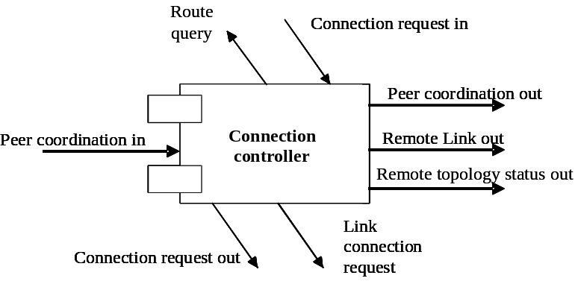
Figure 22/G.8080/Y.1304 – Connection controller component

Remote Topology status Out: This interface is used to present topology status information learned by the connection controller. This status will include the ability to signal across a link.
Connection setup Operation
Connection setup is performed in response to either a connection request, from an enclosing scope connection controller, or from a peer connection controller. In the case of hierarchical routing where the superior (i.e. parent) CC selects the source and destination SNPs, the connection request In/Out interface is used. In all other cases, the peer coordination In/Out interfaces are used. Component operation is the same in both cases.
The first unresolved portion of the route is resolved, via the route table query interface, into a set of links to be traversed, and this new set of links adds to the set. The connection controller inspects the new set of links to see which of these links are available for link connection allocation. Link connections are obtained and their links are removed from the link set. Next, corresponding subnetwork connections are requested from subordinate (i.e. child) connection controllers via the connection request out interface. Any unallocated route components are passed on to the next downstream peer connection controller. The actual sequence of operations depends on many factors, including the amount of routing information available and the access to particular Link Resource Managers; however, the operation of the connection controller is invariant. Connection release is an analogous operation to connection setup, except the operations are reversed.

7.3.2 Routing Controller (RC) component
The role of the routing controller is to:
- respond to requests for path (route) information needed to set up connections. This information can range from end-to-end path details to a next hop. The route can be computed by one or more cooperating RCs.
− respond to requests for topology (SNPs and their abstractions) information for network management purposes.
As stated in section 7.1, the Routing Controller Component is an abstract entity that provides the routing function. It can be implemented as a single entity, or as a distributed set of entities that make up a cooperative federation.
Information contained in the route controller enables it to provide routes within the domain of its responsibility. This information includes both topology (SNPPs, SNP Link Connections) and SNP addresses (network addresses) that correspond to the end system addresses all at a given layer. Addressing information about other subnetworks at the same layer (peer subnets) may also be maintained. It may also maintain knowledge of SNP state to enable constraint based routing. Using this view, a possible route can be determined between two or more (sets of) SNPs taking into account some routing constraints. There are varying levels of routing detail that span the following:
− Reachability (e.g. Distance Vector view – addresses and the next hops are maintained).
− Topological view (e.g. Link State – addresses and topological position are maintained).
The routing controller has the interfaces provided in Table 3 and illustrated in Figure 23.
Table 3/G.8080/Y.1304 – Routing controller interfaces
Input interface | Basic input parameters | Basic return parameters
Route Query | Unresolved route element | Route
Local Topology In | Local topology update | –
Network Topology In | Network topology update | –
Remote Topology In | Topology information (link and/or subnetwork) including resource availability
Output interface | Basic output parameters | Basic return parameters
Route Query | Unresolved route element | Route
Local Topology Out | Local topology update | –
Network Topology Out | Network topology update | –
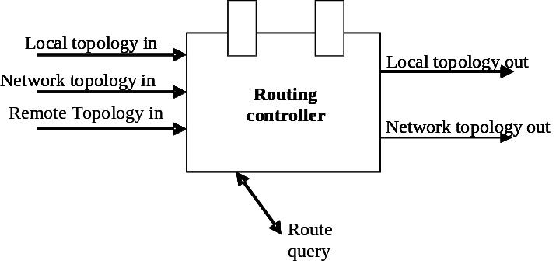
Figure 23/G.8080/Y.1304 – Routing controller component
Route Query interface: This interface accepts an unresolved route element and returns a route. An RC may query another RC (or RCs) in parent or child Routing Areas to assist in resolving the route. Examples of query results are:
1) Return an egress SNPP on this subnet that is on a path to a given destination SNPP.
2) Return a sequence of subnetworks that form a path between a given source/destination SNPP pair.
3) Return a sequence of subnetworks that form a path between two sets of SNPPs.
4) Return a sequence of SNPPs that form a path between a given source/destination SNPP pair.
5) Return a sequence of SNPPs that form a path between a given source/destination SNPP pair and includes one or more specific SNPPs.
6) Return a sequence of SNPPs that form a path between a given source/destination SNPP pair that is diverse from a given path.
The SNPPs returned must either all public or all associated to the same VPN.
Local Topology interface: This interface is used to configure the routing tables with local topology information and local topology update information. This is the topology information that is within the domain of responsibility of the routing controller. Local topology information is identified to be either public or be associated to a particular VPN.
Network Topology interface: This interface is used to configure the routing tables with network topology information and network topology update information. This is the reduced topology information (e.g. summarized topology) that is outside the domain of responsibility of the routing controller. Network topology information is identified to be either public or be associated to a particular VPN.
Remote Topology In: This interface is used to accept topology information from a connection controller.

7.3.3 Link resource manager (LRMA and LRMZ) component
The LRM components are responsible for the management of an SNPP link; including the allocation and unallocation of SNP link connections, providing topology and status information. Since a SNPP link can be either public or private, a LRM can also be either public or associated to exactly one VPN.
Two LRM components are used – the LRMA and LRMZ. An SNPP link is managed by a pair of LRMA and LRMZ components one managing each end of the link. Requests to allocate SNP link connections are only directed to the LRMA.
The two cases for SNPP link are illustrated in Figure 24.
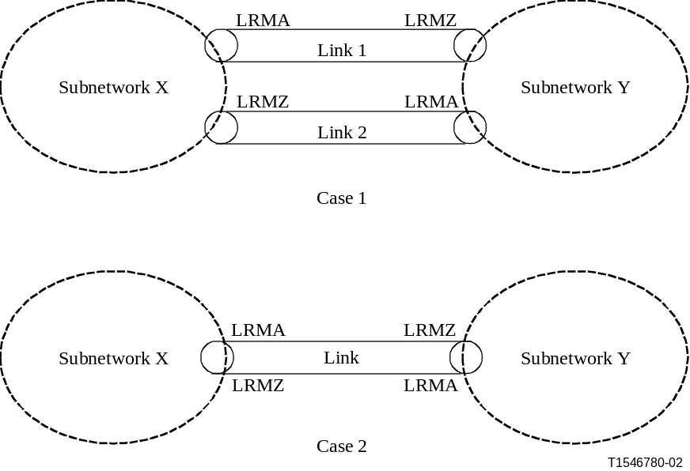
Figure 24/G.8080/Y.1304 – SNPP link cases
In case 1, link 1 is dedicated to connection setup originating from subnetwork X. Requests for SNP link connections from subnetwork X are directed to the adjacent LRMA for link 1. This LRMA can allocate the SNP link connection without negotiation with the LRMZ for link 1. Similarly link 2 is dedicated to connection setup requests originating from subnetwork Y. Requests for SNP link connections from subnetwork Y are directed to the adjacent LRMA for link 2. This LRMA can allocate the SNP link connection without negotiation with the LRMZ for link 2.
In case 2 the link is shared between subnetworks X and Y for connection setup. Requests for SNP link connections from subnetwork X are directed to the adjacent LRMA, since an LRMA component at the far end of the link can also allocate SNP link connections, the LRMA may need to negotiate an allocation with the LRMZ at the far end. A similar process is required for request from subnetwork Y to its adjacent LRMA.

7.3.3.1 LRMA
The LRMA is responsible for the management of the A end of the SNPP link, this includes the allocation and unallocation of link connections, providing topology and status information.
The LRMA component interfaces are provided in Table 4 and illustrated in Figure 25.
Table 4/G.8080/Y.1304 – LRMA component interfaces
Input interface | Basic input parameters | Basic return parameters
SNP link connection request | Request id  SNP Id (optional) | Request id  SNP id pair or denied
SNP link connection unallocation | SNP id | Confirm or denied
Configuration | Link information | –
Translation | Local id | Interface id
Output interface | Basic output parameters | Basic return parameters
SNP negotiation  (Case 2 only) | Request id  List of SNP ids | Request id  SNP id
SNP release  (Case 2 only) | SNP id | Confirm
Topology | Link information | –
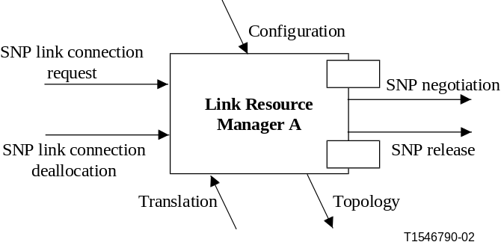
Figure 25/G.8080/Y.1304 – Link Resource Manager A component
Functions
Allocation of link connection
When a request to allocate a link connection is received connection admission is invoked to decide if there is sufficient free resource to allow a new connection. Connection admission can also be decided based on prioritization or on other policy decisions. Connection admission policies are outside the scope of standardization .
If there are insufficient resources the request is rejected.
If sufficient resources are available the connection request is allowed to process as described in the two cases below.
− Case 1: Since the SNP link connections are only allocated from one end of the SNPP link the LRMA can select the SNP link connection without interaction with the LRMZ at the far end of the link.
− Case 2: Since the SNP link connections may be used by the LRMA at either end of the SNPP link the LRMA passes a list of usable SNP ids to the LRMZ. The LRMZ (in cooperation with its local LRMA) selects one of the SNPs and returns the id to the originating LRMA.
Unallocation of a link connection
When a request to unallocate a SNP link connection is received the corresponding SNP is marked as available. In case 2 the associated LRMZ is informed.
Interface to local id translation
If required, the LRM provides the translation of an interface id to a local id. This is used for example if the ends of the SNPP link are in different routing areas.
Topology
This function provides the link topology using the interface SNPP ids and the contained SNP ids.
It also provides link characteristics, e.g. link cost, diversity and quality. Some characteristics, for example link cost, may vary with link utilization. The process used to modify link characteristics is controlled by a local policy.

7.3.3.2 LRMZ
The LRMZ is responsible for the management of the Z end of the SNPP link, this includes providing topology information.
The LRMZ component interfaces are provided in Table 5 and illustrated in Figure 26
Table 5/G.8080/Y.1304 – LRMZ component interfaces
Input interface | Basic input parameters | Basic return parameters
SNP negotiation In  (Case 2 only) | Request id  List of SNP ids | Request id  SNP id or denied
SNP deallocation  (case 2 only) | SNP id | Confirmation
Configuration | Link information | –
Translation | Local id | Interface id
Output interface | Basic output parameters | Basic return parameters
Topology | Link information | –
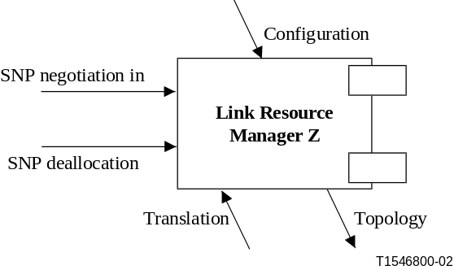
Figure 26/G.8080/Y.1304 – Link Resource Manager Z component
Functions
Allocation of SNP (only used for case 2)
When a list of usable SNP ids is received one is selected and returned.
Deallocation of SNP (only used for case 2)
When the associated LRMA indicates that a SNP has been deallocated the SNP is marked as available.
Interface to local id translation
If required the LRM provides the translation of an interface id to a local id. This is used for example if the ends of the SNPP link are in different routing areas.
Topology
This function provides the link topology using the interface SNPP ids.

7.3.4 Traffic Policing (TP) component
This component is a subclass of Policy Port, whose role is to check that the incoming user connection is sending traffic according to the parameters, agreed upon. Where a connection violates the agreed parameters then the TP may instigate measures to correct the situation.
NOTE – This is not needed for a continuous bit rate transport layer network, and is not further expanded in this Recommendation. Likewise the TP policy interface will not be elaborated in this Recommendation.

7.3.5 Call controller components
Calls are controlled by means of call controllers. There are two types of call controller components:
− A calling/called party call controller: This is associated with an end of a call and may be co-located with end systems or located remotely and acts as a proxy on behalf of end systems. This controller acts in one, or both, of two roles, one to support the calling party and the other to support the called party.
− A network call controller: A network call controller provides three roles, one for support of the calling party, another to support the called party and a third to support calls across domain boundaries
A calling party call controller interacts with a called party call controller by means of one or more intermediate network call controllers.

Note, the call control is only necessary at inter-domain signalling associations. In a call, signalling and connection routing progess to complete the connection, realizing the call. As such, when domain boundaries are crossed, NCCs are used. Call state is recorded in NCCs.

Further, NCCs are not hierarchical; the NCC that exists at the edge of a set of nested domains must implement the policy for all of those domains. Separate NCCs do not exist for each of the nested domains.

7.3.5.1 Calling/called party call controller
The role of this component is:
− generation of outgoing call requests;
− acceptance or rejection of incoming call requests;
− generation of call termination requests;
− processing of incoming call termination requests;
− call state management.
This component has the interfaces provided in Table 6. The calling/called party call controller component is illustrated in Figure 27.
Table 6/G.8080/Y.1304 – Calling/called party call controller component interfaces
Input interface | Basic input parameters | Basic return parameters
Call Accept | Transport Resource Identifier or VPN Transport Resource Identifier | Confirmation or Rejection of call request
Call Release In | Transport Resource Identifier or VPN Transport Resource Identifier | Confirmation of call release
Call Modification Accept | Call Name, parameters to change | Confirmation or rejection of call modification
Output interface | Basic output parameters | Basic return parameters
Call Request | Transport Resource Identifier or VPN Transport Resource Identifier; Route (optional, for VPN only) | Confirmation or Rejection of call request
Call Release Out | Transport Resource Identifier or VPN Transport Resource Identifier | Confirmation of call release
Call Modification Request | Call Name, parameters to change | Confirmation or rejection of call modification

Figure 27/G.8080/Y.1304 – Calling/called party call controller component
Call Request: This interface is used to place requests for setup, maintenance and release of a call. This interface also accepts a confirmation or rejection of a call request.
Call Accept: This interface is used to accept incoming call requests. It also confirms or rejects the incoming call request.
Call Release: This interface is used to place, receive and confirm release requests.
Call Modification Request: This interface is used to place requests to modify an existing call. It also receives the confirmation or rejection of the request.
Call Modification Accept: This interface is used to accept incoming requests to modify an existing call. It also confirms or rejects the request.
Note that the same calling/called party call controller may play the role of originator or terminator in different transactions.

7.3.5.2 Network call controller

Network call controllers are instantiated at domain boundaries (i.e. at E-NNI reference points, where the call parameters need to be examined e.g. different administrations, different recovery domains etc.).
Call controllers that are adjacent, (in the context of a call) form a call segment.
The role of this component is:
− processing of incoming call requests;
− generation of outgoing call requests;
− generation of call termination requests;
- processing of call termination requests.
- translation from VPN Call Source and Destination Identifiers to Transport Resource Identifiers
− call admission control based on validation of call parameters, user rights and access to network resource policy;
− call state management.
This component has the interfaces provided in Table 7, below, and illustrated in Figure 28.
Table 7/G.8080/Y.1304 – Network call controller component interfaces

Input interface | Basic input parameters | Basic return parameters
Call Request Accept | UNI Transport Resource Identifier or UNI Transport Resource Identifier alias | Confirmation or rejection of call request
Network Call Coordination In | UNI Transport Resource Identifier or UNI Transport Resource Identifier alias | Confirmation or rejection
Call Release In | UNI Transport Resource Identifier or UNI Transport Resource Identifier alias | Confirmation of call release
Client NCC Coordination In | Optional Client call parameters,  Optional Client layer identification,  Transport Resource Identifiers | A pair of SNPs in the client layer.
Server NCC Coordination In | A pair of SNPs. | Confirmation or rejection of use
Call Modification Accept | Call Name, parameters to change | Confirmation or rejection of call modification
Output interface | Basic output parameters | Basic return parameters
Call Indication | UNI Transport Resource Identifier or UNI Transport Resource Identifier alias | Confirmation of rejection of call request
Connection Request Out | UNI Transport Resource Identifier or UNI Transport Resource Identifier alias | A pair of SNPs
Network Call Coordination Out | UNI Transport Resource Identifier or UNI Transport Resource Identifier alias | Confirmation or rejection of call request
Directory Request | UNI Transport Resource Identifier or UNI Transport Resource Identifier alias | Local name
Policy Out | Call parameters | Accept or Rejection of Call
Call Release Out | UNI Transport Resource Identifier or UNI Transport Resource Identifier alias | Confirmation of call release
Client NCC Coordination Out | A pair of SNPs in the client layer. | Confirmation or rejection of use
Server NCC Coordination Out | Optional call parameters,  Layer identification,  Transport Resource Identifiers | A pair of SNPs.
Call Modification Request | Call Name, parameters to change | Confirmation or rejection of call modification
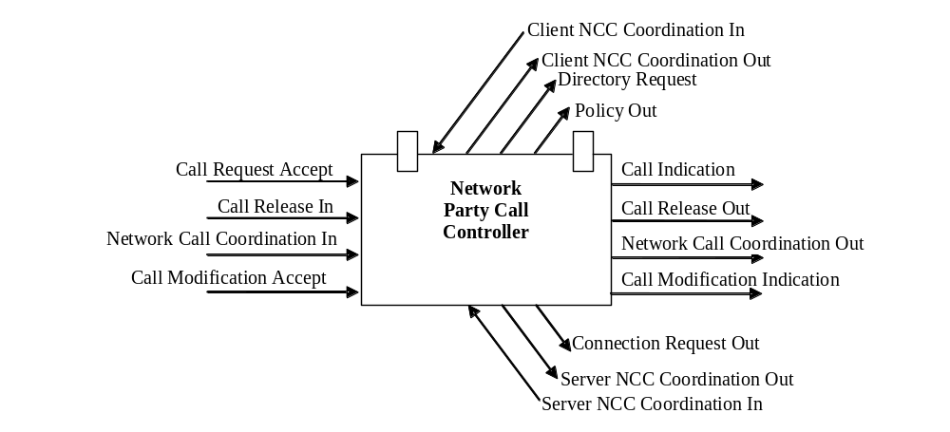
Figure 28/G.8080/Y.1304 – Network call controller component

Call Request Accept: This interface is used to accept a call source and destination identifier pair. This interface also confirms or rejects the incoming call setup request.
Connection Request Out: This interface is used to place a connection setup request to a connection controller as a pair of SNPs.
Directory Request: This interface is used to get an SNPP name from a UNI Transport Resource Identifier or alias. For aliases, it is a matter of policy which SNPP is returned if multiple are represented.
Network Call Coordination: This interface is used for network level call coordination.
Call Release In/Out: These interfaces are used to place, receive and confirm release requests.
Policy Out: This interface provides policy checking.
Client NCC Coordination In: This interface is used to accept a request from a client layer NCC for a pair of SNPs. The NCC is provided with source and destination identifiers in its layer in order to for it to provide a network connection for use by the client layer. SNPs in the client layer that are supported by an adaptation to the network connection are returned. This interface is also used by the client to release or modify the use of the SNP pair. The NCC returns the result of the action.
Client NCC Coordination Out: This interface is used to present a pair of SNPs to a client layer that are supported by an adaptation to a network connection. The client NCC indicates whether or not it accepts this resource. This interface is also used by the server to release or present a modified SNP pair. The client NCC returns the result of the action.
Server NCC Coordination Out: This interface is used to request a pair of SNPs (input and output) that can be used by the call to transfer characteristic information. It is identical to the return parameters of the Connection Request Out interface except that a network connection in this layer is not assumed to be created. This interface is also used to release or request modification of the use of the SNP pair provided by the server layer. The server NCC returns the result of the action.
Server NCC Coordination In: This interface is used to accept a pair of SNPs (input and output) presented from a server layer NCC. It may be accepted to rejected. This interface is also used by the server to release or present a modified SNP pair. The NCC returns the result of the action.
Call Modification Accept: This interface is used to accept a call modification request. This interface also confirms or rejects in the incoming call modification request.
Call Modification Indication: This interface is used to continue a call modification request to another NCC. It also receives confirmation or rejection of the request.
The role of call admission control in the Calling Party Network Call Controller is to check that a valid called user name and service parameters have been provided. The service parameters are checked against a Service Level Specification. If necessary, these parameters may need to be renegotiated with the Calling Party call controller. The scope of this negotiation is determined by policies derived from the original Service Level Specification, which itself is derived from the Service Level Agreement.
The role of call admission control in the Called Party Network Call Controller, if present, is to check that the called party is entitled to accept the call, based on the calling party and called party service contracts. For example, a caller address may be screened, and the call may be rejected.
The Directory Request interface of the Network Call Controller is used to access a directory function that is used to transform identifiers between or within name spaces. An identifier is supplied as input to the directory function which returns one or more identifiers. How the directory is maintained or configured is outside the scope of this Recommendation and will be described in other Recommendations. Examples of mappings that could be provided by the directory function are:
- UNI Transport Resource Identifier to SNPP identifier. A call controller requires an SNPP in order to make a request to a connection controller.
- UNI Transport Resource Identifier alias to UNI Transport Resource Identifier. An application of this is to be able to identify resources associated with a multi-homed ACG with one identifier which is a UNI Transport Resource Identifier alias.
- SNPP identifier to UNI Transport Resource Identifier. To use the Server NCC Coordination Out and Client NCC Coordination In interfaces, UNI Transport Resource Identifiers are needed that are in the server layer. This is used to make the server layer call. Before the call is made, the client layer does not have the UNI Transport Resource Identifiers of the server layer, only the SNPPs in the client layer on the edge of the server layer subnetwork. A mapping between the client layer SNPPs and the server layer UNI Transport Resource Identifiers provides the means of invoking the server layer call.
- SNPP alias to SNPP. This is used for coordination between routing levels.

7.3.5.3 Call controller interactions
The interaction between call controller components is dependent upon both the type of call and the type of connection, as described below.
Switched connections: The calling party call controller (associated with an end terminal) interacts with the network call controller to form an incoming call and the network call controller interacts with the called party call controller (associated with an end terminal) to form an outgoing call. The network call controller interacts with the connection controllers to provide the call. An example of this interaction is illustrated in Figure 29. It should be noted that the calling/called party call controllers have no direct interaction with the connection controller associated with the corresponding network call controller."
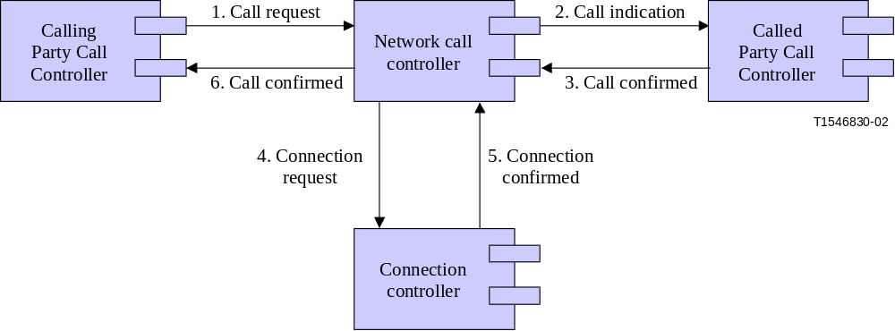
Figure 29/G.8080/Y.1304 – Called/calling party call controller interaction
for switched connections: example 1
Figure 26 shows the situation whereby the called party call controller accepts the call, prior to the ingress network call controller requesting the connection. It is also valid to define the interaction such that the connection setup follows the call, as is illustrated in Figure 27.

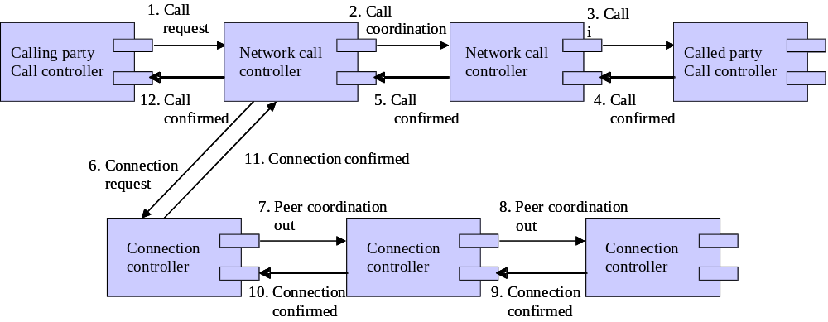Figure 30/G.8080/Y.1304 – Called/calling party call controller interaction
for switched connections: example 2

Soft permanent connections: The network management system is considered to contain the calling/called party controllers. The management system issues a command to configure the calling party call controller that initiates the network call controllers on control plane when the call configuration commands are sent to control plane. The response to a call configuration command from the control plane is considered as a call setup confirmation by management plane. This represents a null call with no service. The protocols between the network management plane and the control plane are a command and command response interface.
Ed: modify figure 31 steps 5 and 6 to be “peer coordination out”.

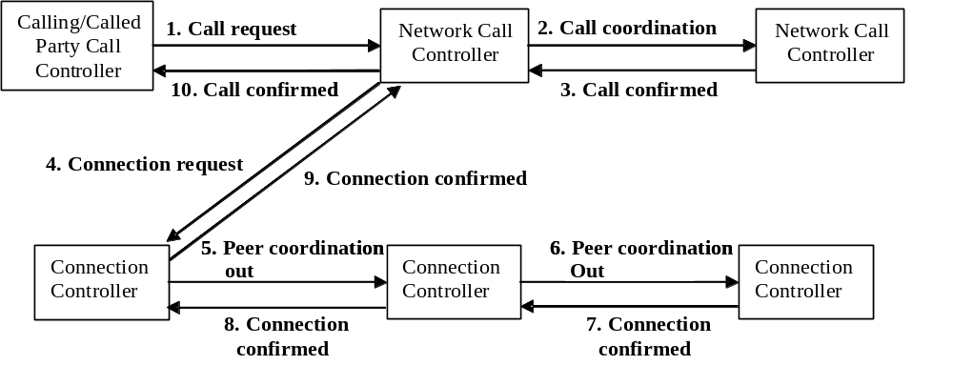
Figure 31/G.8080/Y.1304 – Call controller interactions for soft permanent connections
Proxy call: The calling/called party call controller interacts with the network call controller by means of a call protocol, but is not coincident with the user.
Figure 32 indicates an example of the interactions necessary to support call admission control policy between network call controllers.
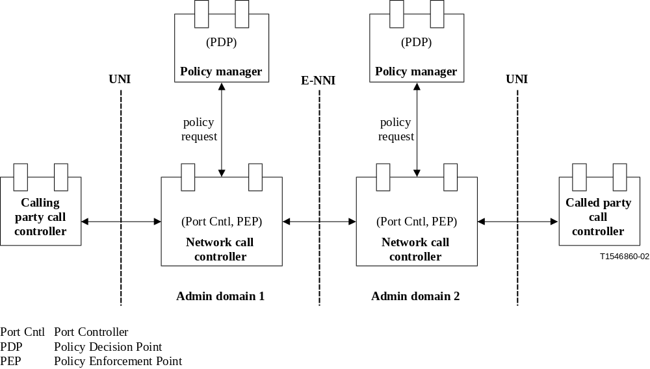
Figure 32/G.8080/Y.1304 – Example of call admission control policy interactions
Layered Calls: Two NCCs in different layers may cooperate to allow support of client CI in a server layer. Use of these interlayer interfaces is governed by operator policy. This may be initiated either to or from a server layer depending on what layer the operation is initiated from. From an NCC, the request to a server layer NCC returns the same result as the “Connection Request Out” interface. The difference is that an association with a server NCC is made. This action either results in the use or creation of, a server layer call segment that will support the client NCC. If the server layer needs to create a call as a result of the use of the “Server NCC Coordination Out“ or “Client NCC Coordination In” interfaces, the Source and Destination Identifiers are used as call parameters. An identical action to the “Call Request Accept” interface behaviour is then performed if connection establishment at that server layer is determined to be the correct action. The server layer NCC could alternately use its “Server NCC Coordination Out” interface to make a (layer recursive) request for an SNP pair from another layer NCC that is a server to it.
An NCC could also initiate an action to a client layer whereby it presents a pair of SNPs that can be used by the client layer for transferring client CI. The “Client NCC Coordination Out” or “Server NCC Coordination In” interfaces are used for this purpose. When this interface is used, the SNP pair presented is able to transfer client CI and no call action at the server layer is initiated. This is used for an operation where a server layer has already established a call and this is presented to the client layer at a later point in time. The client layer may accept or reject the use of the offered SNP pair.

7.3.5.4 Call Modification
The service provided by a call can be modified by actions initiated by a CCC or network management application acting on an NCC at the UNI. The degree of modification is set by operator policy and the policy may or may not be shared with the end user (e.g., informing the user what bandwidth increments are allowed). The extent to which a call can be modified is subject to the following rules:
- The CI associated with the call at the UNI is not modifiable
- The link connection end-points associated with the call at the UNI-N are not modifiable. They may be added/removed however when connections are added/removed from a call.
Actions can either be modification of a call segment where the NCCs remain fixed, or the creation/deletion of call segments within an overall call where NCCs are created/deleted.
Examples of what may be modified at the UNI include bandwidth (e.g., rate of Ethernet call) and number of CCCs involved (e.g., multiparty call).
Examples of what may occur within the network as a result of UNI call modification requests include:
- Changing the number of server layer connections associated with a VCAT call that supports an Ethernet call.
- In response to a request to increase the availability of a call, adding an additional connection to create a 1+1 configuration.
7.3.5.5 Call failure handling
For a new call request, if the network is unable to establish all the connections required to satisfy the call request, any connections or partial connections that have been established will be torn down (deleted) and the call request will be rejected.
For call modifications, if the network is unable to add the connections requested, then the call modification is considered to have failed. Any connections or partial connections will be removed and no changes will be made to the existing call.

7.3.6 Discovery Agent (DA)
The federation of Discovery Agents operates in the transport plane name space, and provides for separation between that space and the control plane names. The federation has knowledge of Connection Points (CPs) and Termination Connection Points (TCPs) in the network, while a local DA has knowledge of only those points assigned to it. Discovery coordination involves accepting potential hints about pre-existing CPs and link connections. The DA holds the CP-CP link connections to enable SNP-SNP link connections to be bound to them later. The resolution interfaces assist in discovery by providing name translation from global TCP handles to the address of the DA responsible for the point, together with the local name of the TCP. Note that hints come from cooperation with other components, or from external provisioning systems.
Discovery agents have no private equipment interfaces, and can be located on any suitable platform.
Table 8/G.8080/Y.1304: Discovery Agent (DA) component interface
Input Interface | Basic Input Parameters | Basic Return Parameters
Coordination In
Hints in | CP pairs
Resolution Request | TCP Name
Output Interface | Basic Output Parameters | Basic Return Parameters
Coordination Out
CP link connection | CP pair
Resolution Result |  | DA DCN Address, TCP Index
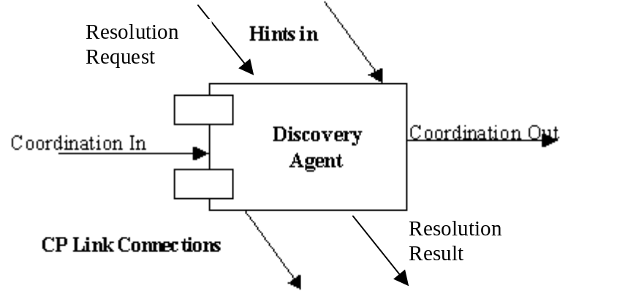
Figure 33/G.8080/Y.1304: Discovery Agent component

7.3.7 Termination and adaptation performers
The TAP is colocated with the adaptation and termination function. It provides the control plane (the LRM) a view of the link connection resource supporting a SNP, and hides any hardware and technology specific details of the adaptation and termination control.
The Termination and Adaptation Performer (TAP) operates at two different times and provides two different functions.
When a resource is assigned to a control plane the TAP is configured with a permitted binding to a SNP, this causes the creation of a SNP (at one end of a link) within the scope of a LRM. If the resource is shared between multiple control planes (e.g. different layer networks or different layer 1 VPNs) the TAP holds a list of permitted bindings. The TAP controls the binding between a CTP and each SNP that references any of the resource within the scope of that TAP. The states of the SNP reflecting the binding relationship are described in Table 9, below.

Table 9/G.8080/Y.1304: SNP Binding States
State | Description
Busy | Permitted binding, the resource being referenced is currently allocated to another control plane or the management plane
Potential | Permitted binding currently the resource being referenced is not allocated to any control plane or the management plane
Allocated | Permitted binding and the resource is configured for and allocated to this LRM
Shutting down | TAP notification that the resource must be returned within an explicit time frame e.g.:  Immediately (interrupt the current call);  Quickly (reroute call before dropping);  Next maintenance window;  When call is dropped
Released | LRM is no longer using the resource
When a SNP is in the Allocated state the TAP must correctly configure the resources (e.g. variable adaptation) and set the state of any other SNPs referencing the same resource to Busy.
When SNP link connections are bound to their corresponding CP link connection, the TAP is responsible for holding the SNP-CP binding. A local TAP cooperates with a remote TAP to coordinate any variable adaptation or other coordination required when forming the CP link connections.
If a LRM wishes to use a SNP in the potential state to satisfy a connection request then during connection setup, a pair of TAPs cooperate via the LRM to coordinate any adaptation setup required by the link connection.
The TAP provides link connection transmission status information and accepts link connection state information to ensure that the management plane indications are consistent. Management plane consistency includes ensuring that the alarm state of the link connection is consistent, so that spurious alarms are neither generated nor reported.

Table 10/G.8080/Y.1304: Termination and Adaptation Performer (TAP) component interface
Input Interface | Basic Input Parameters | Basic Return Parameters
LC connection State (SNP-SNP) | Enum: In service, Out of Service
Coordination In | Technology dependent
Output Interface | Basic Output Parameters | Basic Return Parameters
LC transport state (SNP-SNP) | Enum: Up, Down
Coordination Out | Technology dependent | Technology dependent
Control | Hardware specific | Hardware specific
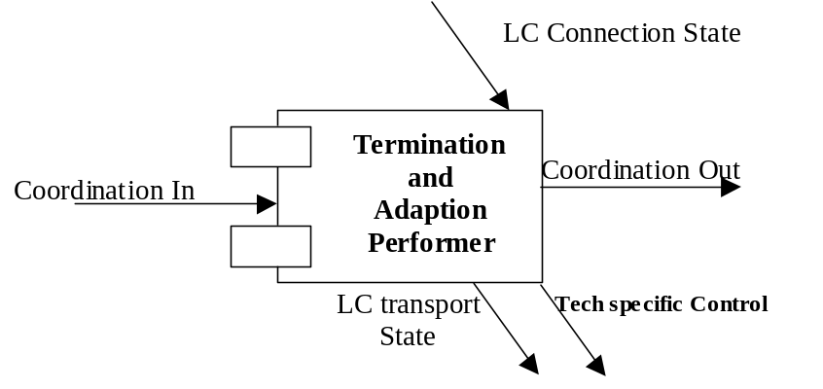
Figure 34/G.8080/Y.1304: Termination and Adaptation Performer component

7.3.8 Link discovery process
The generic process of discovery is split into two separate and distinct times and name spaces. The first part takes place entirely in the transport plane name space (CPs and CTPs)
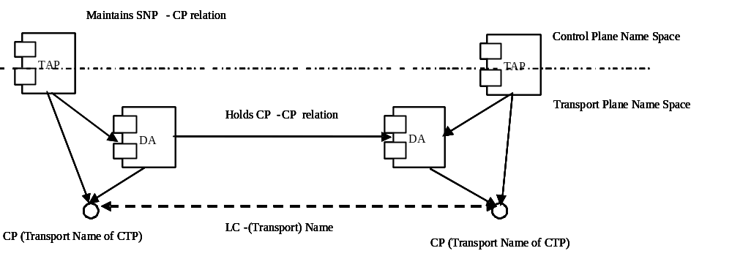
Figure 35/G.8080/Y.1304:Discovery of transport link connections (LC)
The DA operates entirely within the transport name space, and is responsible for holding the transport name of the link connection (associated with each CP). This information may be obtained by using transport mechanisms invisible to the control plane name space, by holding previously obtained relation information or by provisioning. The DA assists in an underlying automatic discovery process by cooperatively resolving transport CP names among all the DAs in the network, thus enabling the DAs (or other components) responsible for each end of the transport link connection to communicate about that link connection.
A CP can be assigned to a set of VPNs, including the empty set and the singleton set. This set of VPNs can be represented by an ownership tag. The DA verifies that ownership tag attached to each CP of a link connection is the same.
The second part takes place entirely within the control plane name space (SNPs).
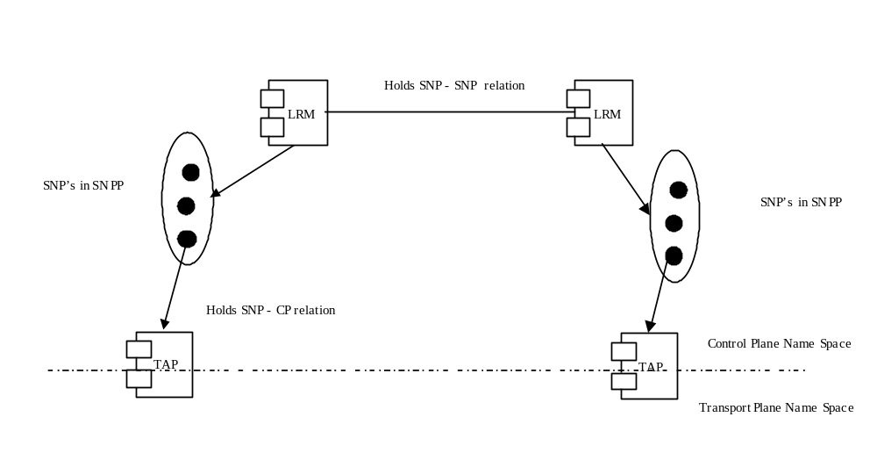
Figure 36/G.8080/Y.1304: Population of control plane link connections
The Link Resource Manager (LRM) holds the SNP-SNP binding information necessary for the control plane name of the link connection, while the TAP holds the relation between the control plane name (SNP) and the transport plane name (CP) of resource. This separation allows control plane names to be completely separate from transport plane names, and completely independent of the method used to populate the DAs with those transport names.
In order to assign an SNP-SNP link connection to an SNPP link, it is only necessary for the transport name for the link connection to exist. Thus it is possible to assign link connections to the control plane without the link connection being physically connected. This assignment procedure may be verified by the LRMs exchanging the Transport link name that corresponds to the SNP.
Note that the fully qualified SNPP link name is a control plane name reflecting the structure of transport plane resources.

7.4 Protocol controller (PC) components
The protocol controller provides the function of mapping the parameters of the abstract interfaces of the control components into messages that are carried by a protocol to support interconnection via an interface. Protocol controllers are a subclass of port controllers, and provide all the functions associated with those components. In particular, they report protocol violations to their monitoring ports. They may also perform the role of multiplexing several abstract interfaces into a single protocol instance as shown in Figure 37. The details of an individual protocol controller are in the realm of protocol design, though some examples are given in this Recommendation.
The role of a transport protocol controller is to provide authenticated, secure, and reliable transfer of control primitives across the network by means of a defined interface. This permits transactions to be tracked and to ensure expected responses are received, or that an exception is reported to the originator. When security functions are present, the protocol controller will report security violations via its monitoring port.
Signalling primitives are passed between the connection controller and the protocol controller, which is semantically transparent to the messaging primitives as this results in external protocol messages and vice versa. Signalling messages are passed between the two protocol controllers. This is illustrated in Figure 38.
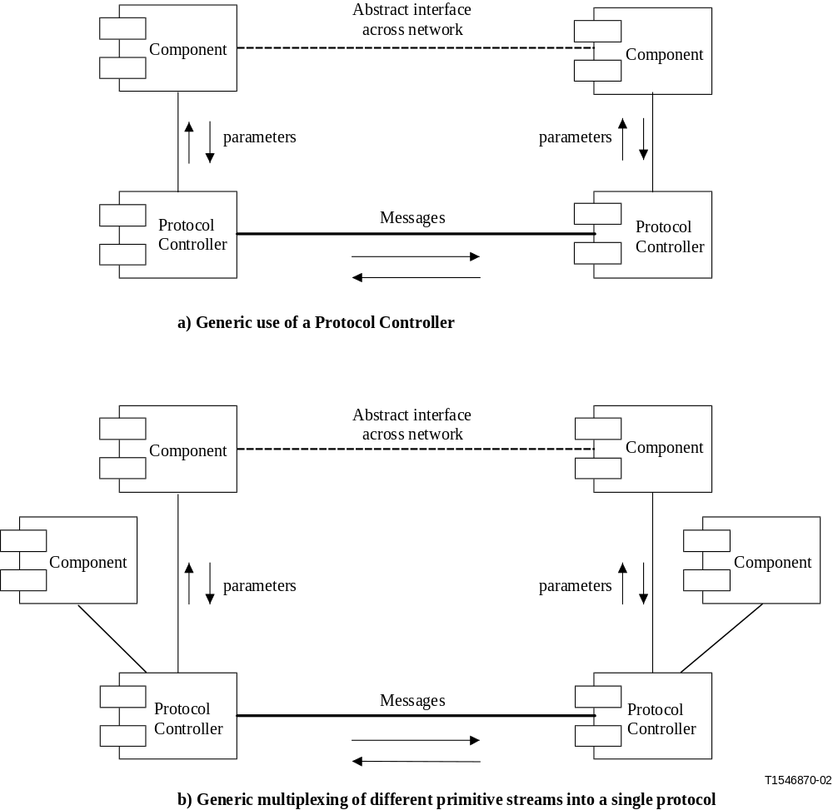
Figure 37/G.8080/Y.1304 – Protocol controller
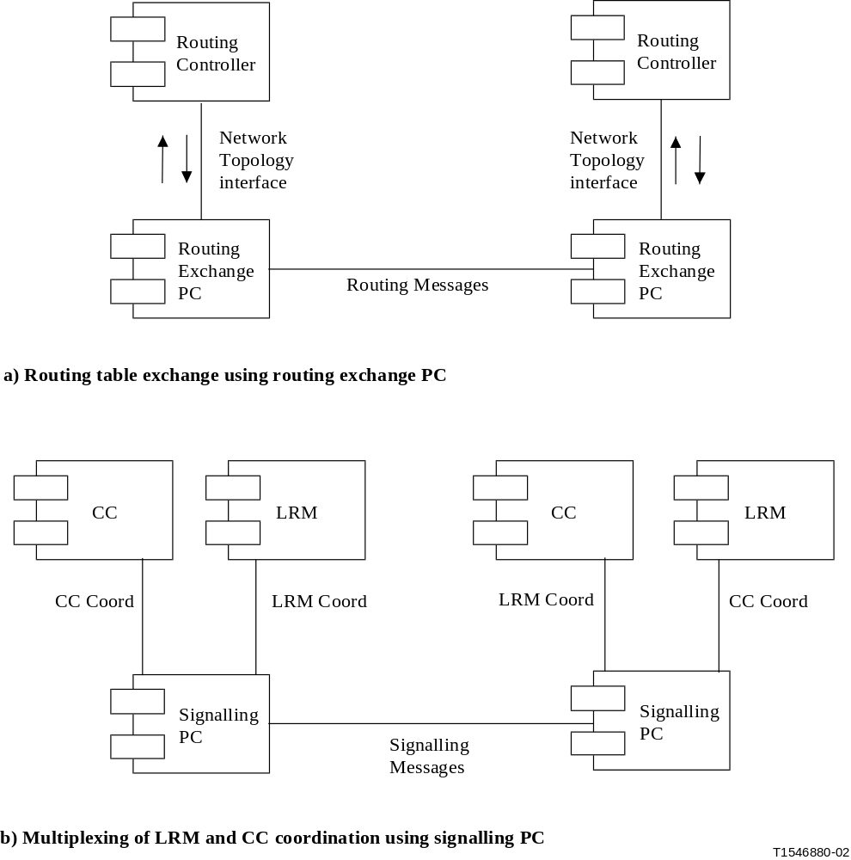
Figure 38/G.8080/Y.1304 – Examples of protocol controller use
Examples of protocol controller use is the transfer of the following information:
− Route table update messages via a routing exchange protocol controller (shown in Figure 38 a));
− Link resource manager coordination messages (where appropriate as in available bit rate connections) via a link resource manager protocol controller;
− Connection control coordination messages via a connection controller protocol controller, shown in Figure 38 b). Note that the LRM and CC coordination interfaces may be multiplexed over the same protocol controller.

8 Reference points
[Ed: removed text during drafting which resulted in deletion of figure 39. Renumbering of figures is needed from this point onward in the document. ]
This Recommendation defines various logical interfaces (i.e. reference points) within a typical transport network where signalling/routing information is exchanged. Reference points may be supported by multiple interfaces. These reference points are the UNI, the I-NNI and the E-NNI. It is important to recognize that there will be multiple domains within the ASON and that the UNI and E-NNI in particular will be used for inter-domain control signalling. The following clauses describe the specific functionalities that need to be carried across the various reference points (UNI, I-NNI and E-NNI) and how they differ.
Policy may be applied at the interfaces that support a reference point. The policies applied are dependent on the reference point and functions supported. For example, at the UNI, I-NNI and E-NNI reference points, policy may be applied to call and connection control. In addition, for the I-NNI and E-NNI reference points, policy may be applied to routing.
A Reference Point represents a collection of services, provided via interfaces on one or more pairs of components. The component interface is independent of the reference point, hence the same interface may be involved with more than one reference point. From the viewpoint of the reference point the components supporting the interface are not visible, hence the interface specification can be treated independently of the component.
The information flows that carry services across the reference point are terminated (or sourced) by components, and multiple flows need not be terminated at the same physical location. These may traverse different sequences of reference points as illustrated in Figure 39.
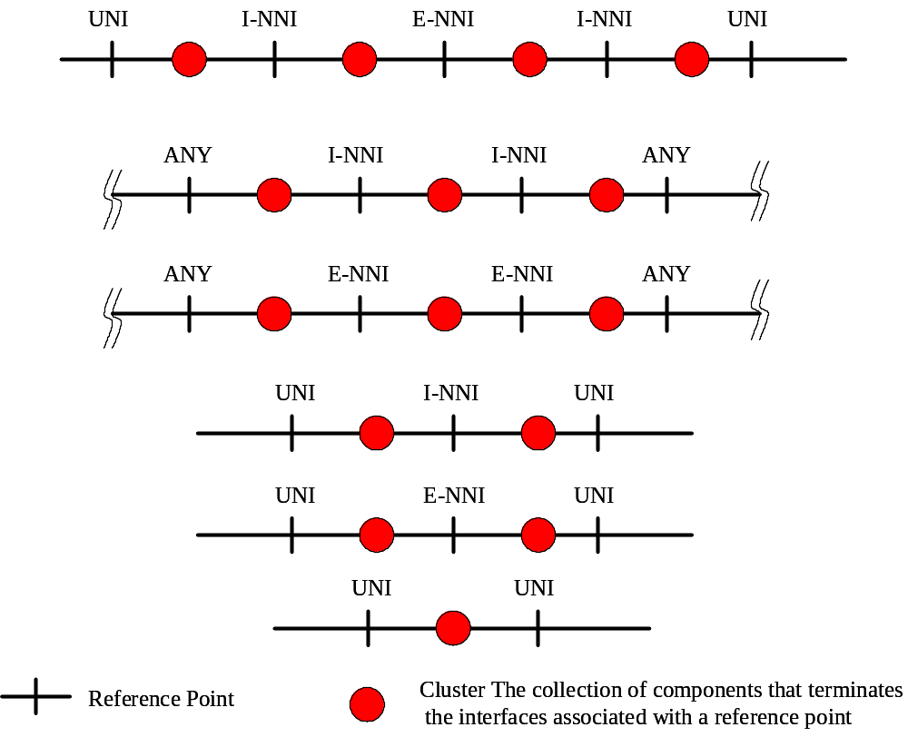
Figure 39/G.8080/Y.1304: Reference points

8.1 UNI
Information flows expected across the UNI reference point support the following functions:
− Call Control.
− Resource Discovery.
− Connection Control.
− Connection Selection.
Note, there is no routing function associated with the UNI reference point.
Additional functions such as security and authentication of calls, or enhanced directory services, may be added to this basic set of functions.
The use of the UNI reference point in L1 VPNs is for further study.

8.2 I-NNI
Information flows expected across the I-NNI reference point support the following functions:
− Resource Discovery.
− Connection Control.
− Connection Selection.
− Connection Routing.

8.3 E-NNI
Information flows expected across the E-NNI reference point support the following functions:
− Call Control.
− Resource Discovery.
− Connection Control.
− Connection Selection.
− Connection Routing
Additional functions such as security and authentication of calls, or enhanced directory services may be added to this basic set of functions.

When the E-NNI reference point exists between a VPN customer domain and a VPN in a service provider domain, supplementary services may be supported (see Recommendation Y.1312). Examples are:
- VPN user authentication and authorization
- VPN user policy management, including connectivity restrictions
- Transparent transfer of control information between VPN users
- VPN participation in the customer Routing control domain
Support for such services is outside the scope of this recommendation.

8.4 User Architecture
The user side will be referred to as the UNI-C (for “client”), and the network side will be referred to as the UNI-N (for “network”).
The G.8080/Y.1304 UNI Transport Resource Identifier (See Clause 10 of Recommendation G.8080/Y.1304) defines one or more globally unique names to each SNPP Link that is part of a UNI. These names are used to identify call destinations. Given that a UNI may contain multiple SNPP links, as in the case of multi-homing, a UNI may therefore have multiple globally unique names for its bearer resources. Note that these names are not user names.
When there are multiple SNPP links that are part of the same UNI, those addresses can be used to discriminate between which SNPP link to use. Factors such as diversity or cost, could be used by callers to select the appropriate SNPP link. SNPP links between a common AGC and a network may be in the same UNI if on the network side, they are within the scope of a common network call controller component.
UNI Transport Resource Identifiers can be used to differentiate between UNIs to a user. When there are multiple UNIs, each has distinct UNI Transport Resource Identifiers and they do not share a common address.
The following describes the UNI-C architecture:
- There exists a transport entity called an Access Group Container (AGC) that can terminate multiple SNPP links. This entity can contain a set of G.805 access groups.
- An AGC is a single layer entity that contains access groups, LRMs, and TAPs. It is similar to G.805 subnetworks except that it is not recursively defined, may or may not be a matrix (it does not have to be specified), and has no defined subnetwork connections. Multiple AGCs from different layers may be co-incident in the same equipment.
- Control plane functions associated with a UNI-C in an AGC are call control (Calling/Called Party Call Controller), and resource discovery (LRM). Limited connection control and connection selection is present to interact with the connection controller on the UNI-N side. This is because the connection control on the UNI-N has a routing interface whereas connection control on the UNI-C tracks connection acceptance/release from the UNI-N side
- Applications that use one or more trails on an AGC are known as “<application name> connection users”. They interact directly with G.805 access points by presenting and receiving adapted information. For each connection user there may be an “<application name> connection requestor”. These entities interact with UNI-Cs to request/release connections. A single connection requestor could obtain connections from one or more UNI-Cs for a related connection user.
- A user is considered to be multi-homed when there are two or more SNPP links connecting the AGC to the network. There is also a service agreement between the user and the network such that the network offers reliability, diversity, or other service characteristic between connections on different multi-homed SNPP links.
Section 8.5 Inter-layer NCC interactions

NCC to NCC Calls
A call may exist between a pair of NCCs in the absence of CCCs. This call is within the same layer. To allow such calls to be requested , a transport resource identifier is assigned to a set of SNPs that reference resources that may be used to support a call.. This is analogous to the UNI Transport Resource Identifier associated with transport resources at the UNI.
The NCC to NCC call may be used in at least two cases. First, as a call that is invoked in an interlayer call, and second, as another type of boundary between domains at the same layer.
When used in an interlayer call, a client NCC is used to initiate the call between another pair of NCCs in a server layer. As the client layer NCC invokes the server layer call, a domain boundary is crossed. This domain boundary is instituted to provide a policy control point, as well as provide separation of the SNPP as well as Transport Resource Identifiers used in the client and server layers. The transport resource identifiers used for the call request are in the server layer. This is illustrated in the figure below.
A server layer connection from an NCC to NCC call used to support a mapped client CI, has an association with an adaptation. Such a call/connection may exist before the adaptation is actually used.

Name Space Interactions
UNI Transport Resource Identifiers are defined to be globally unique. The additional transport resource identifiers defined are not required to be part of the UNI Transport Resource Identifier space. Transport resource identifiers associated with NCC to NCC calls may be from separate identifier spaces.

Within a single layer network, there may be independent SNPP identifiers spaces. Connections can be created across these different SNPP identifier spaces due to the fact that RCs understand the mapping of SNPP identifiers between routing levels.
When two SNPP identifier spaces are not mapped via routing, it is allowed to map one SNPP identifier space into the transport resource identifiers associated with the second SNPP identifier space. One purpose for this would be for a business boundary that has no routing exchange. An interlayer boundary is such a case.
This mapping is accessed as an address resolution function that takes as input, an SNPP identifier and returns a transport resource identifier associated with an SNPP in another identifier space. The existing address resolution in the G.8080 is accessed via the Directory Request output interface of the NCC component. The additional address resolution function would also be accessed by the same output interface. For an interlayer call, a client NCC at the edge of a subnetwork that represents server layer flexibility has two SNPPs in the client layer that it requires a connection for. This is obtained from a route query. The interlayer address resolution function is used by the client layer NCC to obtain the server layer Transport Resource corresponding to those two client layer SNPPs. Using the two Transport Resource Identifiers, a call is made to the server layer.
In Figure 40 below, SNPP-X in the client layer is mapped to Transport Resource Identifier B and SNPP-Y is mapped to Transport Resource Identifier C. An interlayer call can be invoked using the returned transport resource identifier.

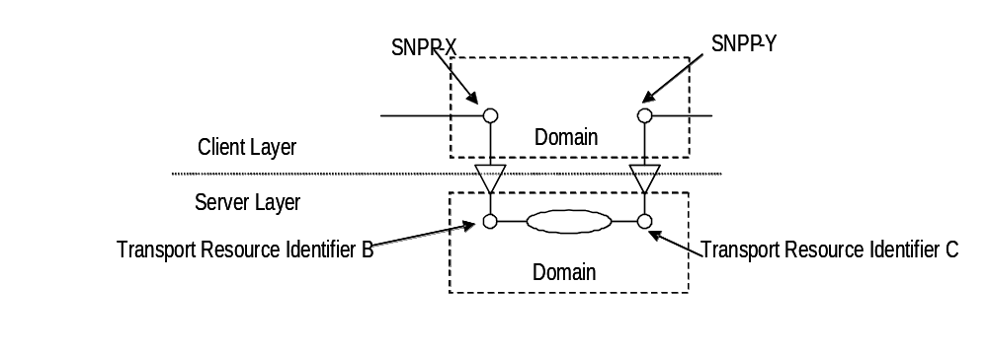
Figure 40/G.8080/Y.1304 – Name space interactions

9 Network management of control plane entities
There is interaction between the control plane and management plane as described in clause 5. This clause identifies some management capabilities that may impact interactions between the management and control planes. Specifically, such management capabilities may include:
1) Creation and deletion of a connection.
2) Division of network resources between those visible to the control plane and those visible to the management plane.
3) Assignment of transport resources to a particular customer to create a VPN.
4) Assignment of unique identifiers to CTPs and assignment of permitted bindings between the CTP and its associated SNPs.
5) Provision of configuration and policy information to the address screening and VPN, if either are present in the control plane.
6) Setting and modification of the signalling system parameters, such as time-outs (e.g. call setup time-out), thresholds, congestion control mechanisms, maximum number of allowed connections, maximum signalling load (above which the signalling processor denies call establishment requests, etc.).
7) In the event of routing occurring in the management plane (centralized):
– calculation of the route for permanent connections and use of management protocols for connection management;
– calculation of the route for soft permanent connections and providing the control plane with an explicit route.
8) Measurement of call performance. The parameters may include:
− call request rates (arrival rates);
− circuit utilization;
− call holding time;
− holding times (average holding time of connections multiplied by the request rate indicates the offered load in Erlangs);
- statistical averages computed across the total number of connection requests over a period of time
- An identification of the VPN to which the call performance parameters pertain.
9) Management of call admission control.
10) Determination of the maximum number of connections that can be supported by a network element and to set, where appropriate, the maximum number to be supported.
11) Distinguishing changes in the state of connections due to management or control plane actions and those resulting from network failures and suppress or generate alarms as appropriate.
12) Setting or modifying survivability priority levels or Quality of Service (QoS) contract levels for all connections associated with a given "performance class".
13) Assigning the maximum value of a connection identifier on a link where appropriate, setting traffic management controls either manually resulting from a specific input or automatically in response to internal or external stimuli. (In the case of automatic control the management system sets the conditions under which control is applied and the strength of response.)
14) Activation or deactivation of "direct routing and alternate routing".
15) Support for temporary re-routing schemes.
16) Management of the signalling network to ensure a consistent configuration of signalling resources.
17) Determination of attributes of signalling links including their functional status, error indications, traffic data or maximum bandwidth.
18) Migration of a permanent connection (PC) to a soft permanent connection (SPC), where the transport resources related to the PC are assigned without service disruption to the control plane.

10 Identifiers

10.1 Name Spaces
There are three separate Transport names spaces in the ASON naming syntax
1. A Routing Area name space.
2. A subnetwork name space.
3. A link context name space.
The first two spaces follow the transport subnetwork structure and need not be related. Taken together, they define the topological point where an SNPP is located. The link context name space specifies within the SNPP where the SNP is. It can be used to reflect sub-SNPP structure, and different types of link names.
An SNPP name is a concatenation of:
- one or more nested routing area names
- an optional subnetwork name within the lowest routing area level. This can only exist if the containing RA names are present.
- one or more nested resource context names.
Using this design, the SNPP name can recurse with routing areas down to the lowest subnetwork and link sub-partitions (SNPP sub-pools). This scheme allows SNPs to be identified at any routing level.
SNP name: An SNP is given an address used for link connection assignment and, in some cases, routing. The SNP name is derived from the SNPP name concatenated with a locally significant SNP index.
An SNPP alias is an alternate SNPP name for the same SNPP link that may be generated from another SNPP name space. Note: the SNPP alias may be generated from the same or different SNPP name space. If present in a routing area, it is available to the RC that is associated with the RA.

10.2 Names and Addresses
Names and addresses provide the necessary means of identification for control plane components to cooperatively control resources in a transport network. As defined in recommendation G.8081, addresses are location dependent and names are not. It is important to note that a given identifier may serve as a name in one context and as an address in another context. For example, consider the routing area A shown in clause 6.3 figure 11. Inside routing area A, the Local SNP ID is an address while the interface SNP ID is a name. However, outside the routing area, the interface SNP ID may be an address in the context of some other routing area (not shown in the figure).
Names and addresses are needed for various entities in the ASON control plane, as described below:

E-NNI Transport Resource:
The E-NNI SNPP Link may be assigned a name for the network call controllers to specify E-NNIs. These names must be globally unique and are assigned by the ASON network. Multiple names may be assigned to the SNPP link. An alias may exist for a set of E-NNI Transport Resource Identifiers , for example when a call must traverse multiple domains and the user can specify a transit domain, but not a specific E-NNI.
When the E-NNI reference point exists between a VPN customer domain and a VPN in a service provider domain, the E-NNI Transport Resource Identifier can be unique among all other E-NNI SNPP links assigned to the VPN and not necessarily globally unique. It can be assigned by the VPN customer or by the ASON network.
UNI Transport Resource: The UNI SNPP Link requires a name for the calling party call controller and network call controller to specify destinations. These names must be globally unique and are assigned by the ASON network. Multiple names may be assigned to the SNPP link. UNI transport resource identifiers may be in a 1:N or N:1 relationship with SNPP links. This enables a calling/called party to associate different applications with specific addresses over a common link. An alias may exist for a set of UNI Transport Resource Identifiers.

Routing Controller Protocol Controller: The Routing Controller Protocol Controller (RCPC) requires a DCN address for exchanging routing protocol messages with peer RCPCs. The Routing Controller Protocol Controller also must have a name that identifies it to peers for the purpose of maintaining routing protocol relationships.
Routing Controller: The Routing Controller requires a name that identifies it as the source for topology information that it generates and shares with other RCs.

Network Call Control Protocol Controller: The Network Call Controller requires a DCN address for exchanging call signalling messages. The Network Call Controller Protocol Controller also must have a name that identifies it to peers for the purpose of maintaining call signalling relationships.

Connection Controller Protocol Controller: A Connection Controller Protocol Controller requires a DCN address for exchanging connection signalling messages. These addresses are unique within the scope of an administrative domain. The Connection Controller Protocol Controller may have a name that identifies it to peers for the purpose of maintaining connection signalling relationships.

Calling/Called party Call Control Protocol Controller: The calling/called party call controller requires a DCN address for exchanging call signalling messages. The Calling/Called Party Call Controller Protocol Controller also must have a name that identifies it to peers for the purpose of maintaining call signalling relationships.

Subnetwork: A subnetwork is given an address representing the collection of all SNPs on that subnetwork, which is used for connection routing. The address is unique within the scope of an administrative domain.

Routing Area: A routing area is given an address representing the collection of all SNPPs on that routing area, which is used for connection routing.

10.3 Relationships between identifiers
Transport resources may be acted upon by both control plane components and management plane components (see Section 5.2). As a result, transport resources will be referenced by context specific identifiers. To allow the applications in these different contexts to exchange information about the common resource a mapping is required between transport resource identifiers used in a management plane context and those used in the control plane context.

Within the set of identifiers used by the control plane for transport plane resources, mappings are also required. For example, mapping a transport resource identifier to one or more SNPPs.

Details of any mappings between identifiers are out of the scope of this recommendation and are described in the appropriate G.771x.x series of Recommendations.

11 Connection availability enhancement techniques
This clause describes the strategies that can be used to maintain the integrity of an existing call in the event of failures within the transport network.
ITU-T Rec. G.805 describes transport network availability enhancement techniques. The terms "Protection" (replacement of a failed resource with a pre-assigned standby) and "Restoration" (replacement of a failed resource by re-routing using spare capacity) are used to classify these techniques. In general, protection actions complete in the tens of millisecond range, while restoration actions normally complete in times ranging from hundreds of milliseconds to up to a few seconds.
The ASON control plane provides a network operator with the ability to offer a user calls with a selectable class of service (CoS), (e.g. availability, duration of interruptions, Errored Seconds, etc). Protection and restoration are mechanisms (used by the network) to support the CoS requested by the user. The selection of the survivability mechanism (protection, restoration or none) for a particular connection that supports a call will be based on: the policy of the network operator, the topology of the network and the capability of the equipment deployed. Different survivability mechanisms may be used on the connections that are concatenated to provide a call. If a call transits the network of more than one operator then each network should be responsible for the survivability of the transit connections. Connection requests at the UNI or E-NNI will contain only the requested CoS, not an explicit protection or restoration type.
The protection or restoration of a connection may be invoked or temporarily disabled by a command from the management plane. These commands may be used to allow scheduled maintenance activities to be performed. They may also be used to override the automatic operations under some exceptional failure conditions.
The Protection or Restoration mechanism should:
− Be independent of, and support any, client type (e.g. IP, ATM, SDH, Ethernet).
− Provide scalability to accommodate a catastrophic failure in a server layer, such as a fiber cable cut, which impacts a large number client layer connections that need to be restored simultaneously and rapidly.
− Utilize a robust and efficient signalling mechanism, which remains functional even after a failure in the transport or signalling network.
− Not rely on functions which are non-time critical to initiate protection or restoration actions. Therefore consideration should be given to protection or restoration schemes that do not depend on fault localization.
The description of how protection and restoration capabilities are used by the transport, control and management planes of an ASON enabled network is for further study.

11.1 Protection
Protection is a mechanism for enhancing availability of a connection through the use of additional, assigned capacity. Once capacity is assigned for protection purposes there is no rerouting and the SNPs allocated at intermediate points to support the protection capacity do not change as a result of a protection event. The control plane, specifically the connection control component, is responsible for the creation of a connection. This includes creating both a working connection and a protection connection, or providing connection specific configuration information for a protection scheme. For transport plane protection the configuration of protection is made under the direction of the management plane. For control plane protection the configuration of protection is under the direction of the control plane rather than the management plane.
Control plane protection occurs between the source connection controller and the destination connection controller of a control plane protection domain, where the source and destination are defined in relation to the connection. The operation of the protection mechanism is coordinated between the source and destination. In the event of a failure the protection does not involve rerouting or additional connection setup at intermediate connection controllers, only the source and destination connection controllers are involved. This represents the main difference between protection and restoration.

11.2 Restoration
The restoration of a call is the replacement of a failed connection by rerouting the call using spare capacity. In contrast to protection, some, or all, of the SNPs used to support the connection may be changed during a restoration event. Control plane restoration occurs in relation to rerouting domains. A rerouting domain is a group of call and connection controllers that share control of domain-based rerouting. The components at the edges of the rerouting domains coordinate domain-based rerouting operations for all calls/connections that traverse the rerouting domain. A rerouting domain must be entirely contained within a Routing control domain or area. A Routing control domain may fully contain several rerouting domains. The network resources associated with a rerouting domain must therefore be contained entirely within a routing area. Where a call/connection is rerouted inside a rerouting domain, the domain-based rerouting operation takes place between the edges of the rerouting domain and is entirely contained within it.
The activation of a rerouting service is negotiated as part of the initial call establishment phase. For a single domain an intra-domain rerouting service is negotiated between the source (connection and call controllers) and destination (connection and call controller) components within the rerouting domain. Requests for an intra-domain rerouting service do not cross the domain boundary.
Where multiple rerouting domains are involved the edge components of each rerouting domain negotiate the activation of the rerouting services across the rerouting domain for each call. Once the call has been established each of the rerouting domains in the path of the call have knowledge as to which rerouting services are activated for the call. As for the case of a single rerouting domain once the call has been established the rerouting services cannot be renegotiated. This negotiation also allows the components associated with both the calling and called parties to request a rerouting service. In this case the service is referred to as an inter-domain service because the requests are passed across rerouting domain boundaries. Although a rerouting service can be requested on an end-to-end basis the service is performed on a per rerouting domain basis (that is between the source and destination components within each rerouting domain traversed by the call).
During the negotiation of the rerouting services the edge components of a rerouting domain exchange their rerouting capabilities and the request for a rerouting service can only be supported if the service is available in both the source and destination at the edge of the rerouting domain.
A hard rerouting service offers a failure recovery mechanism for calls and is always in response to a failure event. When a link or a network element fails in a rerouting domain, the call is cleared to the edges of the rerouting domain. For a hard rerouting service that has been activated for that call the source blocks the call release and attempts to create an alternative connection segment to the destination at the edge of the rerouting domain. This alternative connection is the rerouting connection. The destination at the edge of the rerouting domain also blocks the release of the call and waits for the source at the edge of the rerouting domain to create the rerouting connection. In hard rerouting the original connection segment is released prior to the creation of an alternative connection segment. This is known as break-before-make. An example of hard rerouting is provided in Figure 41. In this example the Routing control domain is associated with a single routing area and a single rerouting domain. The call is rerouted between the source and destination nodes and the components associated with them.
Soft rerouting service is a mechanism for the rerouting of a connection for administrative purposes (e.g. path optimisation, network maintenance, and planned engineering works). When a rerouting operation is triggered (generally via a request from the management plane) and sent to the location of the rerouting components the rerouting components establish a rerouting connection to the location of the rendezvous components. Once the rerouting connection is created the rerouting components use the rerouting connection and delete the initial connection. This is known as make-before-break.
During a soft rerouting procedure a failure may occur on the initial connection. In this case the hard rerouting operation pre-empts the soft rerouting operation and the source and destination components within the rerouting domain proceed according to the hard rerouting process.
If revertive behaviour is required (i.e. the call must be restored to the original connections when the failure has been repaired) network call controllers must not release the original (failed) connections. The network call controllers must continue monitoring the original connections, and when the failure is repaired the call is restored to the original connections.
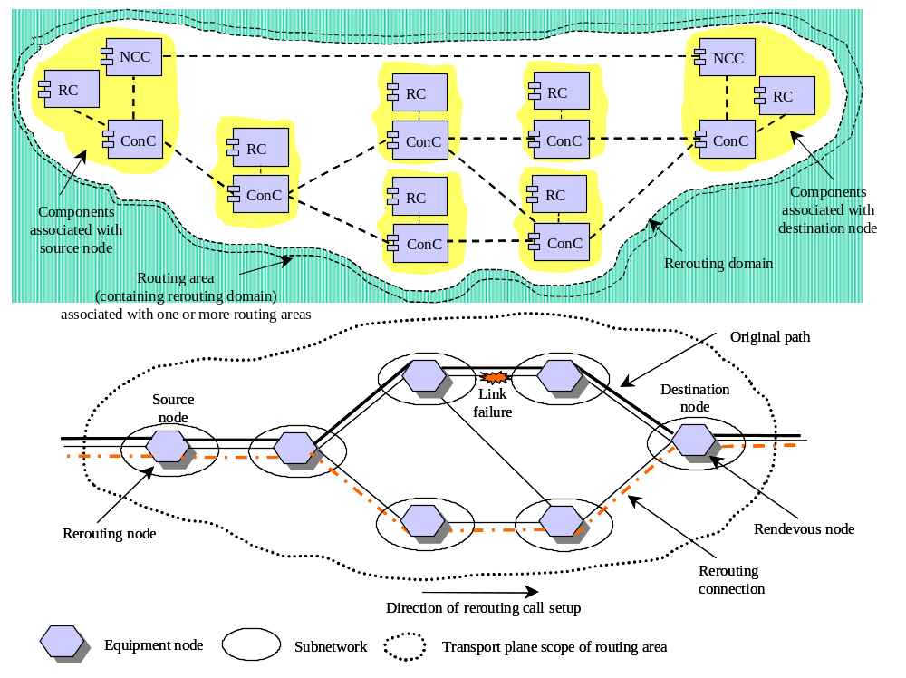
Figure 41/G.8080/Y.1304: Example of hard rerouting
11.2.1 Rerouting in response to failure
11.2.1.1 Intra Domain Failures
Any failures within a rerouting domain should result in a rerouting (restoration) action within that domain such that any down stream domains only observe a momentary incoming signal failure (or previous section fail). The connections supporting the call must continue to use the same source (ingress) and destination (egress) gateways nodes in the rerouting domain.
11.2.1.2 Inter Domain Failures
Two failure cases must be considered, failure of a link between two gateway network elements in different rerouting domains and failure of inter-domain gateway network elements.
11.2.1.3 Link Failure between adjacent gateway network elements
When a failure occurs outside of the rerouting domains (e.g. the link between gateway network elements in different rerouting domains A and B in Figure 42a no rerouting operation can be performed. In this case alternative protection mechanisms may be employed between the domains.
Figure 42b shows the example with two links between domain A and domain B. The path selection function at the A (originating) end of the call must select a link between domains with the appropriate level of protection. The simplest method of providing protection in this scenario is via a protection mechanism that is pre-established (e.g. in a server layer network. Such a scheme is transparent to the connections that run over the top of it). If the protected link fails the link protection scheme will initiate the protection operation. In this case the call is still routed over the same ingress and egress gateway network elements of the adjacent domains and the failure recovery is confined to the inter-domain link.
11.2.1.4 Gateway Network Element Failure
This case is shown in Figure 43. To recover a call when B-1 fails a different gateway node, B-3, must be used for domain B. In general this will also require the use of a different gateway in domain A, in this case A-3. In response to the failure of gateway NE B-1 (detected by gateway NE A-2) the source node in domain A, A-1, must issue a request for a new connection to support the call. The indication to this node must indicate that rerouting within domain A between A-1 and A-2 is to be avoided, and that a new route and path to B-2 is required. This can be considered as rerouting in a larger domain, C, which occurs only if rerouting in A or B cannot recover the connection.
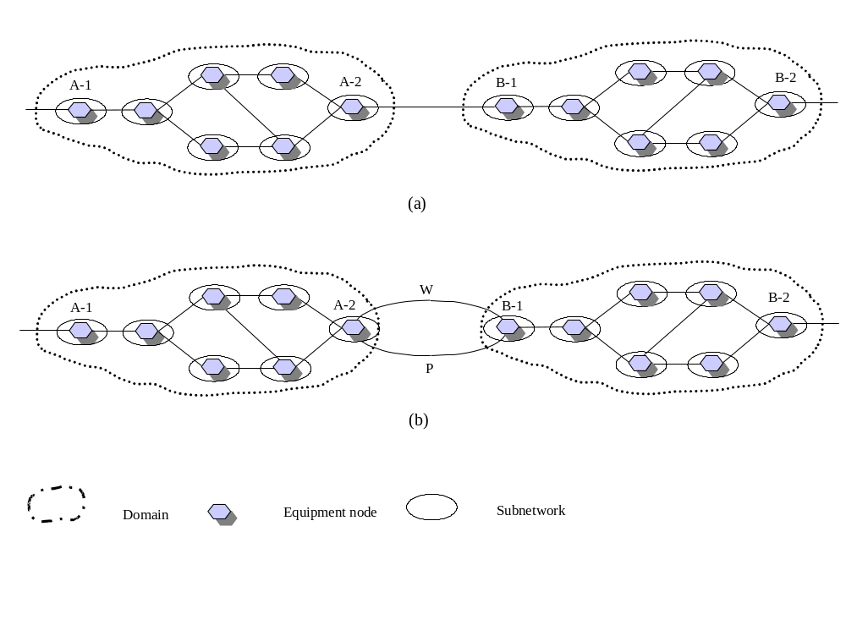
Figure 42/G.8080/Y.1304: Link failure scenarios
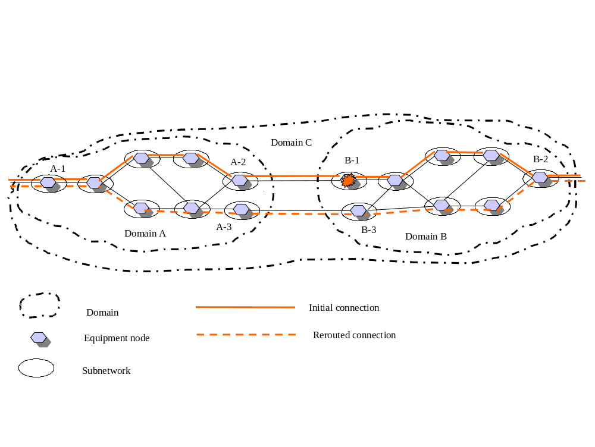
Figure 43/G.8080/Y.1304: Rerouting in event of a gateway network element failure

12 Resilience
Resilience refers to the ability of the control plane to continue operating under failure conditions. Operation of the control plane depends upon elements of the Data Communications Network (DCN), the transport plane, the management plane and the internal components of the control plane itself (refer to Figure 1/G.8080/Y.1304). Additional information is provided in Appendix II.

12.1 Principles of control and transport plane interactions
The following principles are used for control and transport plane interactions when communications become available between the two planes.
- The control plane relies on the transport plane for information about transport plane resources.
- Consistency between the control plane view and the corresponding transport network element is established first (vertical consistency)
- Once local consistency is established, horizontal consistency is attempted. Here, control plane components synchronize with their adjacent components. This is used to re-establish a consistent view of routing, call, and connection state.
Another principle of control and transport plane interaction is that:
- Existing connections in the transport plane are not altered if the control plane fails and/or recovers. Control plane components are therefore dependent on SNC state.
For resiliency, the transport plane resource and SNC state information should be maintained in non-volatile store. Further some information about the control plane use of the SNC should be stored. This includes whether the SNC was created by Connection Management and how it was used. For example, which end of the SNC is towards the head end of the whole connection. At a given node, the control plane must ensure it has resource and SNC state information that is consistent with the resource and SNC state information maintained by the transport NE. If not, the control components responsible for that node must:
- advertise zero bandwidth available to adjacent nodes to ensure there will be no network requests to route a new connection through that node
- not perform any connection changes (e.g., releases).
SNC state is the most important information to recover first because it is the basis of connections that provide service to end users. This follows the principle above. During recovery, the control plane reconstructs the call and connection state corresponding to existing connections. For example, routing will need to disseminate correct SNP information after it is synchronized by the local control plane components (LRM).
The control plane re-establishment of information consistency with the transport NE should occur in the following sequence:
- the Link Resource Manager synchronizes with the transport NE state information
- the Connection Controller then synchronizes with the Link Resource Manager
- the Network Call Controller then synchronizes with the Connection Controller.
Following the re-establishment of local state consistency, the control plane must then ensure SNC state information consistency with adjacent nodes, as discussed in principle 3 above, prior to participating in control plane connection setup or release requests.

12.2 Principles of Protocol Controller Communication
When communication between protocol controllers is disrupted existing calls and their connections are not altered. The management plane may be notified if the failure persists and requires operator intervention (for example, to release a call).
A failure of the DCN may affect one or more Protocol Controller to Protocol Controller communication sessions. The Protocol Controller associated with each signalling channel must detect and alarm a signalling channel failure.
When a Protocol Controller to Protocol Controller communication session recovers, state re-synchronization between the Protocol Controllers should be performed.
Failure of a Protocol Controller is handled similar to a failure of a Protocol Controller to Protocol Controller session.

12.3 Control and Management Plane Interactions
Should management plane functions become unavailable, various control functions may be impaired. When management plane functions become available, the control plane components may need to report to the management plane actions that they took while the management plane was unavailable (e.g., call records).
Annex A
Connection services
[Ed: This text is from G.807 section 6.2. ]

The control of connectivity is essential to the operation of a transport network. The transport network itself can be described as a set of layer networks, each acting as a connecting function whereby associations are created and removed between the inputs and outputs of the function. These associations are referred to as connections. Three types of connection establishment are defined:
1) Permanent connection: This form of connection is established by provisioning every network element along the path with the required information to establish an end-to-end connection. Provisioning is provided either by means of management systems or by manual intervention. Where a network management system is used, access to a database model of the network is normally required first, to establish the most suitable route, and then to send commands to the network elements that support the connection. This type of connection is referred to as a hard permanent connection. See Figure A-1. Note, Permanent connections are not described by the G.8080 architecture.
2) Switched connection(SC): This form of connection is established on demand by the communicating end-points within the control plane using a dynamic protocol message exchange in the form of signalling messages. These messages flow across either the I-NNI or E-NNI within the control plane. This type of connection is referred to as a switched connection. Such connections require network naming and addressing schemes and control plane protocols. See Figure A-2.
3) Soft permanent connection(SPC): This form of connection establishment exists whereby a network provides a permanent connection at the edge of the network and utilises a switched connection within the network to provide end-to-end connections between the permanent connections at the network edges. Connections are established via network generated signalling and routeing protocols. The establishment of such connections is dependent upon the definition of an NNI. Provisioning is therefore only required on the edge connections. There is no defined UNI. This type of network connection is known as a soft permanent connection (SPC). From the perspective of the end-points a soft permanent connection appears no different than a provisioned, management controlled, permanent connection. See Figure A-3.
The most significant difference between the three methods above is the party that sets up the connection. In the case of provisioning, connection set-up is the responsibility of the network operator, whilst in the signalled case, connection set-up may also be the responsibility of the end user. Additionally, third party signalling should be supported across a UNI.
NOTE − The type of connection may have impact on future billing systems.
The control plane shall support either a switched connection (SC) or soft permanent connection (SPC) of the basic connection capability in the transport network. These connection capability types are defined below:
• Uni-directional point-to-point connection;
• Bidirectional point-to-point connection;
• Uni-directional point-to-multipoint connection.
NOTE − A further connection type can be considered, namely an asymmetric connection. This may be constructed either as two uni-directional point-to-point connections, having different properties in each direction, or as a special case of bidirectional connection

The function of a UNI is to pass signalling messages directly to the network control plane entity. Alternatively, where a network operator already has extensive management systems in place that provide planning assignment and auto-configuration, these signalling messages may be passed directly to service management and network management system agents to effect connection set-up. Such an application will allow near real time automated service provision from the existing management platforms.

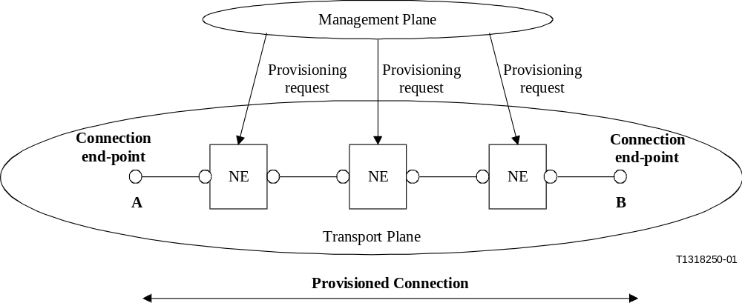
Figure A-1/G.8080/Y.1304 − Example of end-to-end transport connection set-up using provisioning via management plane {ed: change figure to permanent connection”}
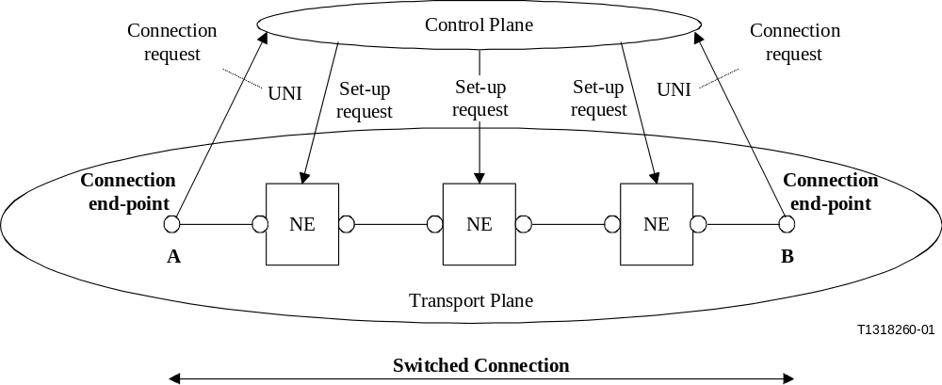
Figure A-2/G.8080/Y.1304 − Example of end-to-end transport connection set-up using control plane signalling (a switched connection from A to B)
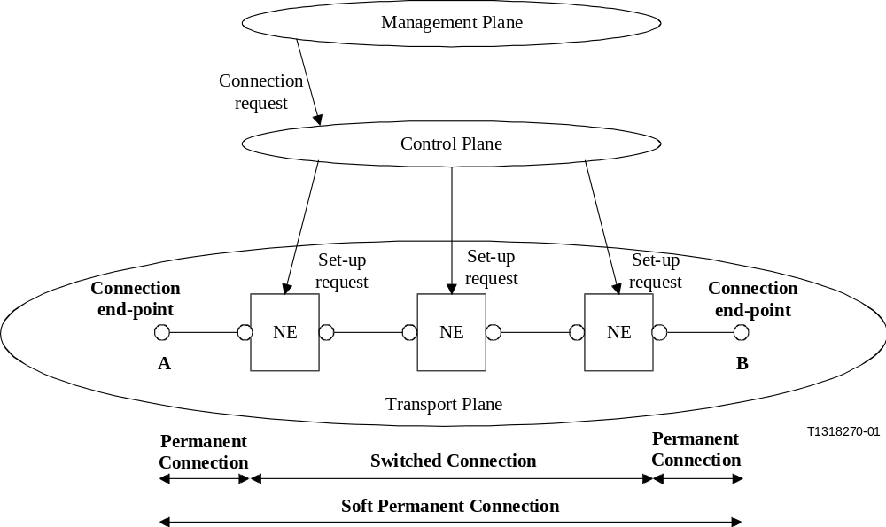
Figure A-3/G.8080/Y.1304 − Example of end-to-end transport connection set-up as soft permanent connection (SPC)

Appendix I
(Informative)
ASON layer networks
[ED: the following table has to be updated to include VCAT]
The Automatic Switched Optical Network may be applied to layer networks. Examples of layer networks defined in other ITU-T Recommendations are provided in Table I.1. ASON may be also applied to other layer networks including support of virtually concatenated payloads
Table I.1/G.8080/Y.1304 – Layer networks: SDH, OTN and PDH
SDH |  | LOVC Path | VC-11 |  | OTN | Digital Path | ODU1
SDH |  | LOVC Path | VC-12 |  | OTN | Digital Path | ODU2
SDH |  | LOVC Path | VC-2 |  | OTN | Digital Path | ODU3
SDH | HOVC Path | LOVC Path | VC-3 |  | OTN | Digital Section | OTUk, k=1,2,3
SDH | HOVC Path | VC-4 |  |  | OTN | Optical Path | OCh
SDH | HOVC Path | VC-4-4c |  |  | OTN | Section | OMSn
SDH | HOVC Path | VC-4-16c |  |  | OTN | Section | OTSn
SDH | HOVC Path | VC-4-64c |  |  | OTN | Section | OPSn
SDH | HOVC Path | VC-4-256c
SDH | Section | MSn, n=1,4,16,64,256 |  |  | PDH | Path | P11x, P11s
SDH | Section | RSn, n=1,4,16,64,256 |  |  | PDH | Path | P12x, P12s
SDH | Section | ES1  OSn, n=1,4,16,64,256 |  |  | PDH | Path | P21x
SDH | Section | sSTM-1k, k=1,2,4,8,16 |  |  | PDH | Path | P22x, P22e
SDH | Section | sSTM-2n, n=1,2,4 |  |  | PDH | Path | P31x, P31e
SDH | Section | E31/P31s |  |  | PDH | Path | P32x, P32
SDH | Section | E4/P4s |  |  | PDH | Path | P4x, P4e
 |  |  |  |  | PDH | Section | Eq, q=11,12,21,22,31,32,4

Appendix II
(Informative)
Illustrative examples of implementations

The architecture of the Automatically Switched Optical Network is defined in terms of various functions.
The architecture, as specified in G.8080/Y.1304, allows flexibility in implementation and recognizes that network operators may have differing practices. The architecture also recognizes that the functions may be implemented in a variety of ways. Furthermore, depending on the functionality required, not all components may be necessary. For example, the architecture described in G.8080/Y.1304 provides flexibility in routing and allows both centralized and distributed routing. In the case of distributed routing, there are interactions between a number of routing controller functions, whilst in a centralized scheme, routing can as an alternative be maintained by the management plane, removing the need for a routing controller component. Requests for circuits, including their routes, are passed to the control plane from the management plane.
Although flexibility is provided within the architecture, defined interfaces and information flows enable interconnection of the various components. One such example is illustrated in Figure II.1/G.8080/Y.1304, below. An additional example is contained in Appendix III, Figure III.1/G.8080/Y.1304.

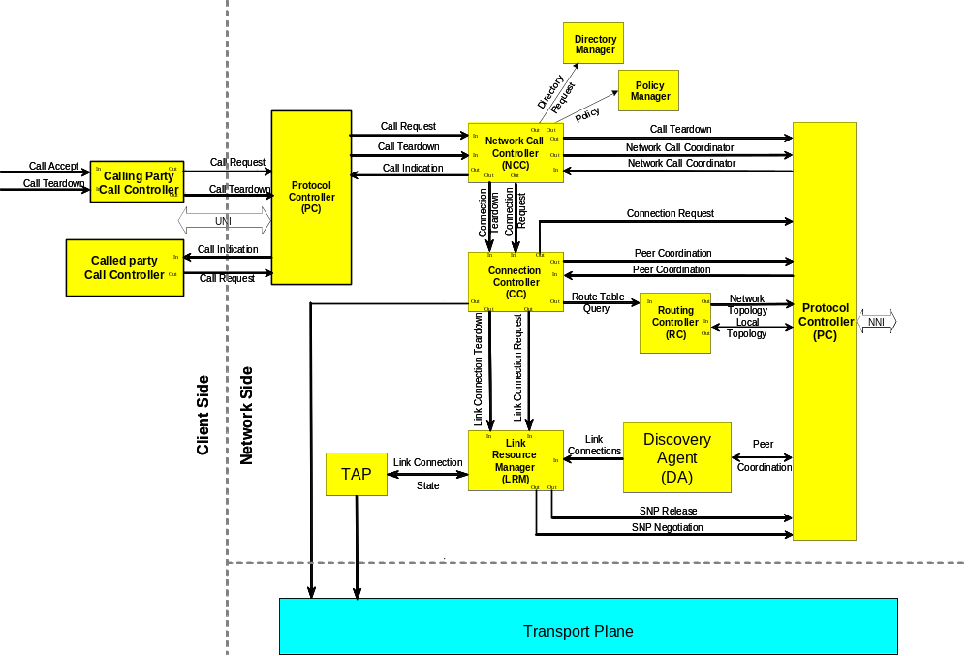
Figure II.1/G.8080/Y.1304:Illustrative example of interconnection of components
Appendix III
(Informative)
Resilience Relationships
Resilience refers to the ability of the control plane to continue operating under failure conditions. Operation of the control plane depends upon elements of the Data Communications Network (DCN), the transport plane, the management plane and the internal components of the control plane itself (refer to Figure 1/G.8080/Y.1304). The following clauses identify the control plane dependencies on those areas. The desired degree of control plane resiliency can then be engineered by providing appropriate redundancy for the dependent functions.
III.1 Control Plane – DCN Relationships
The control plane relies on the DCN for the transfer of signalling messages over some or all of the following interfaces (refer to Figure III.1/G.8080/Y.1304): UNI, NNI, NMI. The impact of a signalling channel failure on the operation of the control plane will be examined for each of the Protocol Controllers associated with each interface.
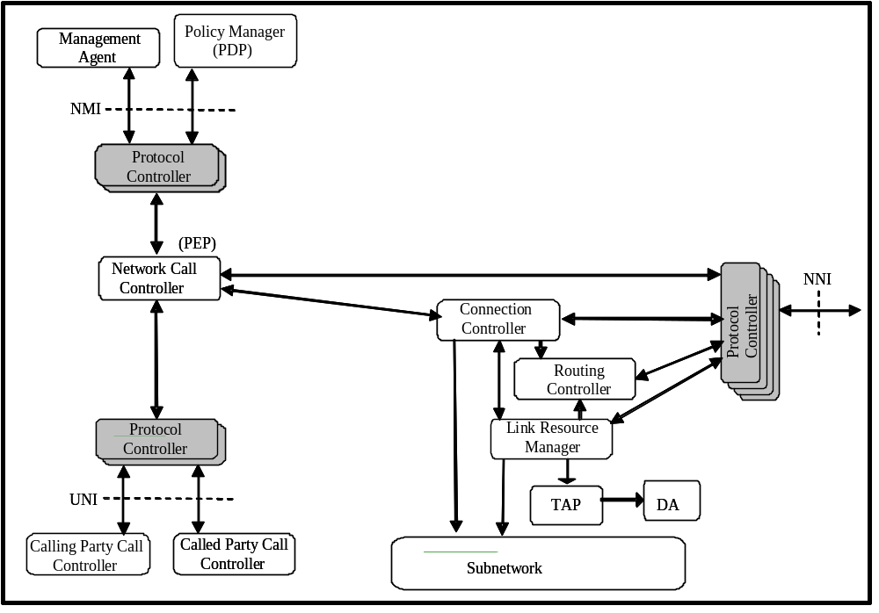
Figure III.1: G.8080/Y.1304 Control Plane Components (an interpretation)
III.1.1 UNI
There are potentially two separate Protocol Controllers handling the signalling sessions over the UNI: one for the Calling Party Call Controller link and one for the Called Party Call Controller link.
III.1.1.1 Failure Case
A failure of the signalling session supporting the UNI for the Calling Party Call Controller link will result in the loss of the Call Request / Call Release control flows.
A failure of the signalling session supporting the UNI for the Called Party Call Controller link will result in the loss of the Call Request / Call Indication control flows.
A failure of either of the UNI-related signalling session impacts the Network Call Controller function.
In all cases above, existing calls and their connections are not altered. The management plane may be notified if the failure persists and requires operator intervention (for example, to release a call).
III.1.1.2 Recovery Case
When the signalling channel recovers, state re-synchronization between the client call controllers and the network call controller, and the connection controllers over the UNI, should be performed.
III.1.2 NNI
There are potentially four separate Protocol Controllers handling the signalling sessions over the NNI: one for the Network Call Controller link, one for the Connection Controller link, one for the Routing Controller link and one for the Link Resource Manager link.

III.1.2.1 Failure Case
A failure of the signalling session supporting the NNI for the Network Call Controller link will result in the loss of the Network Call Controller Coordination control flows. Call setup or release will not be possible, but there is no impact on connection setup or release.
A failure of the signalling session supporting the NNI for the Connection Controller link will result in the loss of the Connection Controller Coordination and Connection Request / Call Release control flows. Connection setup or release will not be possible. Further, if Call Control is piggybacked on Connection Control, no call setup or release will be possible either.
A failure of the signalling session supporting the NNI for the Routing Controller link will result in the loss of the Network / Local Topology control flows.
A failure of the signalling session supporting the NNI for the Link Resource Manager link will result in the loss of the SNP Negotiation / Release control flows.
A failure of the Link Resource Manager signalling session impacts the Routing Controller function and the Connection Controller function. A failure of the Routing Controller signalling session impacts the Connection Controller function. A failure of the Connection Controller signalling session impacts the Network Call Controller function.
In all cases above, existing calls and their connections are not altered. The management plane may be notified if the failure persists and requires operator intervention (for example, to release a call).
Note that a failure of the DCN may affect one or more or all of the above signalling session simultaneously. The Protocol Controller associated with each signalling channel must detect and alarm a signalling channel failure.
III.1.2.2 Recovery Case
Upon restoral of a previously failed signalling channel, the corresponding Protocol Controller must ensure all messaging resumes in sequence. Components are responsible for re-establishing state information after Protocol Controller recovery.
III.2 Control Plane – Transport Plane Relationships
This clause considers only those transport plane failures that affect the ability of the control plane to perform its functions, for example when an LRM cannot be informed. Transport plane failures, such as port failures, are not in this scope as it is expected that the control plane is informed of this situation. Information consistency between the two planes is treated in clause 12.1.
III.2.1 Transport Plane Information - Query
The control plane will query the transport plane under the following scenarios:
when a Connection Controller signalling session activates, or re-activates (for example, following the recovery of a data link or transport NE)
control plane queries about the transport resources
as part of transport resource information synchronization (for example, when the control plane recovers following a failure)
III.2.3 Transport Plane Information – Event Driven
The transport plane will inform the control plane on an event basis under the following scenarios:
failure of a transport resource
addition / removal of a transport resource
III.2.3.1 Transport Plane Protection
Transport plane protection actions, which are successful, are largely transparent to the control plane. The transport plane is only required to notify the control plane of changes in availability of transport resources.
Transport plane protection attempts, which are unsuccessful, appear to the control plane as connection failures and, may trigger control plane restoration actions, if such functionality is provided. Given that the control plane supports restoration functionality, the following relationships exist.
The Routing Controller must be informed of the failure of a transport plane link or node and update the network/local topology database accordingly. The Routing Controller may inform the local Connection Controller of the faults.
III.2.4 Transport Plane Dependency On Control Plane
If the control plane fails, new connection requests that require the use of the failed control plane components, cannot be processed. Note however, that the management plane could be used as a fallback to respond to new connection requests. Established connections must not be affected by a control plane failure.
III.3 Control Plane – Management Plane Relationships
The control plane may obtain directory and policy information from the management plane during the call admission control validation process. Failure of the directory or policy servers could result in the failure of connection setup requests.
Examples of this are:
At the Network Call Controller (at the calling or called party end), call requests may need to be validated by policy checking.
When connection controllers request a path from the Routing Controller, a policy server may need to be consulted.
Call release actions can take place in the control plane if the management plane is not available. A record of these actions must be maintained by the control plane so that when the management plane becomes available, a log can be sent to the management plane or the control plane can be queried for this information.
III.3.1 NMI
All control components have monitor, policy and configuration ports which provide the management view of the control plane components (see Clause 7.2.1).
There are potentially two separate Protocol Controllers / signalling sessions involving management information flows: one for the Policy Manager session and one for a transport management session. Other Protocol Controllers may be introduced in the future for other management functions.
III.3.1.1 Failure Case
A failure of the signalling session supporting the Policy Manager link will result in the loss of the Policy Out control flows.
A failure of the transport management signalling session will result in the loss of FCAPS (Fault, Configuration, Accounting, Performance, Security) information exchange.
A failure of the Policy session impacts the Network Call Controller function. For example, the potential failure of new connection setup requests when the call admission control validation process requires Policy Manager access
III.3.1.2 Recovery Case
When management signalling communication is recovered, information stored in the control plane that should be sent to management plane is sent (e.g., call records). Information pending from the management plane to the control plane should be sent (e.g., revised policy or configuration).
III.4 Intra-Control Plane Relationships
The impact of control plane component failures on the operation of the control plane overall will be examined per the component relationship illustrated in Figure 29.5. To achieve continuous operation of the control plane under a component failure, the ability to detect a component failure and switch to a redundant component, without loss of messages and state information, is required.
If control plane components are not redundant, then when a failed component recovers, it must re-establish a sufficient view of the transport plane resources in order to be operational.
It is assumed that the communications between components other than Protocol Controllers (i.e., non-PC communications) is highly reliable. Such communications is likely internal to a control plane node and is implementation specific, thus it is outside the scope of this recommendation.
III.4.1 Network Call Controller
The failure of a Network Call Controller will result in the loss of new call setup requests and existing call release requests.
III.4.2 Connection Controller
The failure of a Connection Controller will result in the loss of new connection setup requests and existing connection release requests. As Call Control signalling is often implemented via the Connection Controller and its Protocol Controller, a failure of the Connection Controller may impact the Network Call Controller function (e.g., may not be able to release existing calls).
III.4.3 Routing Controller
The failure of a Routing Controller will result in the loss of new connection setup requests and loss of topology database synchronization. As the Connection Controller depends on the Routing Controller for path selection, a failure of the Routing Controller impacts the Connection Controller. Management plane queries for routing information will also be impacted by a Routing Controller failure.
III.4.4 Link Resource Manager
The failure of a Link Resource Manager will result in the loss of new connection setup requests and existing connection release requests, and loss of SNP database synchronization. As the Routing Controller depends on the Link Resource Manager for transport resource information, the Routing Controller function is impacted by a Link Resource Manager failure.
III.4.5 Protocol Controllers
The failure of any of the Protocol Controllers has the same effect as the failure of the corresponding DCN signalling sessions as identified above. The failure of an entire control plane node must be detected by the neighbouring nodes NNI Protocol Controllers.
III.4.6 Intra-Control Plane Information Consistency
As discussed in clause 12.2.1, at a given node, control plane component resource and SNC state information consistency with the local transport NE resource and state information must be established first. Then control plane components must ensure SNC state information consistency with its adjacent control plane components. Any connection differences must be resolved such that no connection fragments remain or misconnections occur. Following the control plane information consistency cross-check, the control plane components are permitted to participate in control plane connection setup or release requests.

Appendix V
Example of layered call control
[Ed: Appendix IV was deleted as per agreements in final review February 14, 2006. This appendix, (and following references) will be changed as appropriate. This will be done following consent as this is purely editorial.]
(Informative)

Figure V-1 illustrates the mapped server case with the inter-layer call model for two Ethernet clients. They attach to a common VC-3 network that does not support Ethernet switching. Suppose that a 40Mbit/s call is requested over a Gigabit Ethernet UNI. To carry Ethernet CI, a VC-3 connection is created. The decision by the NCC_{MAC} to make a call to the corresponding NCC_{VC-3} is driven by operator policy. Both layers are shown with only the VC-3 layer having a network connection. Once the VC-3 connection is established, the ETH FPP link connection between the two NCC_{MAC} comes into existence

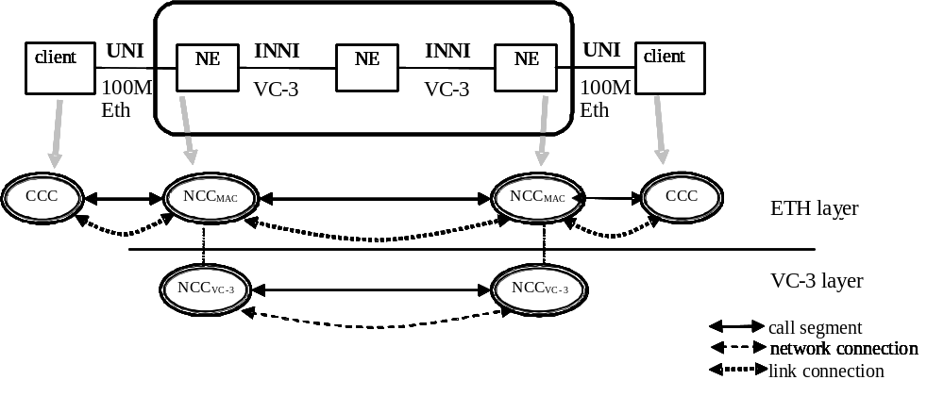
Figure V.1/G.8080/Y.1304: Ethernet over VC-3 example
In the sequence of events, the establishment of calls at different server layers may be independent in time. For example, the incoming Ethernet call could trigger the VC3. Alternately the VC-3 connection may already exist and then be associated to an incoming MAC call. The association of the VC-3 connection to the requested Ethernet call is also driven by operator policy.

There are numerous other examples of interlayer calls such as Fibre Channel over SDH/OTN.
AppendixVI
Component interactions for connection setup
(Informative)
[Ed: New text is indicated as highlighted for the purposes of change tracking. ]
[Ed: note: renumber appendix based on deletion of appendix IV. This will be done following consent, as this is purely editorial. See note for Appendix V, above.]

Component interactions for connection setup

Section 7.1 states that controller components are abstract entities that may be implemented as a single entity or as a distributed set of entities making up a cooperative federation. However, for clarity of illustration, the examples in this Appendix show potential implementation approaches in which the components shown are not abstract entities but rather specific instances of implementation code. Specifically:
- Network Call Controllers are shown as a distributed cooperative federation
- Routing Controllers are shown in a distributed cooperative federation
- Connection Controllers are shown as a single entity for a matrix
- LRM are shown as a single entity handling all link ends for a matrix
In some examples, a shaded box is used to show the boundaries of the distributed cooperative federation that make up an abstract entity.
In order to control a connection it is necessary for a number of components to interact.
Three basic forms of algorithm for dynamic path control can be distinguished, hierarchical, source routing and step-by-step routing as shown in the following figures. The different forms of path control result in a different distribution of components between nodes and relationships between these connection controllers. In case an RC does not have sufficient routing information to provide a route for a connection request, it may communicate with other RCs for to resolve the route using the Route Query interface as described in section 7.3.2.

VI.1 Hierarchical Routing
In the case of hierarchical routing, as illustrated in Figure VI-1, a node contains a routing controller, connection controllers and link resource managers for a single level in a routing area hierarchy. The decomposition of routing areas follows the decomposition of a layer network into a hierarchy of subnetworks (in line with the concepts described in ITU-T Rec. G.805). Connection controllers are related to one another in a hierarchical manner. Each routing area has its own dynamic connection control that has knowledge of the topology of its routing area but has no knowledge of the topology of routing areas above or below itself in the hierarchy, or other routing areas at the same level in the hierarchy.
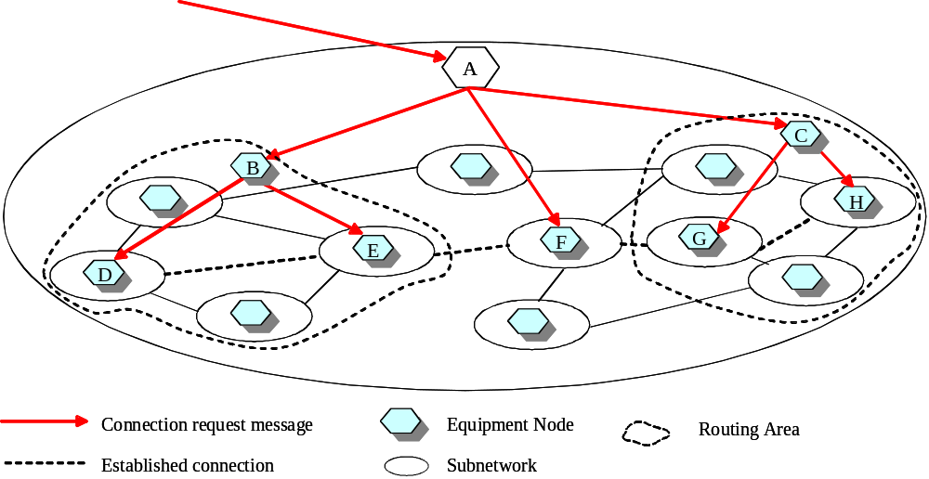
Figure VI-1/G.8080/Y.1304 – Hierarchical signalling flow

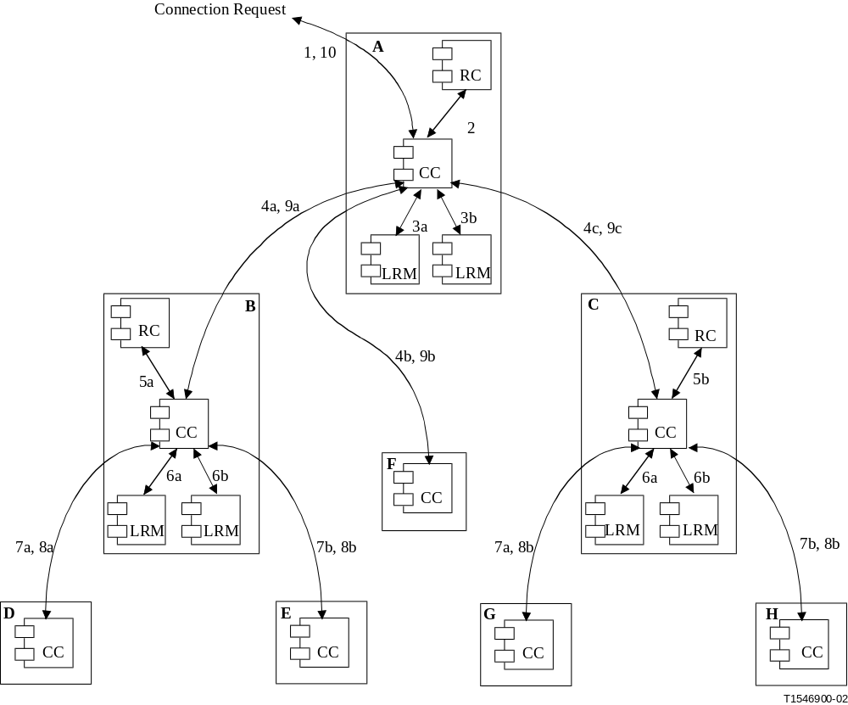
Figure VI-2/G.8080/Y.1304 – Hierarchical routing interactions

In Figure VI-2, the detailed sequence of operations involved in setting up a connection using hierarchic routing is described. The steps involved are listed below:
1) A connection request arrives at the connection controller (CC) from the connection request in interface, specified as a pair of SNPs at the edge of the top level routing area.
2) The routing controller(RC) is queried (using the Z end SNP over the route table query interface) and returns the set of links and subnetworks involved.
3) Link connections are obtained (in any order, i.e. 3a, or 3b in FigureVI-2) from the link resource managers (LRM) over the link connection request interface.
4) Having obtained link connections (specified as SNP pairs), subnetwork connections can be requested from the child routing areas, by passing a pair of SNPs over the connection request in interface and confirming subnetwork connections to the CC via the connection request out interface. Again, the order of these operations is not fixed, the only requirement being that link connections are obtained before subnetwork connections can be created. The initial process now repeats recursively.
5) The child routing controllers now resolve a route between the SNPs specified.
6) Link connections are obtained (in any order) from the link resource managers (LRM) over the link connection request interface.
7) As a final step, the lowest level switches, which do not contain any routing or link allocation components at all, provide the necessary subnetwork connections.
8) The remaining steps indicate the flow of confirmations that the connection has been set up, culminating in step 10), where the confirmation is returned to the original user.

VI.2 Source and step-by-step routing
While similar to hierarchical routing, for source routing, the connection control process is now implemented by a federation of distributed connection and routing controllers. The significant difference is that connection controllers invoke a different sequence of path computation functions between routing levels for hierarchical vs. source routing. The signal flow for source (and step-by-step) routing is illustrated in Figure VI-3.

In order to reduce the amount of network topology each controller needs to have available, only that portion of the topology that applies to its own routing area is made available.
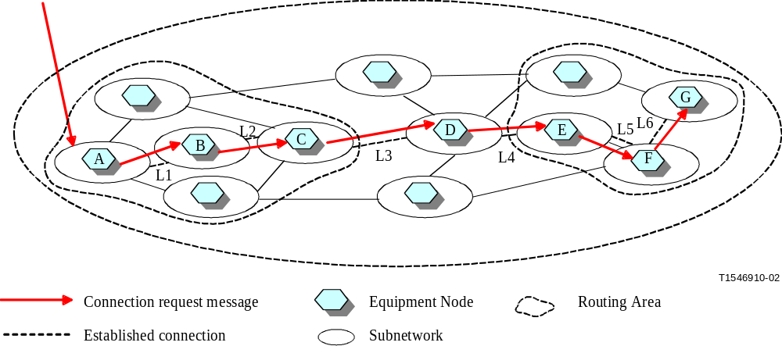
Figure VI-3/G.8080/Y.1304 – Source and step-by-step signalling flow
VI.2.1 Source routing
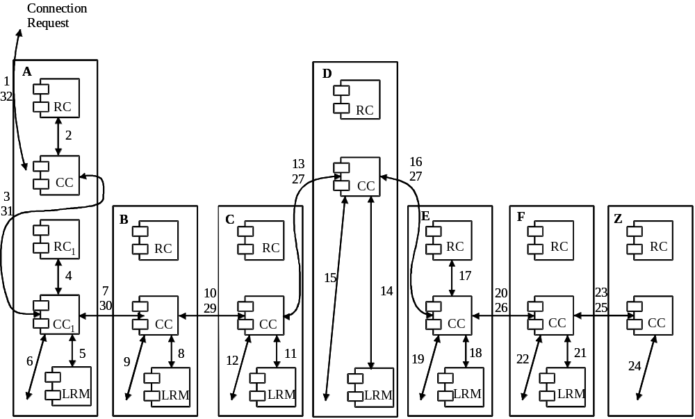
Figure VI-4/G.8080/Y.1304 – Source routing interactions
In the following steps we describe the sequence of interactions shown in Figure VI-4. The following notation is used: X_{A} represents the component at the highest level in Node A, X_{An} represents the component that is at the next nth highest level in Node A.
1) A connection request arrives at the connection controller (CC_{A}) from the connection request in interface, specified as a pair of names (A and Z) at the edge of the subnetwork.
2) The routing controller (RC_{A}) is queried (using the Z end SNP over the Route Table Query interface) and returns route (A, L3, L4, Z).
3) As CC_{A} does not have access to the necessary link resource manager (LRM_{C}), the request (A, L3, L4, Z) is passed on to a peer CC_{A1} (over the connection request out/in interface), which controls routing through this routing Area.
4) CC_{A1} queries RC_{A1} (over the route query interface) for L3 and obtains a list of additional links, L1 and L2.
5) Link L1 is local to this node, and a link connection for L1 is obtained from LRM_{A} over the link connection request interface.
6) The SNC is made across the local switch (controller not shown).
7) The request, now containing the remainder of the route (L2, L3,L4 and Z), is forwarded to the next peer CC_{B} (over the peer coordination out/in interface).
8) LRM _{B} controls L2, so a link connection is obtained from this link over the link connection request interface.
9) The SNC is made across the local switch (controller not shown).
10) The request, now containing the remainder of the route (L3, L4 and Z), is forwarded to the next peer CC_{C} (over the peer coordination out/in interface).
11) LRM _{C} controls L3, so a link connection is obtained from this link over the link connection request interface.
12) The SNC is made across the local switch (controller not shown).
13) The request, now containing the remainder of the route (L4,Z), is forwarded to the next peer CC_{D} (over the peer coordination out/in interface).
14) LRM_{D} controls L4, so a link connection is obtained from this link over the link connection request interface.
15) The SNC is made across the local switch (controller not shown).
16) The request, now containing the remainder of the route (Z), is forwarded to the next peer CC_{E} (over the peer coordination out/in interface).
17) CC_{E} queries RC_{E} (over the route table query interface) for Z and obtains links L5 and L6.
The process of connecting across the next routing area (i.e. steps 18 to 24 in Figure VI-4) is identical to that already described. Events 25 to 33 describe the flow of confirmation signals to the connection originator.

VI.2.2 Step-by-step routing
In this form of routing there is further reduction of routing information in the nodes, and this places restrictions upon the way in which routing is determined across the subnetwork. Figure VI-5 applies to the network diagram of Figure VI-3.
The process of step-by-step routing is identical to that described for Source Routing, with the following variation: routing controller RC_{A1} can only supply link L1, and does not supply link L2 as well. CC_{B} must then query RC_{B} (via the route table query interface) for L2 in order to obtain L2. A similar process of obtaining one link at a time is followed when connecting across the second routing area.

1） A connection request arrives at the connection controller (CCA) from the connection request in interface, specified as a pair of names (A and Z) at the edge of the subnetwork.
2） The routing controller (RCA) is queried (using the Z end SNP over the Route Table Query interface) and returns the egress link, L3.
3） As CC_{A} does not have access to the necessary link resource manager (LRMC), the request (A, L3, Z) is passed on to a peer CCA1 (over the connection request out/in interface), which controls routing through this routing Area.
4） CC_{A1} queries RCA1 (over the route query interface) for L3 and obtains L1.
5） Link L1 is local to this node, and a link connection for L1 is obtained from LRMA over the link connection request interface.
6） The SNC is made across the local switch (controller not shown).
7） The request, now containing the route (L3 and Z), is forwarded to the next peer CC_{B} (over the peer coordination out/in interface).
8） CC_{B1} queries RC_{B1} (over the route query interface) for L3 and obtains L2.
9） LRM_{B} controls L2, so a link connection is obtained from this link over the link connection request interface.
10） The SNC is made across the local switch (controller not shown).
11） The request, now containing the remainder of the route (L3 and Z), is forwarded to the next peer CCC (over the peer coordination out/in interface).
12） LRM_{C} controls L3, so a link connection is obtained from this link over the link connection request interface.
13） The SNC is made across the local switch (controller not shown).
14） The request, now containing the remainder of the route (Z), is forwarded to the next peer CCD (over the peer coordination out/in interface).
15） CCD queries RCD (over the route query interface) for Z and obtains link L4.
16） LRM_{D} controls L4, so a link connection is obtained from this link over the link connection request interface.
17） The SNC is made across the local switch (controller not shown).
18） The request, now containing the remainder of the route (Z), is forwarded to the next peer CC_{E} (over the peer coordination out/in interface).
19） CCE queries RCE (over the route query interface) for Z and obtains link L5.
20） LRM_{E} controls L5, so a link connection is obtained from this link over the link connection request interface.
21） The SNC is made across the local switch (controller not shown).
22） The request, now containing the remainder of the route (Z), is forwarded to the next peer CC_{F} (over the peer coordination out/in interface).
23） CC_{F} queries RC_{F} (over the route query interface) for Z and obtains link L6.
24） LRM_{F} controls L6, so a link connection is obtained from this link over the link connection request interface.
25） The SNC is made across the local switch (controller not shown).
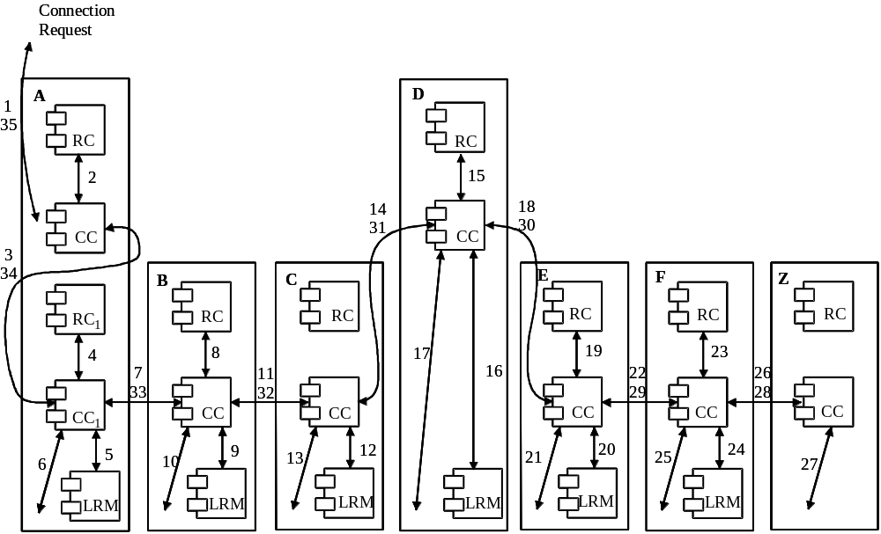
Figure VI-5/G.8080/Y.1304 – Step-by-step routing

VI.2.3 Combination of Source and Step-by-step routing

The following illustrates an example where source and step-by-step routing can be used, but at different routing levels. In this example, the low level routing is source routing, while the high level routing is step-by-step.

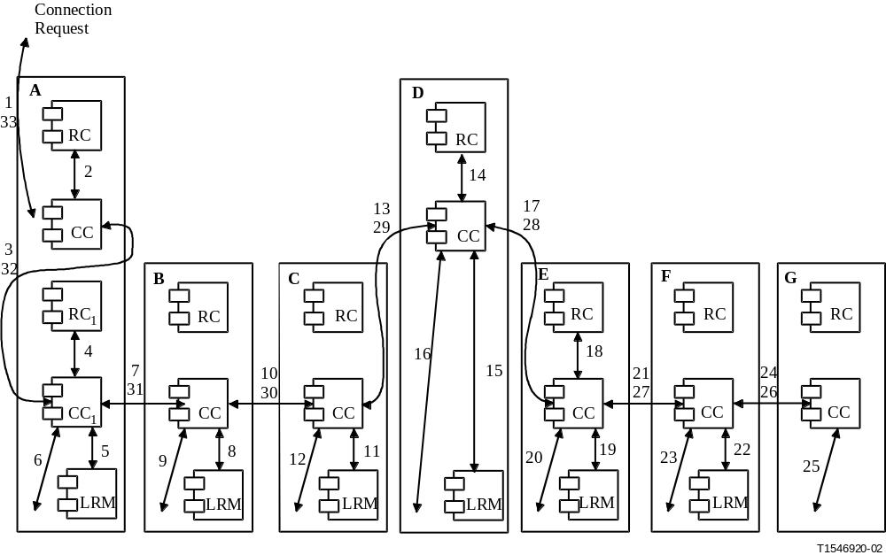
1） A connection request arrives at the connection controller (CC_{A}) from the connection request in interface, specified as a pair of names (A and Z) at the edge of the subnetwork.
2） The routing controller (RC_{A}) is queried (using the Z end SNP over the Route Table Query interface) and returns the egress link, L3.
3） As CC_{A} does not have access to the necessary link resource manager (LRMC), the request (A, L3, Z) is passed on to a peer CC_{A1} (over the connection request out/in interface), which controls routing through this routing Area.
4） CC_{A1} queries RC_{A1} (over the route table query interface) for L3 and obtains a list of additional links, L1 and L2.
5） Link L1 is local to this node, and a link connection for L1 is obtained from LRM_{A} over the link connection request interface.
6） The SNC is made across the local switch (controller not shown).
7） The request, now containing the remainder of the route (L2, L3 and Z), is forwarded to the next peer CC_{B} (over the peer coordination out/in interface).
8） LRM_{B} controls L2, so a link connection is obtained from this link over the link connection request interface.
9） The SNC is made across the local switch (controller not shown).
10） The request, now containing the remainder of the route (L3 and Z), is forwarded to the next peer CC_{C} (over the peer coordination out/in interface).
11） LRM_{C} controls L3, so a link connection is obtained from this link over the link connection request interface.
12） The SNC is made across the local switch (controller not shown).
13） The request, now containing the remainder of the route (Z), is forwarded to the next peer CC_{D} (over the peer coordination out/in interface).
14） CC_{D} queries RC_{D} (over the route table query interface) for Z and obtains link L4.
15） LRM_{D} controls L4, so a link connection is obtained from this link over the link connection request interface.
16） The SNC is made across the local switch (controller not shown).
17） The request, now containing the remainder of the route (Z), is forwarded to the next peer CC_{E} (over the peer coordination out/in interface).
18） CC_{E} queries RC_{E} (over the route table query interface) for Z and obtains links L5 and L6.

VI.3 Connection protection
When the control plane is used to provide protection, a protection connection is setup to protect the working connection before the happening of a failure. After a working connection failure is detected, only the source and destination connection controllers are involved to complete the protection switching operation from the original working connection to protection connection.

Figure VI-6 shows an example of connection protection using source based routing and distributed signalling. Here the protection signalling flow is shown after a link failure is detected. The relationship of the working and protection is assumed to be 1:1. That is, CI is not transferred on both working and protection at the same time. Instead, when the working path is interrupted by a link failure, the control plane is used to switch user CI to the protection path.

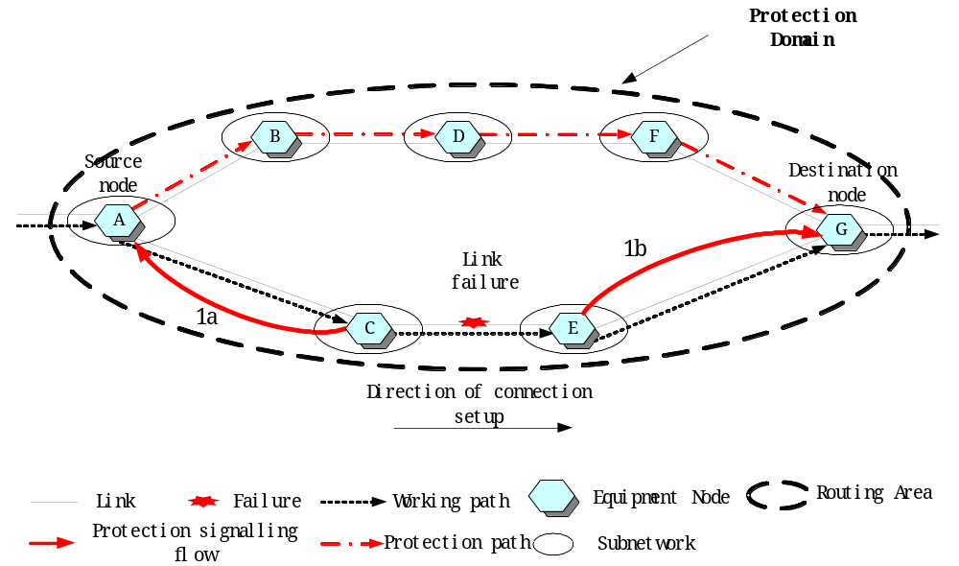

Figure VI-6/G.8080/Y.1304 – Protection signalling flow
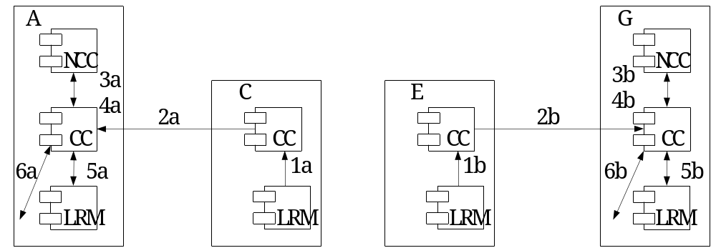
Figure VI-7/G.8080/Y.1304 – Protection interactions
In Figure VI-7, the detailed sequence of operations involved in protection is described. The steps involved are listed below:
1) A bidirectional link failure notification generated by the Link Resource Managers (LRM) arrives at the Connection Controller (CC) containing the failure link information. This occurs in node E and node C.
2) The link failure notification is forwarded to CC_{A} from CC_{C} and to CC_{G} from CC_{E}.
3) At both CC_{A} and CC_{G}, the NCCs are alerted to the failure of the working path.
4) The NCCs initiate the protection switching request to their CCs that cause the SNC to be made across the local switch from working connection to protection connection.

VI.4 Restoration – Hard Rerouting – Intra-domain - Hierarchical method
In hard rerouting, which is known as break-before-make, the original connection segment is released prior to the creation of an alternative connection segment.
Figure VI-8 shows the signalling flow of a hard rerouting scenario with hierarchical connection control after an intra domain link failure is detected. In the step of rerouting connection creation hierarchical algorithm is adopted.
In Figure VI-9, the detailed sequence of operations involved in Figure VI-8 is described. The steps involved are listed below:
1) An intra domain link failure notification generated by the Link Resource Managers (LRM) arrives at the Connection Controller (CC), containing the crankback routing information which specifies the failure link. This may occur in node J or node H or both according to which node detects the link failure.
2) The intra domain link failure notification is forwarded to CC_{B}.
3) Link Connections are released (in any order, i.e. 3a, or 3b in Figure 4) by LRM.
4) The SNCs are released by the lowest level switches.
5) The connection release confirmations are returned to CC_{B}.
6) The Routing Controller (RC_{B}) is queried with crankback routing information and returns the set of Links excluding the failure link and Subnetworks involved.
7)–9) Steps 7 to 9 describe the flow of connection set-up using hierarchical algorithm which is identical to that described in 7.5.1 Hierarchical Routing.
10) If failed to set up the connection in rerouting domain A, the crank back routing information is forwarded to upper level rerouting domain C.
11) The remained Link Connections are released by LRM.
12) The SNCs are released by the lowest level switches. This requires release at nodes G and J via CC_{B} and then CC_{G} and CC_{J}.
13) The connection release confirmations are returned to CC_{A}. This includes release from CC_{B}.
14) RC_{A} is queried with crank back routing information and returns the set of Links excluding the failure link and Subnetworks involved.
15)–21) Steps 15 to 21 describe the flow of connection set-up using hierarchical algorithm which is identical to that described in 7.5.1 Hierarchical Routing.
22) If failed to set up the connection in rerouting domain C, the crankback routing information is forwarded to upper level rerouting domain.
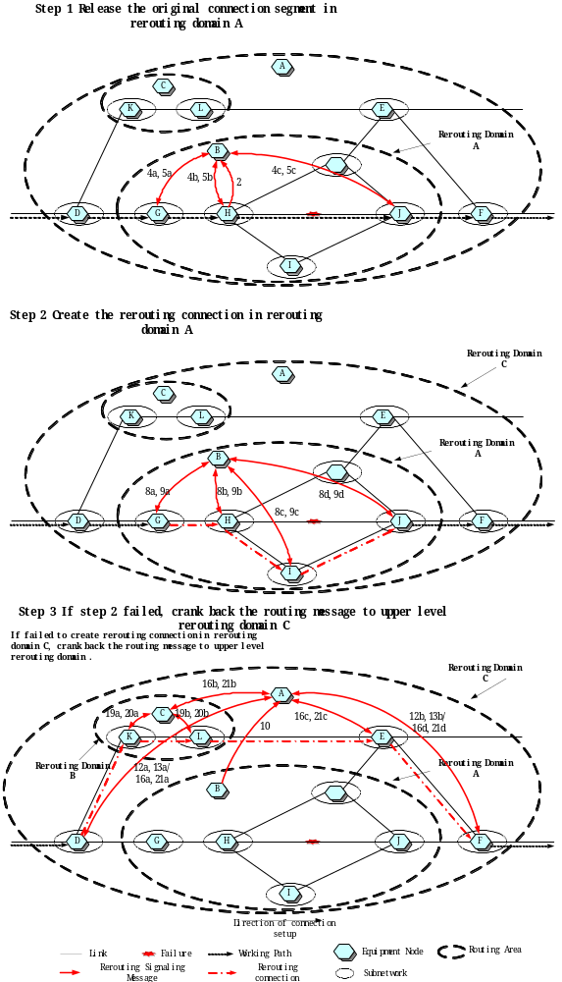
Figure VI-8/G.8080/Y.1304 – Signalling flow of hard rerouting using hierarchical algorithm after an intra domain link failure
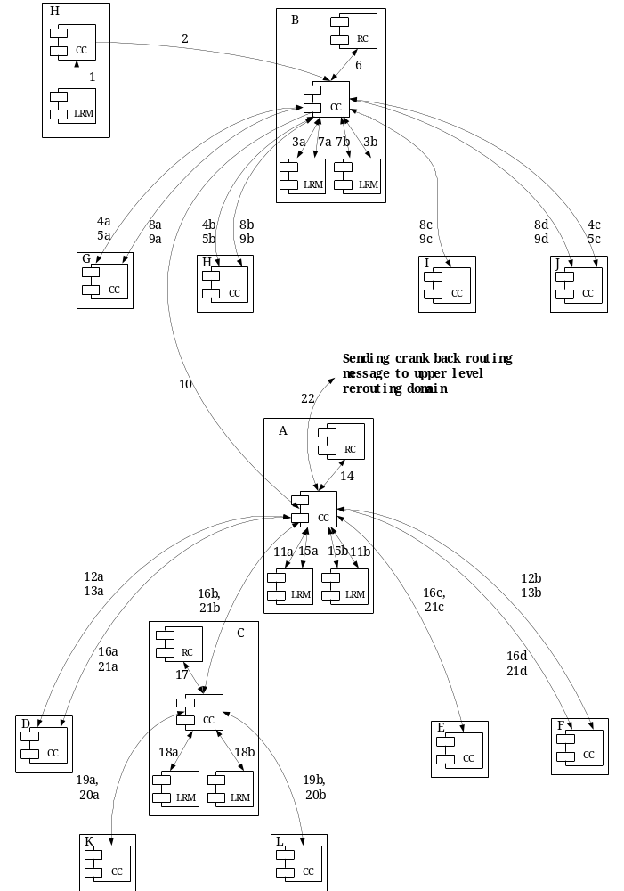
Figure VI-9/G.8080/Y.1304 – Component ineractions of hard rerouting using hierarchical algorithm after an intra domain link failure

VI.5 Restoration – Soft Rerouting – Intra-domain - Source method
Soft rerouting service is a mechanism for the rerouting of a call for administrative purposes. When a rerouting operation is triggered (generally via a request from the management plane) and sent to the location of the rerouting components, the rerouting components establish a rerouting connection that traverses (or does not traverse) the appointed set of components according to the administrative purposes. In soft rerouting, which is known as make-before-break, the initial connection is deleted after the creation of a rerouting connection.
Figure VI-9 shows the signalling flow of a soft rerouting scenario with source (or step-by-step) routing connection control after receiving a management plane request to reroute a connection excluding a certain intra domain link.
In Figure VI-10, the detailed sequence of operations using source routing involved in Figure 10 is described. The steps involved are listed below:
1) A management plane request arrives at the Connection Controller (CC_{G}), containing constraints that the rerouting connection must comply with. For example, an explicit route of the rerouting connection. In this example, there is an exclusion constraint that specifies that link L1 is not to be used in the rerouting connection.
2a) Routing Controller (RC_{G}) receives a rerouting connection set-up request initiated by CC_{G} containing the pair of SNPs at the edge of the rerouting domain A and the exclusion constraint.
2b) RG_{G} returns the set of Links excluding the link L1.
3)–15) Steps 3 to 15 describe the flow of connection set-up using source routing algorithm which is identical to that described in 7.5.2 Source and step-by-step routing. The new connection is joined to the original one coming into domain A at G and J.
If the connection is set up successfully in rerouting domain A, steps 16a is followed else steps 16b is followed.

16a) The link connection of the original path is released by LRM_{G} in step 16a which consists of steps 16a1 and 16a2.
17) The SNC is released across the local switch.
18) The connection release request, containing the original connection information, is forwarded to CC_{H}.
19) The link connection of the original path is released by LRM_{H}.
20) The SNC is released across the local switch.
21) The connection release request, containing the original connection information, is forwarded to CC_{J}.
22) The SNC is released across the local switch.
23) The connection release confirmation is returned to the source CC_{G} and the rerouting process completes.

16b) The crankback routing information is forwarded to CC_{D} in upper level rerouting domain C.
17a) RC_{D} receives a rerouting connection set-up request initiated by CC_{D} containing the pair of SNPs at the edge of the rerouting domain C and the exclusion constraint to avoid domain A.
17b) RC_{D} returns the set of Links excluding domain A.
18)–39) Steps 18 to 39 describe the flow of connection set-up using source routing algorithm which is identical to that described in 7.5.2 Source and step-by-step routing.
40) The link connection of the original path is released by LRM_{D} in step 40 which consists of steps 40a and 40b.
41) The SNC is released across the local switch.
42) The connection release request, containing the original connection information, is forwarded to CC_{G}.
43) The link connection of the original path is released by LRM_{G}.
44) The SNC is released across the local switch.
45) The connection release request, containing the original connection information, is forwarded to CC_{H}.
46) The link connection of the original path is released by LRM_{H}.
47) The SNC is released across the local switch.
48) The connection release request, containing the original connection information, is forwarded to CC_{J}.
49) The link connection of the original path is released by LRM_{J}.
50) The SNC is released across the local switch.
51) The connection release request, containing the original connection information, is forwarded to CC_{F}.
52) The SNC is released across the local switch.
53) The connection release confirmation is returned to the source CC_{D}.

____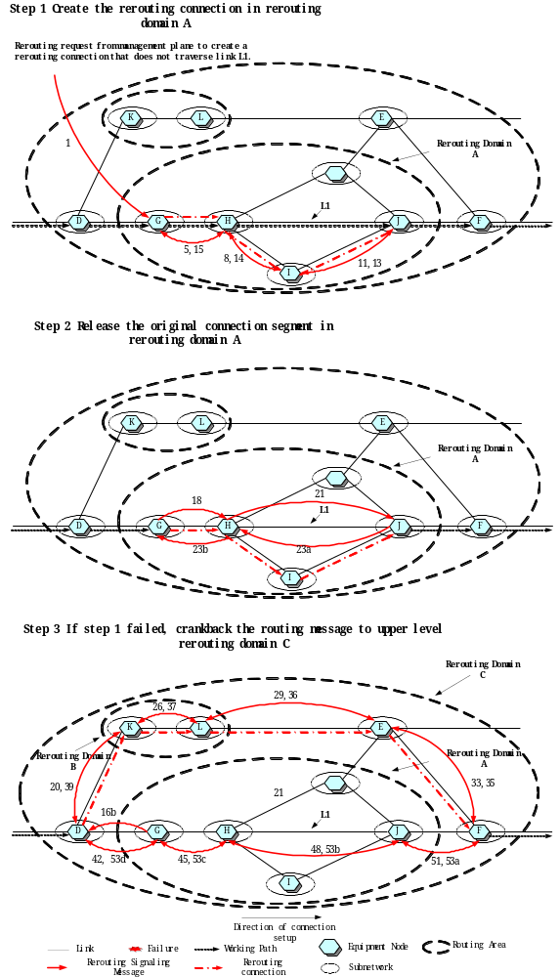_
Figure VI-9/G.8080/Y.1304 – Signalling flow of soft rerouting using source (or step-by-step) routing algorithm excluding an intra domain link
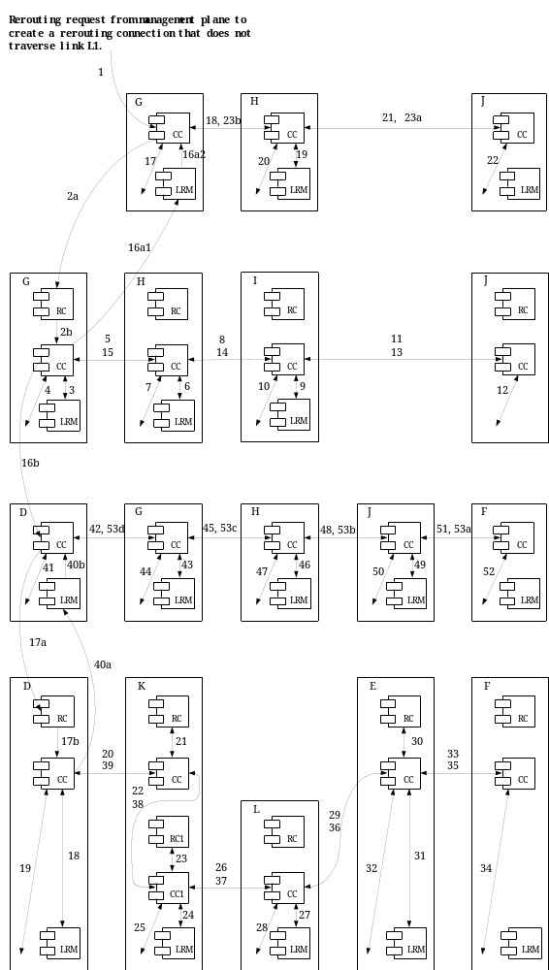
Figure VI-10/G.8080/Y.1304 – Component interactions of soft rerouting using source routing algorithm excluding an intra domain link

VI.6 Restoration – Revertive Rerouting – Intra-domain - Source method
In revertive behaviour rerouting, the original connection must not be released and is monitored by the network call controllers. When the failure is repaired the call is restored to the original connection.
Figure VI-11 shows the signalling flow of a revertive behaviour rerouting scenario with source (or step-by-step) routing connection control after an intra domain link failure is detected.
In Figure VI-12, the detailed sequence of operations using source routing involved in Figure VI-11 is described. The steps involved are listed below:
1) An intra domain link failure notification generated by the Link Resource Managers (LRM) arrives at the Connection Controller (CC), containing the crankback routing information which specifies the failure link. This may occur in node J or node H or both according to which node detects the link failure.
2) The intra domain link failure notification is forwarded to CC_{G}. No SCN changes are made.
3) The Routing Controller (RC_{G}) is queried with crankback routing information and returns the set of Links excluding the failure link and Subnetworks involved.
4)–16) Steps 4 to 16 describe the flow of connection set-up using source routing algorithm which is identical to that described in 7.5.2 Source and step-by-step routing.
17) If failed to set up the connection in rerouting domain A, the crankback routing information is forwarded to upper level rerouting domain C.
18) RC_{D} is queried with crankback routing information and returns the set of Links excluding domain A.
19)–40) Steps 19 to 40 describe the flow of connection set-up using source routing algorithm which is identical to that described in 7.5.2 Source and step-by-step routing.

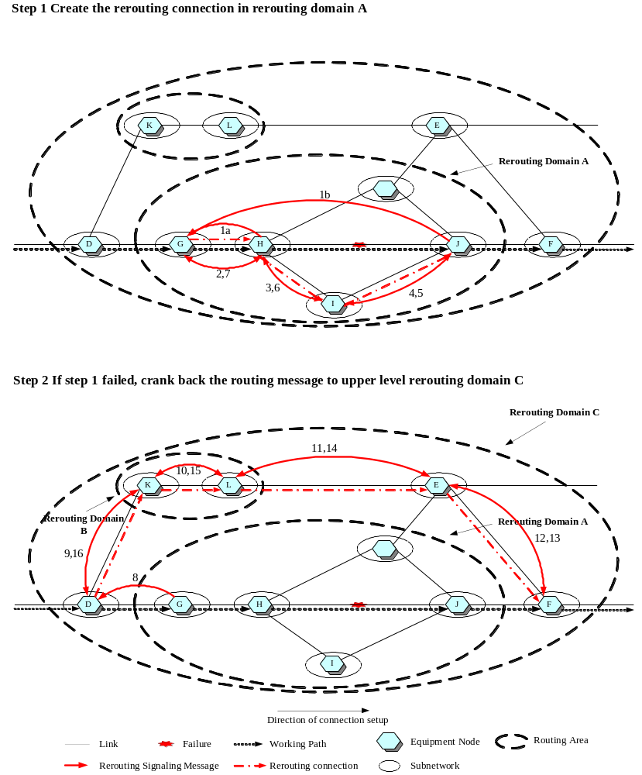
Figure VI-11/G.8080/Y.1304 – Signalling flow of revertive behaviour rerouting using source (or step-by-step) routing algorithm after an intra domain link failure
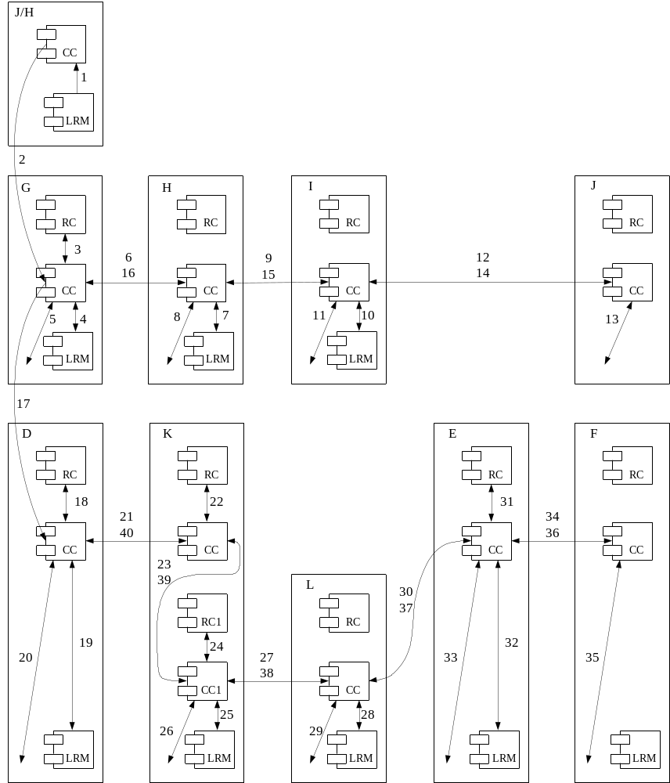
Figure VI-12/G.8080/Y.1304 – Component interactions of revertive behaviour rerouting using source routing algorithm after an intra domain link failure

VI.7 Source Routing using Routing Query interface
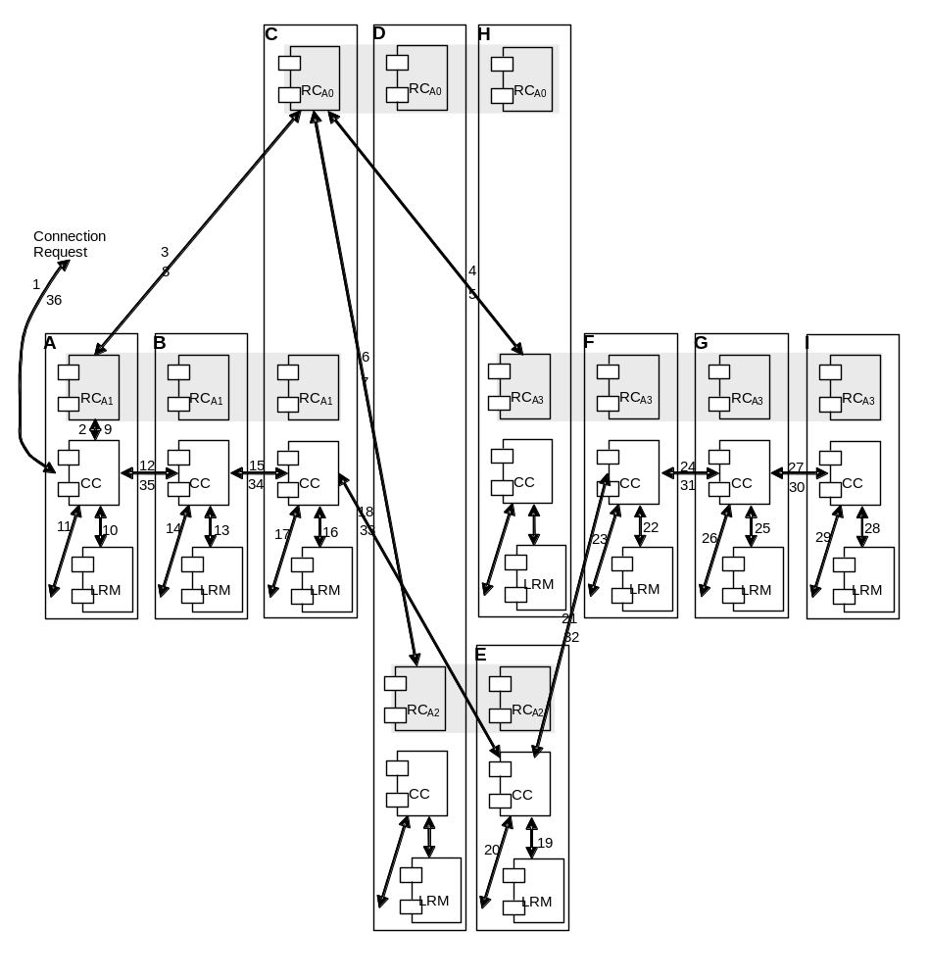
Figure VI-13/G.8080/Y.1304 – Component interactions for source routing using Routing Query interface

This figure illustrates the detailed sequence of operations involved in setting up a connection using source routing assisted by RC-RC route query. The notation RC_{A1,} RC_{A2,} etc., represent Routing Controller in Area A1, A2, etc. The actual communication components may be facilitated by other intermediate components -- for example, the communication from RC_{A0} on Node C to RC_{A2} on Node D may be performed by transferring the message through RC_{A0} on Node D.
The steps involved are listed below.
- A connection request arrives at the connection controller (CC_{A}) from the connection_request_in interface, specified as a pair of names (A and Z) at the edge of the subnetwork.
- The routing controller RC_{A1} on Node A is queried (using the Z end SNP over the Route Query interface).
- The routing controller RC_{A1} on Node A recognizes that the destination address is not visible within area A1 so it sends a route query to RC_{A0} on Node C for assistance over the Route Query Interface. While RC_{A1} on Node C has the same routing information as RC_{A1} on Node A as they are in a common routing area, RC_{A0} on Node C has visibility to the destination making the computation of a path possible.
- In the process of computing a path to the destination, RC_{AO} on Node C recognises that to reach the destination it needs to reach Area A3. However, since there are multiple paths between Area A1 and Area A3, it needs the assistance of RC_{A2} and RC_{A3} to determine the best path. Thus a query is sent by RC_{AO} on Node C to RC_{A3} on Node H to determine which link from A2 to A3 should be used.
- RC_{A3} on Node H computes the possible paths from the links entering Area A3 from Area A2 to the destination within Area A3. From this, it can determine the costs of using either of the paths, and returns this information to RC_{AO} on Node C.
- As with RC_{A3} on Node H, RC_{AO} on Node C sends a query to RC_{A2} on Node D to determine the paths between the egress links that egress Area A2 and enter Area A3 and the ingress links that enter Area A2 from Area A1.
- RC_{A2} on Node D computes the possible paths across Area A2, and returns this information to RC_{AO} on Node C.
- RC_{A0} on Node C provides to RC_{A1} on Node A the list of paths developed from the edge of Area A1 to the destination in area A3 and includes the aggregate cost for each path developed.
- RC_{A1} on Node A now has the necessary information to compute a path across Area A1 utilizing the cost information provided by RC_{A0} on Node C to determine the lowest cost end-to-end path. For the remainder of this example, we assume the path chosen is from A, via L1 to B, via L2 to C, via L3 to E, via L4 to F, via L5 to G, and via L6 to I. It then sends the response back to CC on Node A, which starts the process to form the end-to-end connection request using route (A, L1, L2, L3, L4, L5, L6, and Z).
- L1 is local to Node A, and a link connection for L1 is obtained from LRM_{A} over the link connection request interface.
- The appropriate SNC is established on the local switch (controller not shown).
- The connection request (L2, L3, L4, L5, L6 and Z) is then forwarded to the next CC on Node B (over the peer coordination_out/in interface).
- LRM_{B} controls L2, so a link connection is obtained from this link over the link connection_request interface.
- The appropriate SNC is established on the local switch (controller not shown).
- The connection request (L3, L4, L5, L6 and Z) is then forwarded to the next CC on Node C (over the peer coordination_out/in interface).
- LRM_{C} controls L3, so a link connection is obtained from this link over the link connection_request interface.
- The appropriate SNC is established on the local switch (controller not shown).
- The connection request (L4, L5, L6 and Z) is then forwarded to the next CC on Node E (over the peer coordination_out/in interface).
- LRM_{E} controls L4, so a link connection is obtained from this link over the link connection_request interface.
- The appropriate SNC is established on the local switch (controller not shown).
- The connection request (L5, L6 and Z) is then forwarded to the next CC on Node F (over the peer coordination_out/in interface).
- LRM_{F} controls L5, so a link connection is obtained from this link over the link connection_request interface.
- The appropriate SNC is established on the local switch (controller not shown).
- The connection request (L6 and Z) is then forwarded to the next peer CC on Node G (over the peer coordination_out/in interface).
- LRM_{G} controls L6, so a link connection is obtained from this link over the link connection_request interface.
- The appropriate SNC is established on the local switch (controller not shown).
- The connection request (Z) is then forwarded to the next CC on Node I.
- LRM_{I} controls the egress link to the destination node, so a link connection is obtained from this link over the link connection request interface.
- The appropriate SNC is established on the local switch (controller not shown).
- The CC on Node I then sends a confirmation back to the CC on Node G. The exchange of responses then repeats between pairs of CCs all the way going back to the connection originator CC on Node A.
Appendix VII
[Ed : Note, This appendix will be renumbered based on the deletion of Appendix IV, See editors not related to Appendix V]
Bibliography

[B1] IETF RFC 2753: A Framework for Policy-based Admission Control, January 2000.
[B2] Unified Modelling Language (UML) (OMG UML Specification v. 1.3:OMG document ad/99-06-08).

