INTERNATIONAL TELECOMMUNICATION UNION |  | STUDY GROUP 11
TELECOMMUNICATION  STANDARDIZATION SECTOR  STUDY PERIOD 2009-2012 |  | TD 120 (GEN/11)
English only
Original: English
Question(s): | 5/11 | Geneva, 19-23 January 2009
TEMPORARY DOCUMENT
Source: | Editor
Title: | Draft Q.Flowstatesig: Signalling protocols and procedures relating to Flow State Aware access QoS control in an NGN

Summary
This document is to update the draft recommendation Q.Flowstatesig based on the agreements reached at this January 2009 meeting.

Signalling protocols and procedures relating to Flow State Aware access QoS control in an NGN

Summary

This Recommendation specifies the signalling format and procedures for Flow State Aware (FSA) Transfer Capability in a Next Generation Network (NGN). The FSA Transfer Capability provides QoS controls that operate on a per-flow basis, allowing flows to receive different treatment depending on signalled parameters. These parameters are requested using in-band signalling. The parameters contained in these signals are included in the “flow state” maintained on each flow (or each aggregate flow) at each FSA node.
Service options that may be selected include requested support of the highest available end-to-end (or FSA edge-to-edge) rate for data transfer. Another option is immediate transmission, wherein a flow may start or assume a new rate immediately on the understanding that the network will provide a guaranteed rate as soon as possible. This will be provided when network resources permit. Yet another option is for a negotiated guaranteed rate.
The focus of this Recommendation is on broadband (including mobile) service access scenarios typically involving restricted bandwidth shared by many flows. In such circumstances, customer satisfaction, when there is temporary congestion, may be best handled by applying flow preferences and QoS differently for each customer and not simply on the type of media. This leads to the notion of customised QoS supported partly by signalling and partly through web-based tools.
These concepts may also be applied to flow aggregates, with associated signalling support acting at the aggregate level. Customisation of aggregates in this Recommendation is limited to the notions of preference priority and FSA Transfer Capability.

Table of Contents
Signalling protocols and procedures relating to Flow State Aware access QoS control in an NGN 6
1. Scope 6
2. References 6
3.1 Terms defined elsewhere: 6
3.2 Terms defined in this Recommendation 6
4. Abbreviations and acronyms 6
5. Conventions 6
6. High-level description 6
7. Protocol description 12
7.1 QoS parameters related to flow-based QoS management 12
7.1.1 Overview of the QoS Structure 12
7.1.2 Overview of QoS Structure parameters for IPv4 12
7.1.4 IPv4 and IPSEC 13
Note that, for IPv6 flows, FSA QoS management can operate with IPSEC as currently specified. 7.1.5 Overview of QoS Structure parameters for IPv6 13
7.1.5 Overview of QoS Structure parameters for IPv6 14
7.2 Message sequences related to FSA Transport service set up and clear down. 14
7.2.1 FSA Maximum Rate (MR), sender requests set-up. 14
7.2.2. MR clear-down 16
7.2.3 FSA Available Rate (AR), sender requests set-up. 16
7.2.4 AR clear down. 16
7.2.5 FSA Variable Rate (VR), sender requests set up. 17
7.2.5.1 Initial set up of minimum rate. 17
7.2.5.2 Set up of additional available rate. 18
7.2.6 VR clear down. 18
7.2.7 FSA Guaranteed Rate (GR), sender requests set up. 18
7.2.7.1 Initial signalling exchange: Request and Response. 18
7.2.7.2 Set-up signalling exchange: Confirm 19
7.2.8 GR clear down. 20
7.3 Procedures and Format of FSA signalling packets. 20
7.3.1. IPv4 Signalling Procedures 20
7.3.1.1 Flow state initiation 20
7.3.1.2 Renegotiation 22
7.3.1.3 Format of IPv4 Request/ Response signals. 22
7.3.1.4 FSA Receiver/ receiving FSA edge node procedures 23
7.3.1.5 IPv4 Confirmation and Close Packets 23
7.3.1.6 IPv4 Renegotiate Packet 24
7.3.1.7 Signalling packets generated by FSA nodes 24
7.3.2. IPv6 Signalling Procedures 24
7.3.2.1. Use of the hop-by-hop option to indicate the presence of signalling 24
7.3.2.2 Signalling request and confirmation packet format 24
7.3.2.3 IPv6 Response Packet format 26
7.3.2.4 IPv6 Renegotiate Packet 28
8. Security Considerations and Requirements 29
8.1Authentication 29
8.2 Authorisation 29
8.3 Data Confidentiality 29
8.4 Data Integrity 29
8.5 Accountability 29
8.6 Availability/accessibility 29
8.7 Privacy 29
8.8 Protection against network attacks, from within or outside 29
Annex A: Maintaining flow state for mobile sources 30
A.1 Signalling mobile source addresses 30
Annex B: Rules for encoding floating point rates 32
B.1 AR and GR – Encoding Floating Point 32
Appendix I: Access control scenarios 33
I.1 Introduction 33
I.2 Broadband Service Access with FSA management of premium content delivery 33
I.3 Wifi/ WiMAX Service Access with FSA management of premium content delivery 34
I.4 User management of important flows 35
Appendix II: Flow State Aware QoS management when the end-systems are not Flow State Aware 36
II.1 Options for indicating flow treatment 36
II.2 Service options 39
II.2.1 Broadband Service Access with FSA management of premium content delivery 39
II.2.2 User management of important flows 40
II.3 QoS Mappings between FSA transport services and Diffserv 41
Appendix III: Flow State Aware QoS management allowing for multicast 43
III.1 Multicast IPTV traffic 43
Appendix IV: A comparison of RSVP and FSA to determine how simple it would be to make FSA signalling appear as an extension of RSVP 45
IV.1 A comparison of the two QoS architectures. 45
IV.2 Ability to merge FSA as a new extension of RSVP 48

ITU-T draft Recommendation Q.flowstatesig

Signalling protocols and procedures relating to Flow State Aware access QoS control in an NGN

1. Scope
This document provides the recommendation for Flow State Aware (FSA) signalling protocols in support of the Quality of Service (QoS) requirements of broadband and mobile service access control. In particular, the signalling supports QoS management of access bandwidth on a per-flow basis, including resource reservation and admission control. The scope includes FSA-based access QoS management in Next Generation Networks (NGNs). However, note that, as this recommendation is restricted to access control, the extension of signalling protocols to support edge functions at network domain boundaries is out of scope. It is expected that edge functions will be needed for interworking QoS support between FSA and non-FSA networks. Similarly out of scope are any edge functions at network domain boundaries needed for interworking between two FSA networks, where one uses in-band signalling exclusively for all FSA service support, and the other uses out-of band signalling for resource reservation and clear-down coupled with in-band signalling to establish the agreed flow state

2. References

3. Definitions

3.1 Terms defined elsewhere:
This Recommendation uses the following terms defined elsewhere:
TBD

3.2 Terms defined in this Recommendation
TBD

4. Abbreviations and acronyms
TBD

5. Conventions
TBD

6. High-level description
Recommendation [ITU-T Y.2121] specifies the requirements for the support of the Flow State Aware (FSA) Transfer Capability in a Next Generation Network (NGN). This transfer capability provides Quality of Service (QoS) controls that operate on a per-flow basis, allowing flows to receive different treatment depending on stored parameters at FSA network nodes. These parameters may be either statically provisioned, assigned dynamically by a FSA network node based on policy (for example, in response to congestion conditions), or requested/ confirmed by an end-system using in-band signalling. The set of values of all such parameters defines the “flow state” maintained on each flow at each FSA node.
A flow may be managed through either static or dynamic assignment of flow state parameters. Purely static assignment of all parameters may not require anything to be signalled by an end-system that desires to initiate a new flow (this is a special property of the Maximum Rate FSA service described in clause 6). More generally, signalling will be needed in terms of reservation of bandwidth and clear-down, and also to convey dynamically-assigned parameter values to new flows
This Recommendation defines the protocol aspects of both parameter value assignment and modification, where such values are to be assigned dynamically rather than statically.
Dynamic provisioning allows the ability to request a traffic contract for an IP flow (as defined in [ITU-T Y.1221]) from a specific source node to one or more destination nodes. In response to the request, the network determines if resources are available to satisfy the request and provision the required resources. Clause 6.5 of [ITU-T Y.1221] describes the case of dynamic provisioning within a Flow State Aware network, initiated by a Flow State Aware source node.
QoS requirements (as would be applied to services supported by Flow State Aware transfer) go beyond just the delay and loss that can occur in the transport of IP packets. The requirements include:
- bandwidth/capacity needed by the application, and
- the priority that bandwidth is maintained during congestion and is restored after various failure events.
To achieve the required QoS for FSA transfer, networks must incorporate the following functions:
1) Functions supporting the FSA Packet forwarding behaviours that are applied per flow.
2) Flow admission control recognising and processing requests for associated FSA transport services.
3) Functions supporting the signalling for allocating necessary resources for each flow.
4) In addition it may be noted that, if either:
- aggregate bandwidth between the source FSA QoS Manager and receiver FSA QoS Manager is not reserved, or if
- that aggregate bandwidth does not, at least, have a very high probability of being available when needed (especially because the core is significantly under-utilised)
then packet discards may occur within the core network that are not detected by the FSA QoS Managers at either end. So as not to exacerbate congestion conditions in the core network and in order to improve the QoS of all users, end-system elastic applications should reduce their rate of sending when experiencing significant packet discards. Furthermore, although low bit-rate real time applications (especially voice) may continue to send without reducing their rate when congestion conditions exist in the core, it would be inadvisable to allow much higher bit-rate inelastic applications to continue in such circumstances. Therefore aggregate bandwidth management across the core should be included for all service scenarios that involve high bit-rate inelastic applications.

Figure 6-1 shows the main functions which are involved in establishing and ceasing FSA transfer and ensuring the correct provisioning of resources to meet QoS objectives.
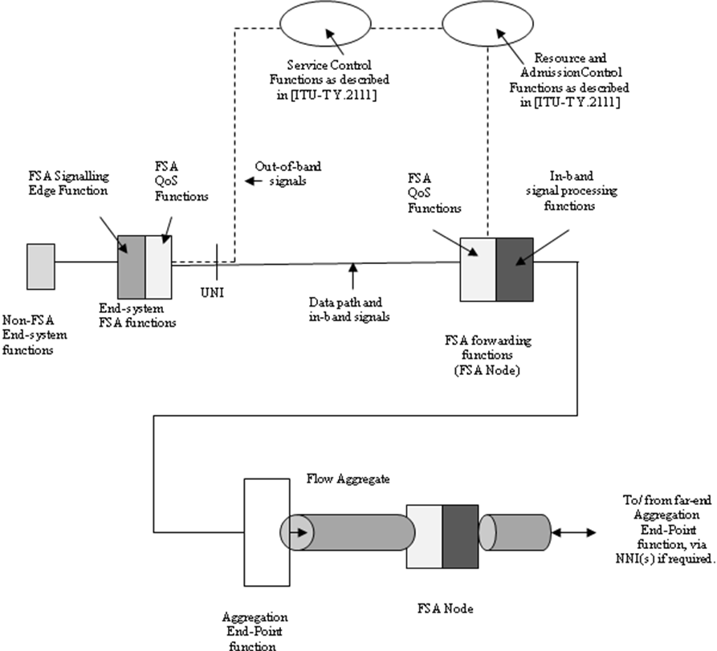
Figure 6-1 Overview of FSA functions
Two alternative methods of signalling are shown in Figure 6-1. One method uses in-band signalling exclusively, the other method uses out-of-band signalling for resource reservation and clear-down coupled with in-band signals to establish agreed flow state in each FSA node. Definitions of the terms “in-band signalling” and “out-of-band signalling” are included in Recommendation [ITU-T Y.2121] to describe the meaning of such terms when linked to the concept of a flow rather than pre-established channels designated for signalling or content transport. It is a Network Operator or Service Provider choice on what options are supported, but any FSA network shall be capable of at least passing every type of FSA in-band signal transparently to allow interoperation with networks that exclusively use such signals.

For the case of in-band signalling, the signalling messages are incorporated into the user data packets themselves, allowing the QoS requirements to be setup during the initial network traversal from sender to receiver (and back if needed). Each FSA node in the path examines the in-band signal and agrees to or adjusts parameter values it can support.
As specified in [ITU-T Y.2121] there are four general types of FSA transport service. The first is a fully guaranteed rate flow, which implies no oversubscription of network resources. The second is a maximum rate flow, which allows some oversubscription but very low delay. The third is a variable rate flow, where available rate is combined with a minimum rate guarantee. The fourth is an available rate flow, one that can be used to determine the highest rate the network can immediately support, eliminating slow-start problems.
The focus of this Recommendation is FSA signalling protocols in support of the QoS requirements of broadband and mobile service access control. The focus may be further sub-divided into three main cases, as shown in Figures 6-2, 6-3 and 6-4.

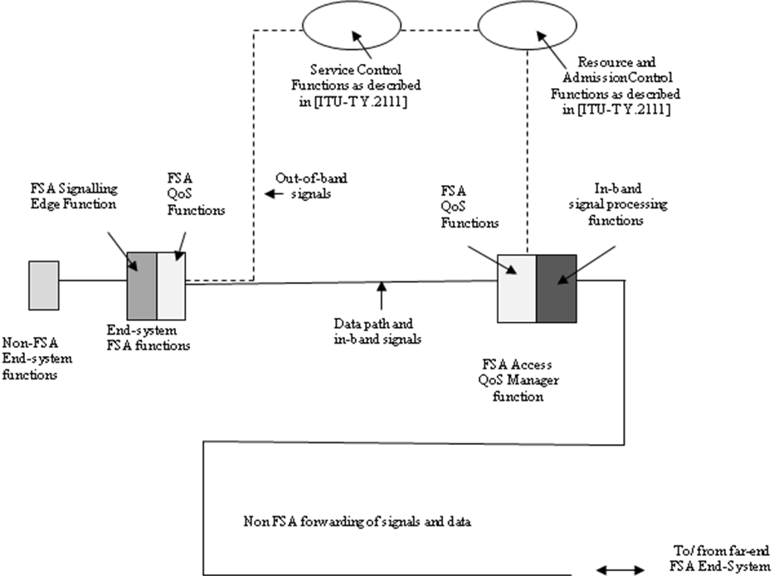

Figure 6-2 Case 1: Asymmetric access control with FSA-aware End-systems
Figure 6-2 shows Case 1 which assumes that End-systems have FSA functions to initiate signals as appropriate for each flow. The FSA Access QoS Manager is a network edge node that manages:
- the QoS of flows passing in either direction between itself and the FSA End-system.
- Optionally, the QoS down to the Non-FSA End-system functions, where the bandwidth limitations of this are known.

This Recommendation covers protocol aspects involving both near-end and far-end FSA End-systems as well as the FSA Access QoS Manager. For out-of-band signals, this Recommendation also includes Service Control and Resource Reservation functions as described in [ITU-T Y.2111].
The inclusion of far-end FSA End-systems is only related to their optimal management with respect to the limited access bandwidth. There is no inclusion of other FSA network nodes. This implies that there is an asymmetry wherein the far-end systems are not strongly constrained by access bandwidth and do not require a FSA Access QoS Manager. Case 1 is therefore a special derivative of Case 2, described next.

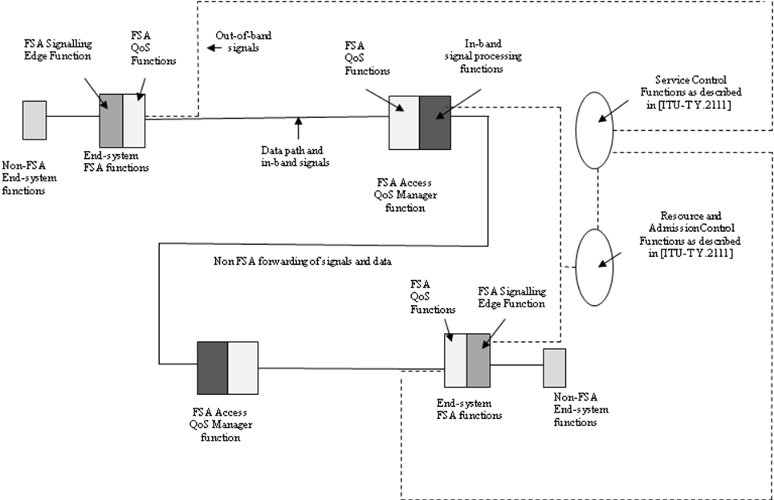

Figure 6-3 Case 2: Symmetric access control with FSA-aware End-systems
In Case 2, the communicating End-systems are each managed by a FSA Access QoS Manager. Furthermore, signalling enables each Access QoS Manager to inform flow state information to an upstream Access QoS Manager.
Note that there are no routing requirements to consider in any of the cases under consideration in this Recommendation. The upstream forwarding path towards any Access QoS Manager may be realised using any appropriate technology that supports the desired QoS.
The Access QoS Manager is limited in its functions for supporting QoS on the path between an upstream and a downstream Access QoS Manager. It may manage the aggregate traffic forwarded along this path so that it is limited to a given ceiling value, where this given value is provided by network management. A further option is addressed in this Recommendation that allows the signalling of aggregate traffic requests or modifications between Access QoS Managers. Such signals can be passed in-band through the addition of Aggregation End-Point functions in the FRA Access QoS Manager (see Figure1). The requirements relating to Aggregation End-Point functions are captured in [ITU-T Y.2121].

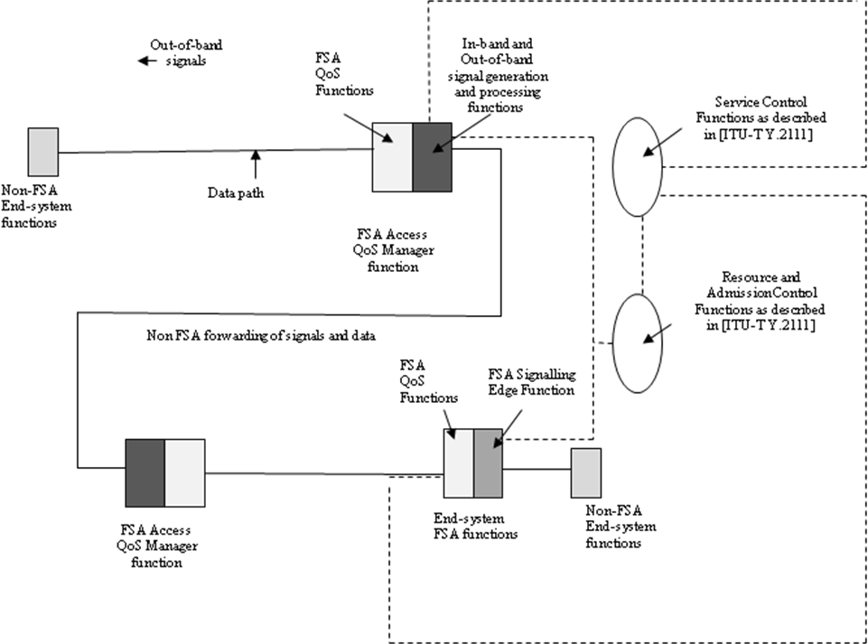

Figure 6-4 Case 3: Non FSA-aware End-system
In Case 3, the FSA Access QoS Manager provides “intelligence” functions to support non-FSA end systems. In this case, the FSA Access QoS manager will detect new flows and can apply policies relating to such new flows. These policies can be based partly on initial, or default QoS parameters that may be associated with a particular end user. Policies may also allow modification of flow state values based on, for example, measurement of flow rate.
No FSA signals are expected from, or are passed to, the end system. To manage upstream FSA end systems, in-band signals are inserted into the forwarding path towards the upstream source. Out-of-band signals may also be generated that may result in reservations being granted. This, in turn, may result in a change of status and in-band modification of flow state that takes account of granted resources.
Appendix I describes service scenario examples that may be associated with all three cases described above.

7. Protocol description
Clause 6 details the main models for access QoS management. In this clause we will first formulate the parameters that can be requested or modified relating to the QoS treatment of an individual flow or flow aggregate.

7.1 QoS parameters related to flow-based QoS management

7.1.1 Overview of the QoS Structure
The critical part of the in-band QoS Signalling Protocol consists a QoS Structure that represents a set of fields containing values and indications on the requested flow treatment or on network responses to this request.
The uses of the QoS Structure are as follows:
7.1.1.1 Travelling in the first packet, the QoS Structure is examined by each FSA node to determine if the QoS request can be supported. If it can be supported the packet proceeds to the next FSA node without change. If the FSA node cannot provide the rates or delay requested, it reduces the request in the QoS Structure to what it can support. It then forwards the packet.
7.1.1.2 The QoS Structure will be provided in the first packet. It should not be encrypted even when the remaining data information is encrypted. In this way the FSA Nodes can process flows quickly and efficiently with the correct QoS.

7.1.1.3 If any FSA node finds it cannot continue to accept the rates it has approved, it may selectively discard packets from that flow. This loss of packets is the indication that the receiver may use to create a response towards the source that includes a QoS Structure indicating a reduced new rate if appropriate.
Note that the FSA Edge QoS Manager will need to adjust the Available Rate of long duration flows as load builds up.

7.1.2 Overview of QoS Structure parameters for IPv4

The IPv4 Request/Response QoS Structure is 13 fields as follows:
- Source Address change: Set to 0 on original request. Set to the prior real source address to re-start a flow after a move or in a response (see clause 6.z).
- AR: Available Rate – floating point rate for network assigned rates.
- GR: Guaranteed Rate –floating point rate for requested guaranteed rate.
- PP: Preference Priority – indicates the override priority of the flow.
- DP: Delay Priority.
- CD: Change/Direction field – indicating an action type, such as request or response.
- TP: Type of FSA transport, such as available rate, or maximum rate.
- CH: Charging information. Forward charging (paid by sender), Reverse charging (paid by receiver).
- Second QoS structure attached: Indicates two QoS structures are included in the same packet, for example so that one relate to a response to a forward request and one relates to a separate request for QoS in the reverse direction.
- BT: Burst Tolerance – describing the tolerance to a flow that is permitted to exceed its rate before packets are discarded.
- QoS Version: QoS Structure Version Field – (initially set to 1)
- M: Modified marker. Set to 0 by sender on request. Set to 1 by FSA nodes if any field changed during a request or renegotiate. Set to 0 and not changed on Response.
- Source Port changed Set to 0 on original request set to the real source port when re-starting a flow after a move or in a response (see Annex A).

7.1.4 IPv4 and IPSEC
If IPSEC is used in IPv4, there is no way for the FSA nodes to recognize the flow since the ports and protocol are hidden. Thus with encrypted IPv4 flows using unmodified IPSEC, FSA QoS management cannot be used on individual flows. FSA QoS management can, however, be applied to a flow aggregate of flows where IPSEC is employed.
For FSA QoS management at the individual IPv4 flow level, a suitable form of encryption would be encryption of the data field only of any packet.

Note that, for IPv6 flows, FSA QoS management can operate with IPSEC as currently specified.

7.1.5 Overview of QoS Structure parameters for IPv6

The IPv6 QoS Request Option Field is 16 fields as follows:
- Next Header: Identifies the type of header immediately following this option
- Header Extension Length:
- Option Type: Option Type indicates the QoS code to be selected. It must start with ‘001’ since it is of type “skip if not recognized” and subject to “change each hop”. No options are currently assigned with the 001 header.
- Option Length:
- AR: Available Rate – floating point rate for network assigned rates.
- GR: Guaranteed Rate –floating point rate for requested guaranteed rate.
- PP: Preference Priority – indicates the override priority of the flow.
- DP: Delay Priority.
- CD: Change/Direction field – indicating an action type, such as request or response.
- TP: Type of FSA transport, such as available rate, or maximum rate.
- CH: Charging information. Forward charging (paid by sender), Reverse charging (paid by receiver).
- Second QoS structure attached: Indicates two QoS structures are included in the same packet, for example so that one relate to a response to a forward request and one relates to a separate request for QoS in the reverse direction.
- BT: Burst Tolerance – describing the tolerance to a flow that is permitted to exceed its rate before packets are discarded.
- QoS Version: QoS Structure Version Field – (initially set to 1)
- M: Modified marker. Set to 0 by sender on request. Set to 1 by FSA nodes if any field changed during a request or renegotiate. Set to 0 and not changed on Response.
- Reserved (16 bits) Set to 0

7.2 Message sequences related to FSA Transport service set up and clear down.

7.2.1 FSA Maximum Rate (MR), sender requests set-up.

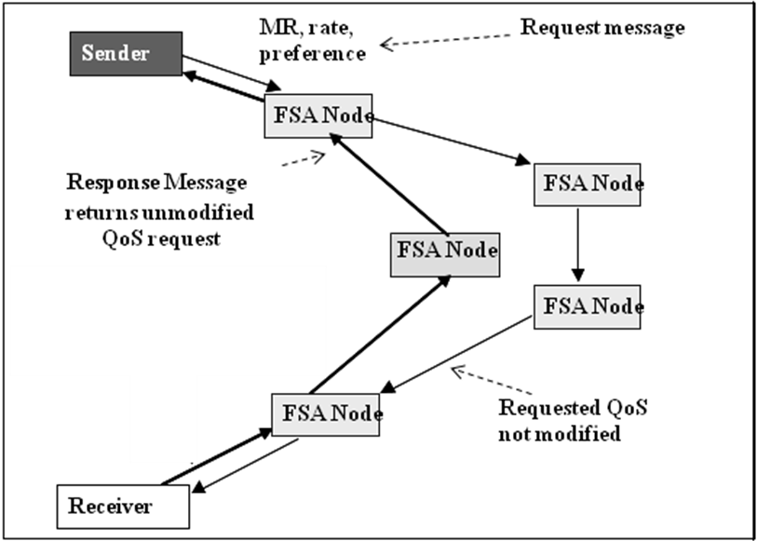
Figure 7-1 Maximum Rate message sequence

In Figure 7-1, the source (Sender) forwards to the Receiver a request packet with the requested QoS. This packet will be read by intermediate FSA nodes as well as the Receiver and includes the following QoS parameters:
- Requested FSA Transport Service = MR
- Requested Maximum Rate
- Requested preference priority

Once the sender has sent the first request packet, it may transmit data packets immediately. The purpose of the response packet is primarily a confirmation that the sending path and receiver are aware of, and have installed flow state on, the requested flow.
However, if the receiver or network chooses to reject the flow request, this is returned in the response packet and it may be assumed that data packets could be deleted where these have already been forwarded by the sender. Similarly, if no response packet is returned to the sender, as determined following the RESPONSETIMEOUT at the sender, then it may be assumed that an error has occurred and it is unknown if packets already forwarded are reaching the receiver.
If the sender wishes to change to a larger maximum rate for part of the flow, then it must send a new request. Otherwise some packets would be non-compliant when compared to the policed maximum rate. Having sent a new Maximum Rate request, the sender may immediately transmit at this new rate, but:
- The new request is likely to return the flow to the “vulnerable to discard state”
- If no response packet is returned or if a rejection is included in the response packet then it may be assumed that packet discards are likely for packets that would have been marked as non-compliant in relation to the initial maximum rate.

7.2.2. MR clear-down
Flow state times out and is deleted if data packets corresponding to that flow are not seen at an FSA node for a period equal or greater than STATETIMEOUT.

7.2.3 FSA Available Rate (AR), sender requests set-up.

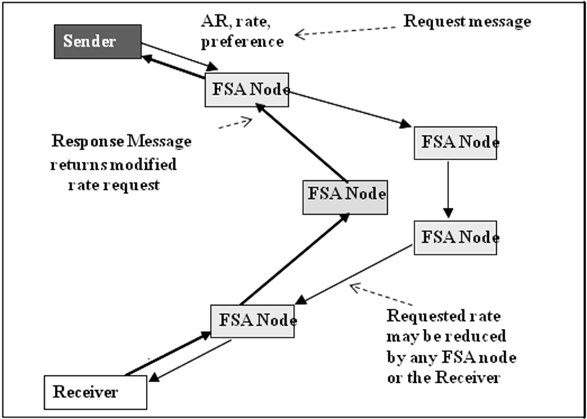
Figure 7-2 Available Rate message sequence

In Figure 7-2, the Sender forwards to the Receiver a sequence of request packet, repeated typically after every 128 data packets. Each request packet will be read by intermediate FSA nodes as well as the Receiver and includes the following QoS parameters:
- Requested FSA Transport Service = AR
- Requested Available Rate
- Requested preference priority
Following each request, the sender may maintain its previous rate until a response message is received and, thereafter must shape its forwarding to the new rate received in the response packet.
AR has no initial rate (unlike VR) and so the sender must wait for the first response packet before forwarding data packets.
If no response packet is returned to the sender, as determined following the RESPONSETIMEOUT at the sender, then it may be assumed that an error has occurred and the sender should not change its current available rate.

7.2.4 AR clear down.
Flow state times out and is deleted if data packets corresponding to that flow are not seen at an FSA node for a period equal or greater than STATETIMEOUT.

7.2.5 FSA Variable Rate (VR), sender requests set up.

7.2.5.1 Initial set up of minimum rate.
In Figure 7-3, the source (Sender) forwards to the Receiver a request packet with the requested QoS. This packet will be read by intermediate FSA nodes as well as the Receiver and includes the following QoS parameters:
- Requested FSA Transport Service = VR
- Requested Minimum Rate
- Requested preference priority

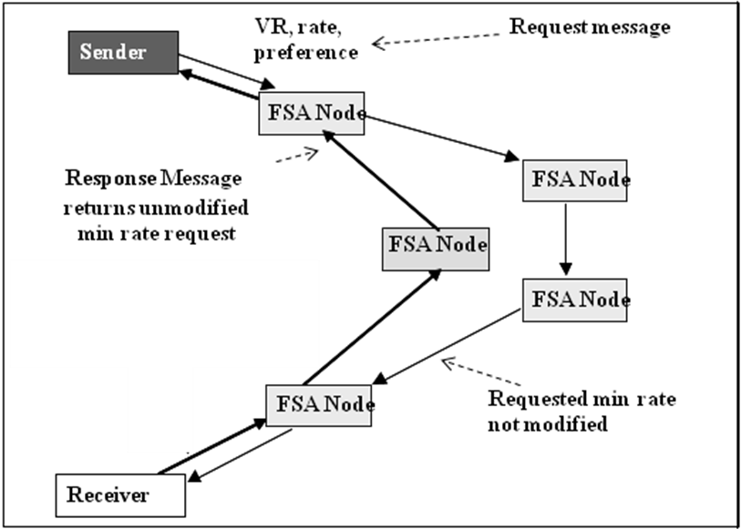
Figure 7-3 Variable Rate initial message sequence

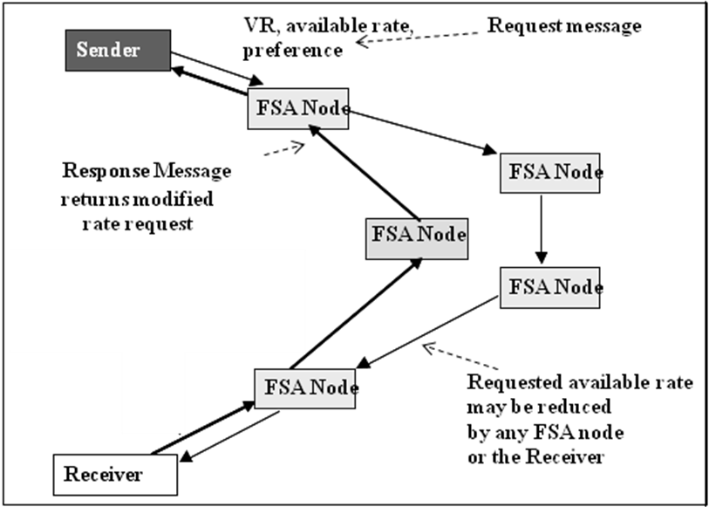

Figure 7-4 Variable Rate set up of additional available rate.
Because there is an initial minimum rate associated with VR, the Sender may transmit immediately at this rate without waiting for the response packet. As with MR, the request may be rejected and any packets already forwarded may be deleted.
If no response packet is returned to the sender, as determined following the RESPONSETIMEOUT at the sender, then it may be assumed that an error has occurred and it is unknown if packets already forwarded are reaching the receiver.

7.2.5.2 Set up of additional available rate.
As shown in Figure 7-4, prior to sending the first data packet, the Sender forwards towards the Receiver the first of a sequence of available rate requests which it typically repeats every 128 data packets. It may transmit at its initial minimum rate until it receives the first response packet to its available rate request. Then it may transmit at rate equal to the minimum rate + the available rate and may maintain this rate until it receives the next response packet.
If no response packet is returned to the sender, as determined following the RESPONSETIMEOUT at the sender, then it may be assumed that an error has occurred and the sender should not change its current available rate component.

7.2.6 VR clear down.
Flow state times out and is deleted if data packets corresponding to that flow are not seen at an FSA node for a period equal or greater than STATETIMEOUT.

7.2.7 FSA Guaranteed Rate (GR), sender requests set up.

7.2.7.1 Initial signalling exchange: Request and Response.
Figure 7-5 shows the initial message exchange, which is similar to MR but indicating a request for the FSA GR Transport Service in the Request message, which is also reflected in the Response message. The Sender is required to not transmit data until after it has sent a further “Confirm” message as shown in Figure 7-6.
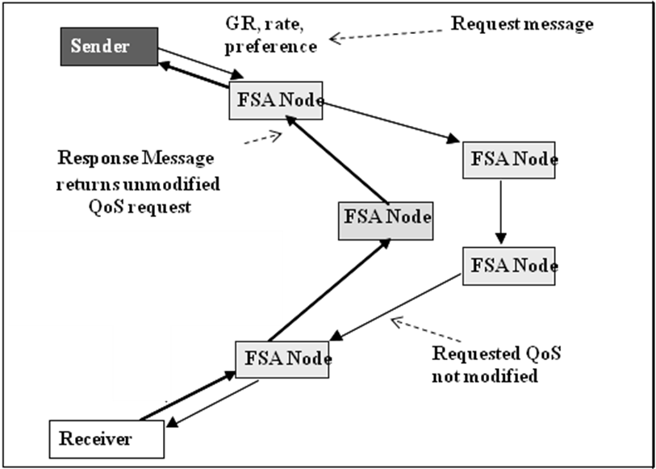
Figure 7-5: Guaranteed Rate- Initial message sequence

7.2.7.2 Set-up signalling exchange: Confirm
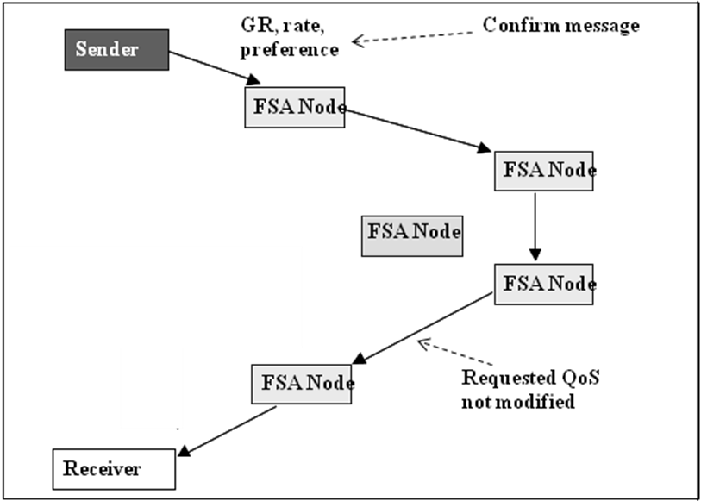
Figure 7-6 Guaranteed Rate- Confirm message

7.2.8 GR clear down.

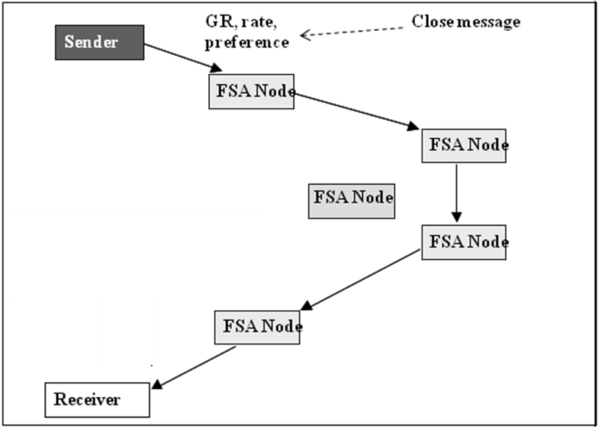
Figure 7-7 Guaranteed Rate- “Close” message
As shown in Figure 7-7 the termination of the flow requires the Sender to forward a “Close” message towards the Receiver which releases resources at each of the FSA-managed links, and clears the flow state.

7.3 Procedures and Format of FSA signalling packets.

7.3.1. IPv4 Signalling Procedures

7.3.1.1 Flow state initiation
For IPv4, a Signalling packet is sent from source to destination at the start of the flow. It contains the QoS Structure in the data section and must have the same source address, destination address, protocol, source port, and destination port as the remainder of the flow. This makes it part of the flow. The Diffserv code [IETF RFC 3260] will be set to “QoSSignal”. This tells the FSA nodes and FSA receiver that it is a signalling packet. It should not contain any additional data except the 16-byte QoS Structure(s).
If the flow is TCP, then the QoS Structure will appear in the TCP data section (see Figure 7-8). The Forward (sender to receiver) QoS Structure will typically be sent in the SYN packet. The FSA sub-layer inserts the Forward QoS Structure in the first packet of a flow and sets Diffserv to “QoSSignal” to indicate the presence of a QoS Structure, modified based on a QoS request from an application. The TCP sequence and acknowledgement numbers are not modified. The FSA capable nodes in the flow path can modify the QoS parameters as required, except CH (see clause 7.3.1.2). When the destination receives the Start Packet request in a SYN packet, it responds with a SYN/ACK packet with one or two QoS Structures. The first 16 byte QoS Structure is the Response to the forward path request and the second QoS Structure is the Reverse path QoS request (if required). Then the sender responds with an ACK packet as in the normal 3-way TCP handshake, including the QoS structure of the reverse path response. Thus the normal 3-way TCP handshake includes all the QoS requests and responses for both the forward and reverse paths without using any extra packets.
The QoS Structures are removed by the FSA sub-layer before the packets are passed to the IP stack.
Note that in the case of a SYN/ACK response the packet can have two QoS Structures, one for each direction.

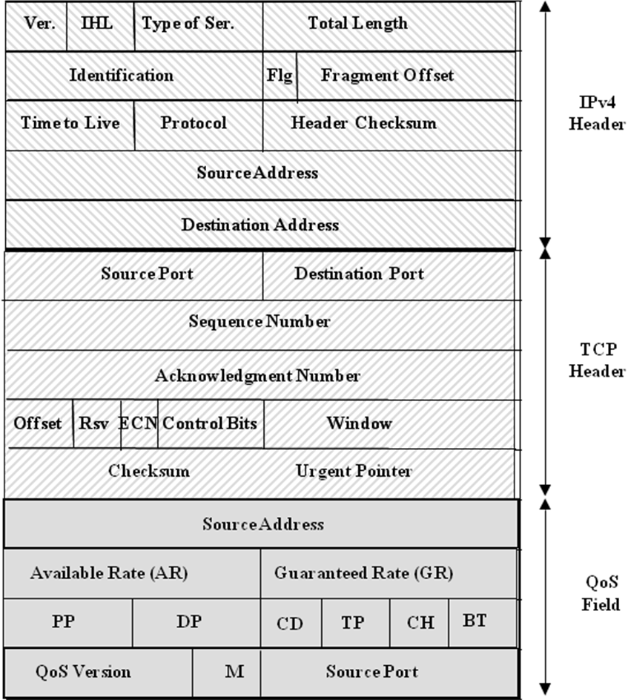

Figure 7-8: IPv4 TCP Request/Response Packet Format
Note also that there may be IP options before the TCP header and there may be TCP options before the QoS Structure.
If the flow is a UDP flow, then the QoS Structure will appear in the UDP data section (see Figure 7-9). The FSA sub-layer can simply insert a packet containing a QoS Structure at any point in a UDP flow. Again, these signalling packets can be removed from the flow by the FSA sub-layer at the receiver.

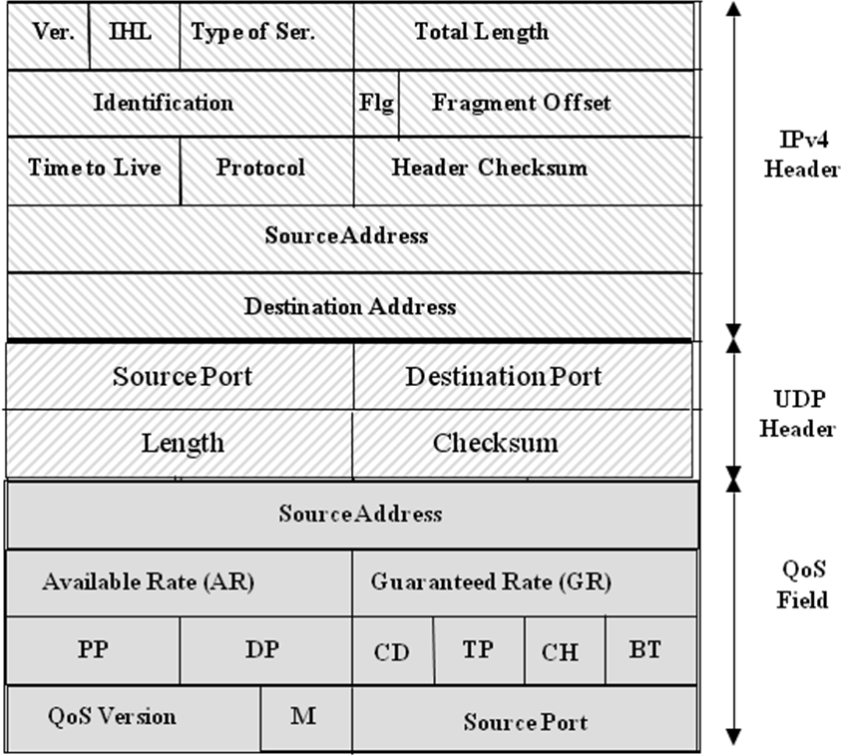
Figure 7-9 IPv4 UDP Request/Response Format

7.3.1.2 Renegotiation
Mid flow updates are accomplished either by
- FSA nodes (including the receiver), through sending a new response packet to the sender or
- By the sender, through a renegotiate signalling packet (see 7.3.1.7).

7.3.1.3 Format of IPv4 Request/ Response signals.

The IPv4 Request/Response QoS Structure is 16-bytes with 12 fields as follows:
- Source Address: (32 bits) Set to 0 on original request. Set to the prior real source address to re-start a flow after a move or in a response (see Annex A).
- AR: (16 bits) Available Rate – floating point rate for network assigned rates e.g. as used for TCP traffic. 15 lower bits used as described in Annex B.
- GR: (16 bits) Guaranteed Rate –floating point rate for requested guaranteed rate e.g. as used in ATM CBR. 15 lower bits used as described in Annex B.
- PP: (8 bits) Pre-emption Priority – indicates the override or pre-emption priority of the flow – 64 levels – 0=lowest, 63=highest in the high order 6 bits. The two low order bits are reserved.
- DP: (8 bits) Delay Priority in 64 levels. – 0=lowest priority, 63=highest priority. The highest level gets priority in transmission, reducing delay variation.
- CD: (4 bits) Change/Direction field – 0=Forward no action required, 1=Start of forward flow to negotiate the QoS parameters, 2=Reverse response returning agreed parameters to the sender, 3=Forward as a confirmation of the negotiated parameters, 4=Missed Start Packet notification inserted by a router in the forward path. 5=Sender request to renegotiate rates on the continuation of a flow once every 128 packets. 6=Resend Start Packet response from destination to sender after receiving #4. 7=Close for a Guaranteed Rate flow. No other values are specified at this time.
- TP: (4 bits) Bits 1 & 2: Type of flow – 0=Available Rate (TCP), 1=Composite Rate (like ATM VBR) where GR is requested and AR is assigned by the network, 2=Maximum Rate (Used where the rate has maximum but the flow should be near lossless), 3=Guaranteed Rate as specified in the GR field. Bit 3: FSA node encountered at first network node. Bit 4: FSA node encountered at final network node. No other values are specified at this time.
- CH: (4 bits) Bit 1: Charging information. – 0 = Forward charging (paid by sender), 1 = Reverse charging (paid by receiver). Bit 2: Second QoS Attached 0 = single QoS Structure, 1 = Second QoS Structure follows. No other values are specified at this time.
- BT: (4 bits) Burst Tolerance – the time (at approved rate) a flow is permitted to exceed its rate (GR+AR) before packets are discarded. Time=2^ (-BT-1) seconds (15 microseconds to 500 ms).
- QoS Version: (12 bits) QoS Protocol Version Field – (initially set to 1)
- M: (4 bits) Modified marker. Set to 0 by sender on request. Set to 1 by routers if any field changed during a request or renegotiate. Set to 0 and not changed on Response.
- Source Port (16 bits) Set to 0 on original request set to the real source port when re-starting a flow after a move or in a response (see Annex A).

7.3.1.4 FSA Receiver/ receiving FSA edge node procedures
In the TCP case where the signalling used the first TCP SYN to contain the QoS Structure, the response can be included in the TCP SYN-ACK packet. The destination address and source addresses, protocol, and ports need not be reproduced since they are already in the SYN/ACK response, but exchanged. This permits the sender to match up the response with the original flow and record the modified parameters. The other QoS parameters are as received in the signalling packet should be returned as received except that the receiver may reduce the rates if they exceed the maximum that the receiver can support. The format of the IPv4 response packet is the same as the request packet for TCP and UDP in IPv4 except that CD is set to 2. Also, the Source Address and Source Port fields should be filled in a response with the actual Source Address and Source Port received from the sender.

7.3.1.5 IPv4 Confirmation and Close Packets
If the request was Guaranteed Rate, when a response is received, the sender should set its rates, DP, BT and PP as specified to confirm the response. For TCP it would be a data packet with Diffserv set to “QoSSignal”. For UDP it would be a data packet with Diffserv set to “QoSSignal”. The contents of the QoS Structure would be the same as received in the response. The intent is to notify the routers along the forward path of the final agreed upon QoS parameters, so that all the routers can release their unused guarantees. The format of the packet is identical to the request packet except that CD is set to 3. When a Guaranteed Rate flow is closed, a close packet with CD=7 must be sent. The format is otherwise the same as the confirmation packet.

7.3.1.6 IPv4 Renegotiate Packet
The format of the IPv4 renegotiation packet is identical to the IPv4 request packet except for the CD field. CD is set to 5. All the QoS parameters received in the response are forwarded as received with no change except the available rate (AR) and CD. This allows the sender to request a change of rate or a FSA node (including the receiver) to indicate that a reduction in rate is required.

7.3.1.7 Signalling packets generated by FSA nodes
When a FSA node on the path determines that it cannot maintain the rates it has agreed to, it may generate a new response packet to the sender or modify a renegotiate packet with the rate changes. It may adjust the Available Rate downward anytime it needs to, due to new network conditions. It must not ever change DP, PP or the BT. It should not change GR except under major overload when trunks fail or higher pre-emption priority traffic pre-empts the current flow. In this case it may suggest a lower GR or reduce GR to zero and set AR to whatever value it can support.

7.3.2. IPv6 Signalling Procedures

7.3.2.1. Use of the hop-by-hop option to indicate the presence of signalling
IPv6 FSA signalling packets will only carry signalling information (i.e. a QoS Structure). All packets containing a QoS Structure should be marked with DiffServ=”QoSSignal” and the other packets in these flows may use normal DiffServ marks so that non-flow routers will treat them with the desired priority.

7.3.2.2 Signalling request and confirmation packet format
The request and confirmation format is in Figure 7-10.
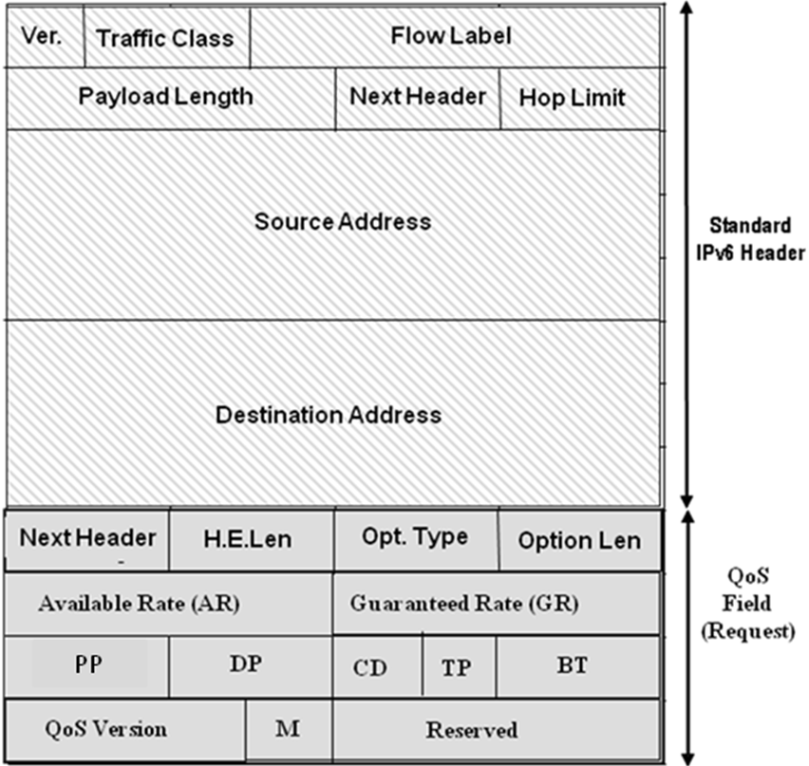
Figure 7-10 – IPv6 Request/ Confirmation Packet Format
The IPv6 QoS Request Option Field is 16-bytes with 15 fields as follows:
- Next Header: (8 bits) Identifies the type of header immediately following this option
- Header Extension Length: (8 bits) Header Extension Length is set to 1 to indicate that the QoS extension field since it is exactly 16 bytes long (8-bytes plus 1 additional 8-byte segment).
- Option Type: (8 bits) Option Type indicates the QoS code to be selected. It must start with ‘001’ since it of type “skip if not recognized” and subject to “change each hop”. No options are currently assigned with the 001 header. Thus, until such time that IANA formally assigns an option code, the default code for experimental use is selected as 00100000 or in decimal, 32.
- Option Length: (8 bits) Option Length is set to 12 (12 more bytes).
- AR: (16 bits) Available Rate – floating point rate for network assigned rates e.g. as used for TCP traffic. 15 lower bits used as described in 5.1.1.

- GR: (16 bits) Guaranteed Rate –floating point rate for requested guaranteed rate e.g. as used in ATM CBR. 15 lower bits used as described in 5.1.1.
- PP: (8 bits) Pre-emption Priority – indicates the override or pre-emption priority of the flow – 64 levels – 0=lowest, 63=highest in the high order 6 bits. The two low order bits are reserved.
- DP: (8 bits) Delay Priority in 64 levels. – 0=lowest priority, 63=highest priority. The highest level gets priority in transmission, reducing delay variation.
- CD: (4 bits) Change/Direction field – 0=Forward no action required, 1=Start of forward flow to negotiate the QoS parameters, 2=Reverse response returning agreed parameters to the sender, 3=Forward as a confirmation of the negotiated parameters, 4=Missed Start Packet notification inserted by a router in the forward path. 5=Sender request to renegotiate rates on the continuation of a flow once every 128 packets. 6=Resend Start Packet response from destination to sender after receiving #4. 7=Close for a Guaranteed Rate flow. No other values are specified at this time.
- TP: (4 bits) Bits 1 & 2: Type of flow – 0=Available Rate (TCP), 1=Composite Rate (like ATM VBR) where GR is requested and AR is assigned by the network, 2=Maximum Rate (Used where the rate has maximum but the flow should be near lossless), 3=Guaranteed Rate as specified in the GR field. Bit 3: FSA node encountered at first network node. Bit 4: FSA node encountered at final network node. No other values are specified at this time.
- CH: (4 bits) Bit 1: Charging information. – 0 = Forward charging (paid by sender), 1 = Reverse charging (paid by receiver). Bit 2: Second QoS Attached 0 = single QoS Structure, 1 = Second QoS Structure follows. No other values are specified at this time.
- BT: (4 bits) Burst Tolerance – the time (at approved rate) a flow is permitted to exceed its rate (GR+AR) before packets are discarded. Time=2^ (-Burst T-1) seconds (15 microseconds to 500 ms).
- QoS Version: (12 bits) QoS Protocol Version Field – (initially set to 1)
- M: (4 bits) Modified marker. Set to 0 by sender. Set to 1 if any field changed by a router.
- Reserved (16 bits) Set to 0
For Guaranteed Rate flows, the format of the IPv6 confirmation packet is identical to the IPv6 request packet except for the CD field. CD is set to 3. All the QoS parameters received in the response are forwarded as received with no change. This allows all the routers to drop excess capacity reservations. The close packet is also the same except CD=7

7.3.2.3 IPv6 Response Packet format
As with IPv4, the destination should respond to the QoS Request Packet with a response packet unless M=0, TP=2, and AR=0. In that case the sender and the routers all know the maximum rate. Otherwise, the agreed rates must be sent back to the sender in a response. The response and (when required) the confirmation are sent as QoS hop-by-hop Option Fields as in the request. This avoids encryption and lets the routers process them. The IPv6 QoS Structure Response is 16-bytes with 14 fields as shown in Figure 7-11

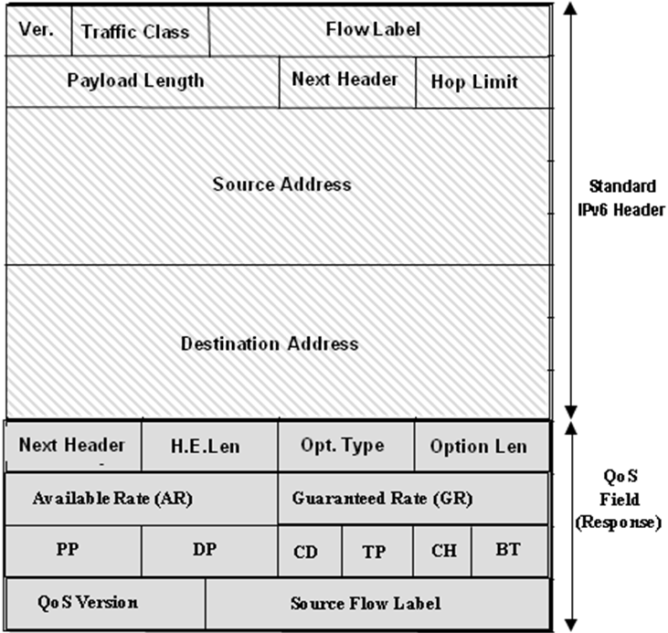
Figure 7-11: IPv6 QoS Response Packet Format

- Next Header: (8 bits) Identifies the type of header immediately following this option
- Header Extension Length: (8 bits) Header Extension Length is set to 1 to indicate that the QoS extension field since it is exactly 16 bytes long (8-bytes plus 1 additional 8-byte segment).
- Option Type: (8 bits) Option Type indicates the QoS code to be selected. It must start with ‘001’ since it of type “skip if not recognized” and subject to “change each hop”.
- Option Length: (8 bits) Option Length is set to 12 (12 more bytes).
- AR: (16 bits) Available Rate – floating point rate for network assigned rates e.g. as used for TCP traffic. 15 lower bits used.
- GR: (16 bits) Guaranteed Rate –floating point rate for requested guaranteed rate e.g. as used in ATM CBR. 15 lower bits used.
- PP: (8 bits) Pre-emption Priority – indicates the override or pre-emption priority of the flow – 64 levels – 0=lowest, 63=highest in the high order 6 bits. The two low order bits are reserved.
- DP: (8 bits) Delay Priority in 64 levels. – 0=lowest priority, 63=highest priority. The highest level gets priority in transmission, reducing delay variation.
- CD: (4 bits) Change/Direction field – 0=Forward no action required, 1=Start of forward flow to negotiate the QoS parameters, 2=Reverse response returning agreed parameters to the sender, 3=Forward as a confirmation of the negotiated parameters, 4=Missed Start Packet notification inserted by a router in the forward path. 5=Renegotiate rates on the continuation of a flow once every 128 packets. 6=Resend Start Packet response from destination to sender after receiving #4. 7=Close for a Guaranteed Rate flow. No other values are specified at this time.
- TP: (4 bits) Bits 1 & 2: Type of flow – 0=Available Rate (TCP), 1=Composite Rate (like ATM VBR) where GR is requested and AR is assigned by the network, 2=Maximum Rate (Used where the rate has maximum but the flow should be near lossless), 3=Guaranteed Rate as specified in the GR field. Bit 3: FSA node encountered at first network node. Bit 4: FSA node encountered at final network node. No other values are specified at this time.
- CH: (4 bits) Bit 1: Charging information. – 0 = Forward charging (paid by sender), 1 = Reverse charging (paid by receiver). Bit 2: Second QoS Attached 0 = single QoS Structure, 1 = Second QoS Structure follows. No other values are specified at this time.
- BT: (4 bits) Burst Tolerance – the time (at approved rate) a flow is permitted to exceed its rate (GR+AR) before packets are discarded. Time=2^ (-Burst T-1) seconds (15 microseconds to 500 ms).
- QoS Version: (12 bits) QoS Protocol Version Field – (initially set to 1)
- Source Flow Label: (20 bits) – Set to the Flow Label of the forward flow.

7.3.2.4 IPv6 Renegotiate Packet
The format of the IPv6 renegotiate packet is identical to the IPv6 request packet except for the CD field. CD is set to 5. All the QoS parameters received in the response are forwarded as received with no change except the available rate (AR) and CD. This allows the sender to request an increased rate or a FSA node (including the receiver) to reduce a rate.

8. Security Considerations and Requirements

8.1Authentication
Flow State Aware user authentication requirements are addressed in [ITU-T Y.2121]. FSA nodes within a domain may authenticate to peer FSA nodes within the domain. FSA nodes communicating as peers across a domain boundary should authenticate with each other.

8.2 Authorisation
Flow State Aware authorisation requirements are addressed in [ITU-T Y.2121].

8.3 Data Confidentiality
In the case where user flows with data confidentiality requirements also invoke the AR, MR, VR, or GR service, the parameters describing the in-band service request shall not be encrypted.

8.4 Data Integrity
Flow State Aware parameters may be protected against unauthorized modification while in transit. Flow State Aware parameter requests may be protected against replay attacks, in conjunction with data integrity protection binding a set of Flow State Aware parameters to a specific flow.

8.5 Accountability
It is recommended that Flow State Aware service invocations are logged, including the identity of the entity requesting the service, the actual service request, and actual service granted.

8.6 Availability/accessibility
Flow State Aware services shall respect the priority preference of each authenticated entity in making admission decisions.

8.7 Privacy
It is recommended that Flow State Aware services ensure the privacy of user specific policy profiles defining QoS parameter limits and privileges.

8.8 Protection against network attacks, from within or outside
It is recommended that Flow State Aware services include mechanisms to protect against malformed service invocations and to mitigate Denial of Service (DoS) attacks.
Annex A: Maintaining flow state for mobile sources
(This annex forms an integral part of this Recommendation)

A.1 Signalling mobile source addresses
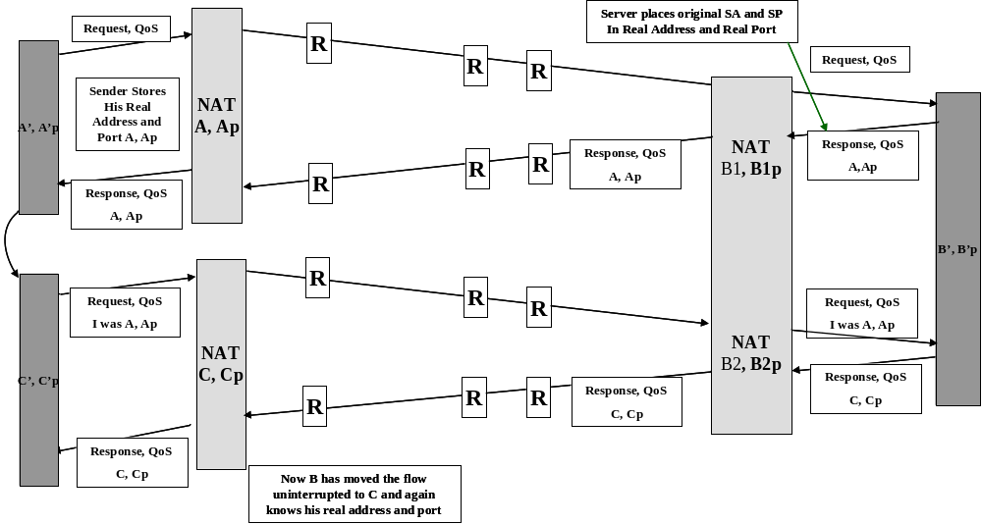
In order to support the source or destination moving while maintaining the flow, mobility of the flow is important. In IPv6, mobility has already been specified with appropriate security. However, for IPv4, the mobility can be supported by a simple addition to the protocol.
Figure A.1: Mobility Flow Chart
Editors note: This figure to be re-drawn to enlarge the text.
Typically each user is behind a NAT device. The NAT device changes its address and port from a real world IPv4 address to a local address and a new port. The technique needed is to record the real world IPv4 address and port at the destination and include the real address and port of the source in the response. The response packet has a place for the source address and port. Then the source can record the real address and port for use when the user moves. When the source moves such that the address changes, this triggers the source to make a new request to the destination for the QoS required. This transaction is shown in figure A.1. The first request was at A and the source (at the”A” end) learns this address and corresponding port (that the “B” end understands as components of the flow identity) from the response packet from B. When the new request is made from location C, it includes the original address and port (A, Ap) in the request. The FSA network nodes treat this as a new request, and assign the best QoS possible. The old flows are timed out. The destination at C recognizes the flow as the original flow because it is still to C, Cp and says its original address and port were A, Ap. This matches the original flow and the destination responds with the new real address C, Cp to make ready for the next move. The destination also matches it up with the old flow so no data is missed. Note that if mobility is desired in IPv4, the destination must send a response packet even if M=0 indicating no change. This is because the source will not know its real address when it moves without a response.
This process works both ways if both the source and the destination are creating one-way flows as is done in TCP. The exchange occurs on both flows and either end can move. This IPv4 mobility technique has no inherent security and the edge routers that authorize the move to the new address C should undertake whatever security checks are appropriate upon the move.
When an IPv4 host that supports this protocol moves, it must add a new Start Packet if it wants to continue a flow. It can recognize that it has moved if it keeps its own NAT address in its flow table. When the sub-layer sees a packet to be sent and the flow table has not been updated to reflect its current source address, it should first send a Start Packet with the new address plus the old address from its flow table and then update its flow table with its current source address. An IPv6 host always includes the QoS Structure in every packet, thus it only needs to ensure the flow label is the same. The addresses are updated by the normal IPv6 mobility process.
Annex B: Rules for encoding floating point rates
(This annex forms an integral part of this Recommendation)

B.1 AR and GR – Encoding Floating Point
AR and GR fields are encoded according to the following rules:
- The most significant bit of AR and GR is zero and reserved.
- The next bit is nz where nz=1 indicates if the number non-zero and nz=0 means the number is zero.
- The next 5 bits of AR and GR are the exponent E,
- The next 9 bits are the mantissa M.
- The rates AR or GR= (1+M/512)*2^E kilobits per second.
- All zero is interpreted as zero.
- Since E can be as large as 31 and M 511, the maximum rate is 4.291 Tbps. The lowest positive rate would be 1 kbps since 0 is zero.
- This is the same type of floating point number used in ATM except that in ATM its units are cells per second. Since there are no cells in IP, the units are kilobits per second. A benefit of using kilobits/sec as the units is that 64 kilobits per second is represented exactly, as are 2^n multiples of 64 kb.
- Rates are to be measured for TCP over the round trip time (RTT) if possible so as to determine the current TCP average rate. Since TCP sends a burst and then waits for the ACK the RTT can be deduced from the longest inter-packet gap. If the RTT cannot be determined and for UDP where there is no gap, the default rate measurement time is the value of a exponential decay filter with a half life of 500 ms (satellite RTT).
- The rate is measured using all the bytes in the IP packet. The rate on a given trunk would include in some cases the Ethernet or MPLS headers. This overhead must be accounted for at each interface so as to compute the trunk load correctly. However, the IP byte count is a usually constant so the user will know what is being asked for and supported. One exception is when fragmentation occurs and in this case those FSA nodes before the fragmentation will have set their rates based on the whole packet, the same as the sender. FSA nodes after fragmentation is done may see increased traffic due to the fragmentation and thus lower the rate. The lower rate will be enforced. A second case exists if the sender uses header compression. If so, it is the compressed packet size that determines the rate since this is the trunk load incurred across the network. Another case is when header compression is used mid-path to reduce the load on a particular link. Here, the rate marked in the QoS Structure should be computed based on the uncompressed header, but the link rate required may be less. Since the average packet size is important to compute the ratio, the first estimate should be based on a best guess assuming large packets, and as the flow proceeds if the packet size is smaller, the extra link capacity can be assigned to other flows.

Appendix I: Access control scenarios
(This appendix does not form an integral part of this Recommendation)

I.1 Introduction
Much of the anticipated use of FSA will be in what may be termed “access control” scenarios. Typically this will involve the management of limited access bandwidth, where “access” provides a forwarding pathway between an end-system and a service edge point.
Three examples of this are considered in this clause, namely:
- Broadband service access with FSA management of premium content delivery
- Wifi/ WiMAX service access with FSA management of premium content delivery
- Replacing some Deep Packet Inspection with end-application control of “important” flows within the limited access bandwidth.
Again, the purpose here is to reinforce the conclusion of this contribution that FSA signalling protocol standardisation is both appropriate and highly relevant to anticipated services.

I.2 Broadband Service Access with FSA management of premium content delivery

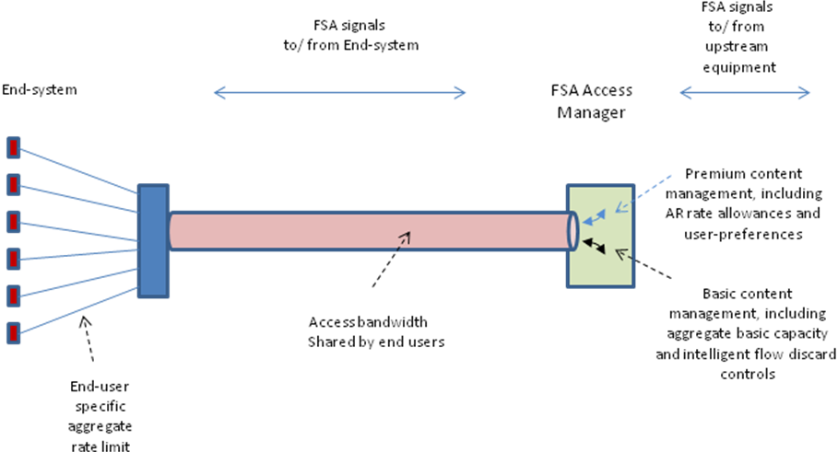

Figure I-1: Broadband Access with FSA-based management of premium content
Editor’s note: remove colours from this figure

Figure I-1 shows the main features of the flow state control of different flows passing downstream to end-systems. The flow state is set up by corresponding signalling from either the end-system or the upstream equipment (e.g. content source equipment).

Two cases of shared access bandwidth are:
- Access bandwidth is dedicated to a single service provider
- Access bandwidth is shared among several service providers

In the latter case the FSA Access Manager may allow a part of the capacity to be “borrowed” when it is available and when one or more service providers are supplying only light traffic levels. Such flows, admitted only because of the availability of “borrowed” capacity, may be designated with a lower preference priority, provided the consequences of this on service experience is agreed to by all providers. Different arrangements may be offered that determine how much of the shared capacity can be “borrowed” and how much (if any) is effectively dedicated to each service provider within the total capacity.

Of course, forwarding according to the preference priority is only one aspect of flow-based management performed by the FSA Access Manager. It manages:
- Available rates, facilitating the faster total delivery time of content
- Maximum rates, facilitating immediate transmissions and sudden requirements for a change of rate whilst supporting very low delay and low/ medium packet loss (very low packet loss being usual for higher preference priority values).
- Preference management, enabling the end-user or the Service Provider to select the flows that are most important.
- Flow-based measurements.

Using such controls, via standardised signalling protocols and procedures, Service Providers may upgrade existing access configurations to begin to offer a range of premium content services.

Shared access bandwidth, involving multiple service providers requires that flow state management can be performed even when there is re-use of IPv4 address space. In other words, when an IP address is not unique except within an associated VLAN or other layer 2 arrangement. The FSA Access Manager must be capable of associating a flow, either by adding a temporary additional header label, or by other means, with a given VLAN.

I.3 Wifi/ WiMAX Service Access with FSA management of premium content delivery

In Figure I-2 the principles are similar, but flow management of downstream content is aimed at delivering appropriate QoS treatment for premium content delivery to mobile end-systems. Signals controlling the flow state management may be generated by the mobile end-systems. Another alternative (that also applies to the case described in clause I.2) is that signals are generated by edge systems that manage the FSA controller, possibly using pre-set values based on the choices of access that are offered by the Service Provider.

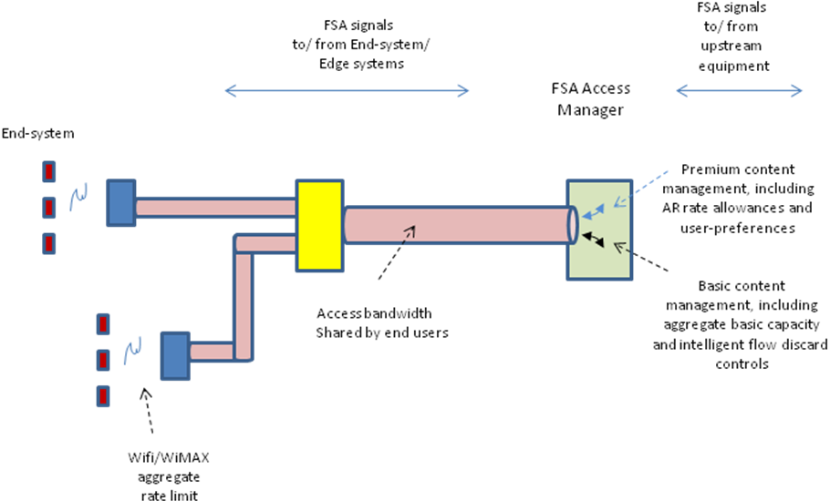

Figure I-2: Mobile access with premium content management

Editor’s note: remove colours from this figure

I.4 User management of important flows
In this scenario, the end-system signals the relative importance of a flow towards the FSA controller. “Importance” can mean the preference priority of a flow as signalled by an end-system. Preference priority then acts to protect some flows at the expense of others during congestion. For example, a user may wish to protect a voice service from a selected service provider (rather than accepting that the network or broadband service provider is in charge of such settings). A possible scenario is that some applications run with user pre-set values which are signalled whenever that application runs.
For example, in Figure I-1, an end-system may run an application (e.g. a voice call) that generates a flow preference priority along the downstream and/ or upstream access pathways. These signalled “user-preferences” (shown in Figs I-1 and I-2) are then stored as flow state and used by the FSA controller to manage QoS.

Appendix II: Flow State Aware QoS management when the end-systems are not Flow State Aware

(This appendix does not form an integral part of this Recommendation)

II.1 Options for indicating flow treatment
This Appendix describes services that can be introduced through the use of a FSA edge QoS manager to support broadband services when the end-systems are not capable of in-band FSA signalling. There are a number of alternative options (not mutually exclusive) for ensuring flows are given the correct treatment. Four of these options are listed below.
- Option 1: Diffserv marking to indicate flow treatment. Flows can be mapped to
  - The MR FSA service class without prior reservation, but subject to policing at a pre-agreed rate that may be customer-specific.
  - The AR FSA service class for “elastic” applications where there is no pre-agreed policing rate. The AR FSA service class may subsequently change the policing rate based on the number of active flows and their use of bandwidth.
- Option 2: QoS information inferred from upstream VLAN identities. This option may be combined with Option 1 to provide further information on flow treatment, such as Preference. For example, a network provider may offer a service provider a high preference VLAN for (some of) its content. This VLAN will usually have an aggregate rate restriction, but will offer a mapping to MR or AR high preference flow treatment.
- Option 3: QoS information inferred from packet inspection or rate measurement. It would be typical that:
  - During the measurement interval, flow treatment is initially mapped in a pre-defined way, using the AR or VR service class and the best current available rate (in the case of VR this would be on top of a pre-defined minimum available rate).
  - Measurements are used to refine the flow treatment required allowing it to move, for example, from elastic flow treatment to non-elastic flow treatment (AR to MR)
- Option 4: Out-of-band signalling to reserve bandwidth. In this case, flows can be mapped to the GR FSA service class for appropriate flow treatment. It could be used in conjunction with Diffserv to separate flows requiring GR treatment from other flows.

These options are depicted in Figures II-1 to II-4.

In these figures, the FSA edge QoS managers are assumed to be capable of in-band signalling to co-ordinate their controls to manage flow-based QoS taking account of:

- The bandwidth capacity available to the aggregate traffic in the path ‘A to B’. This is between the upstream and downstream FSA edge QoS managers.
- The access bandwidth along path ‘B to C’. This is between the end-user’s local FSA adge QoS manager and the DSLAM.
- The bandwidth capacity available to the aggregate end-user traffic forwarded over the DSL link ‘C to D’.
- The capacity towards the service provider, for the aggregate traffic generated by End-systems forwarded from the FSA Edge QoS Manager at ‘A’.

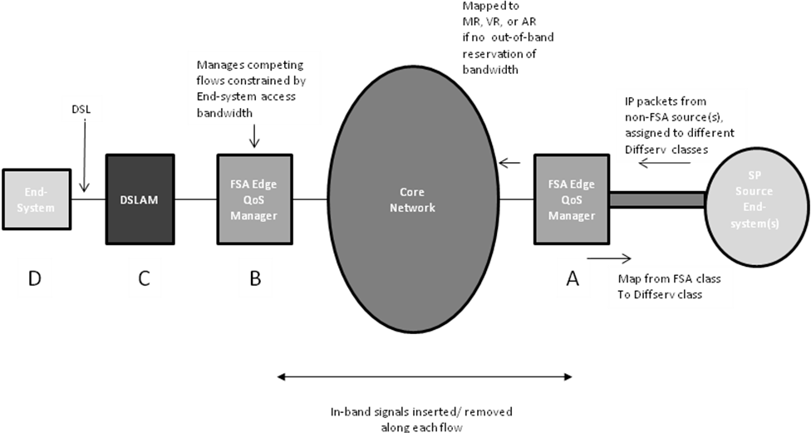

Figure II-1: Flow treatment inferred from Diffserv class
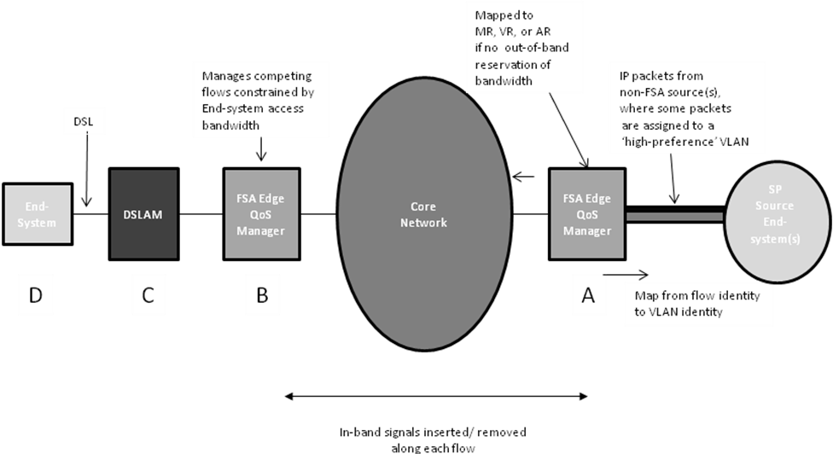

Figure II-2: Flow treatment inferred from VLAN identity

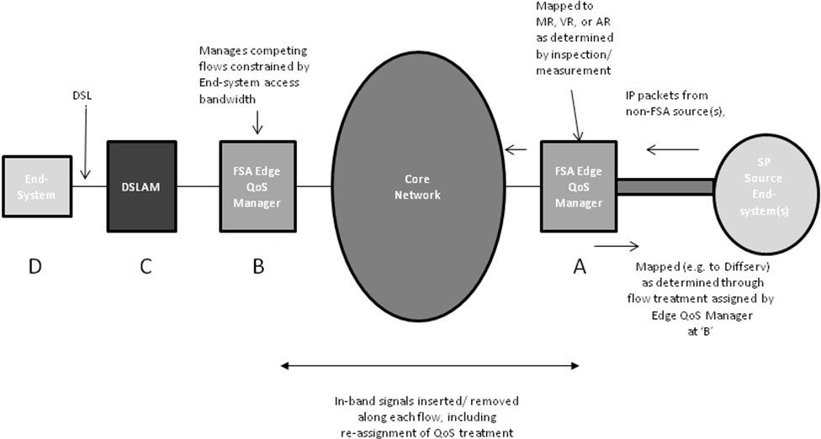

Figure II-3: Flow treatment inferred from measurement/ packet inspection

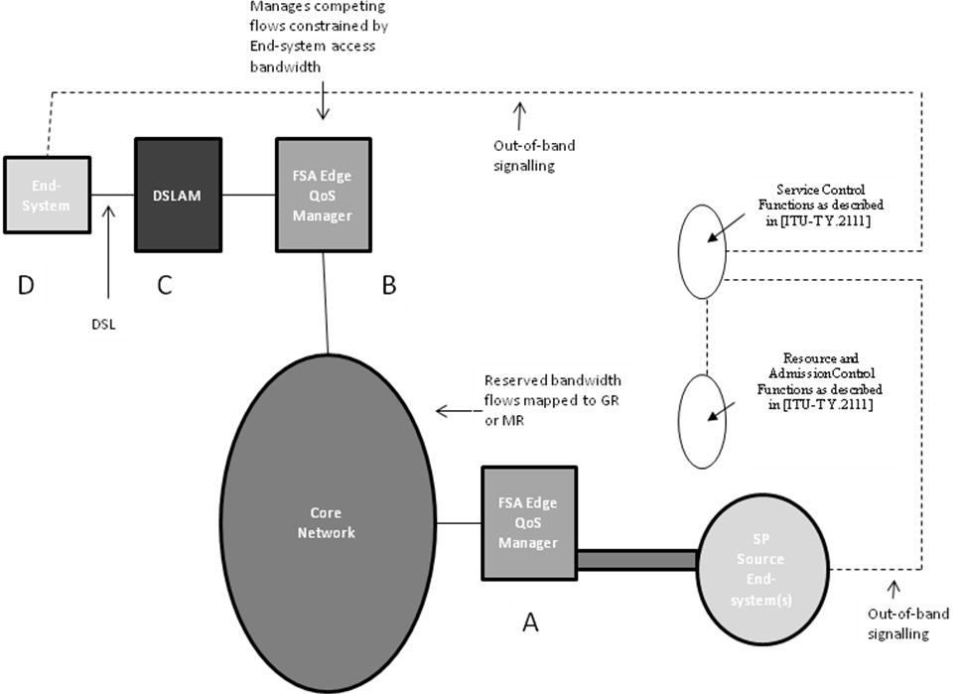

Figure II-4 Flow treatment supported by out-of-band signalling

II.2 Service options
Several service options were described in Appendix I. Some detail is added here, relating to FSA service provision for these options when the End-systems are not capable of FSA in-band signalling.

II.2.1 Broadband Service Access with FSA management of premium content delivery

See also Appendix I, clause I.2. Figure II-5 illustrates how this service can be offered. In this example, the network provider is offering ‘Option 2’ service VLANs, and makes use of Diffserv classes to indicate the correct treatment of flows. It may be noted that the whole solution could be realised using Ethernet with FSA-based QoS control, including the pathway across the core network.

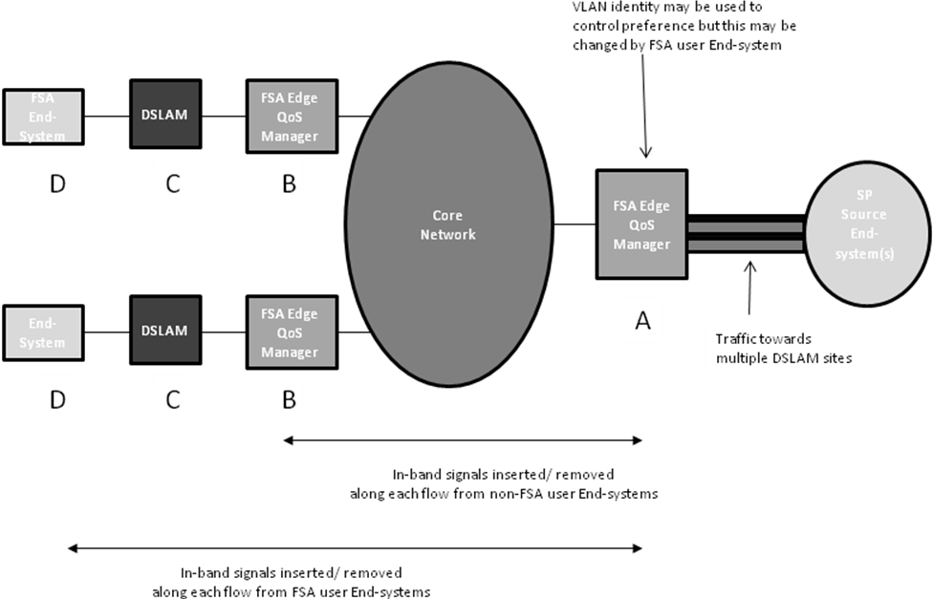
Figure II-5 Broadband FSA-based QoS with no FSA-aware end-systems

II.2.2 User management of important flows

See also Appendix I, clause I.4. In this scenario, some End-systems are capable of FSA in-band signalling, so the scenario may be regarded as a migration from the assumptions of clause II.2.1 above. The FSA Edge QoS Managers ‘B’ and ‘A’ are being updated by in-band signals from End-systems ‘D’. These signals allow the End-system to directly set the preference level on any received flow, or any flow towards the SP.
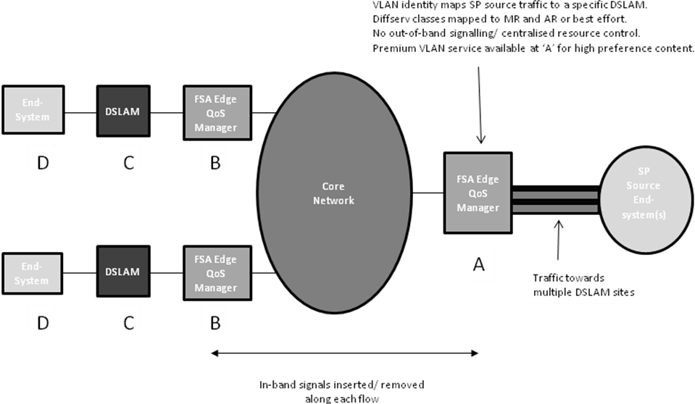

Figure II-6: Dynamic User-selected Preference control

II.3 QoS Mappings between FSA transport services and Diffserv
Clause II.1 ‘Option 1’ describes mappings between Diffserv classes and FSA transport services, especially the Maximum Rate (MR) FSA service and the Available Rate (AR) FSA service. However, flow treatment is not always identical in when a flow is mapped from a Diffserv class into a FSA transport class and vice versa.
It may be noted that the Diffserv Architecture uses the term "Service Level Agreement" (SLA) to describe the "service contract that specifies the forwarding service a customer should receive". There is not always an exact correspondence between SLA’s that can be specified for FSA transport classes and SLA’s that can be achieved by Diffserv service classes.
According to [IETF RFC 4594] there are three fundamental forwarding behaviours that have been defined and characterized for Diffserv. These are basic Default Forwarding (DF) behaviour for elastic traffic, the Assured Forwarding (AF) behaviour, and the Expedited Forwarding (EF) behaviour for real-time (inelastic) traffic.
The following characteristics can be associated with these forwarding behaviours:
- Default Forwarding per-hop behaviour is for the best-effort service. It is typically configured with some minimum aggregate bandwidth guarantee. Packets in transit may be lost, reordered, duplicated, or delayed at random. Generally, networks are engineered to limit this behaviour, but changing traffic loads can push any network into such a state. For FSA transport, such traffic can be mapped to an aggregate FSA transport class. For example the AR aggregate class. In this case, the bandwidth assigned to an aggregate flow at A towards a particular DSLAM B would depend not only on the total traffic at A but also on the constraints along the BC path as signalled by the FSA QoS Manager at B. Therefore best effort traffic treatment becomes associated with edge-to-edge constraints rather than purely per-hop constraints.
- Assured Forwarding per-hop behaviour [IETF RFC 2597] is intended for networks that offer average-rate Service Level Agreements. This is an enhanced best-effort service. It s proposed that an appropriate mapping of this to an FSA transport class, preserving the SLA, is the VR aggregate class or the VR per-flow class. This associates a minimum capacity to the aggregate flow or to an individual flow from point A to any DSLAM B, but improves upon this minimum with an available capacity “top up” if spare capacity would be otherwise unused.
- Expedited Forwarding per-hop behaviour [IETF RFC 3246] is for low-loss, low-delay, and low-jitter services. Traffic remains subject to loss due to line errors and reordering during routing changes. However, using queuing techniques, the probability of delay or variation in delay is minimized. For this reason, it is generally used to carry real-time content. The mapping to FSA transport classes could be achieved as follows:
  - For real-time content with very low loss and very low delay tolerance, (e.g. as appropriate to the telephony Diffserv service class) the per-flow GR FSA transport service class should be used
  - For real-time content that has low delay tolerance and low-to-medium loss tolerance, and may be rate adaptive under the conditions of higher losses (as appropriate to the Diffserv Multimedia Conferencing service class), the per-flow MR FSA transport service could be used.

Table II.1 below lists the unique features of FSA QoS treatment.

FSA Transport Class | Unique QoS treatment features
Guaranteed Rate (GR) | No unique features. Flow treatment comparable to the Diffserv telephony service class
Maximum Rate (MR) | Does not require out-of-band signalling for bandwidth reservation. Selected flows (usually the latest flows to start) are subject to focused discards in the event of congestion. All other flows achieve very low losses and all flows achieve very low delay.
Available Rate (AR) | Uses edge-to-edge signalling to determine the highest available rate. No minimum guarantee per flow.
Variable Rate (VR) | As with AR, but including MR treatment of the minimum guarantee.

Table II.1 Unique features of FSA QoS treatments

Appendix III: Flow State Aware QoS management allowing for multicast

(This appendix does not form an integral part of this Recommendation)

III.1 Multicast IPTV traffic
Figure III-1 shows a typical arrangement where IPTV channels are replicated at a DSLAM and passed to a number of end-systems along the DSL paths AB. This arrangement minimises the traffic load on the backhaul path BC.
It may be noted that, at the point C, any stand-alone monitoring of flows cannot determine which IPTV channels, if any, are copied along paths AB. Of course, this information can be determined at B, if all of the replicated flows are first passed through a FSA function before being forwarded along the DSL links AB. Another possibility is for the point A (i.e. an FSA function located in the end-system) to be used in some way to manage the QoS.

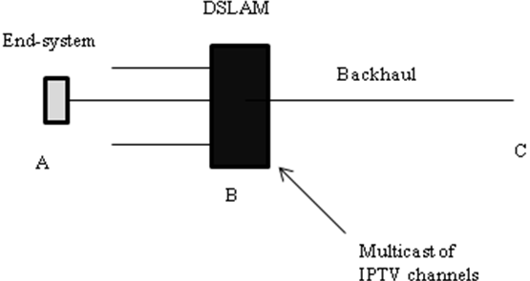
Figure III-1: Multicast of flows limits view of traffic loads along paths AB
One method of managing QoS that takes account of IPTV multicast, and exploits signalling, is as follows. Figure III-2 shows the main concept.
For the purposes of describing this clearly, the term ‘Edge discovery and feedback function’ (EDF) is introduced. It could be associated with either point A or point B in Figure III.1. In practice, any FSA function introduced at either A or B could include flow-based packet discard, but another approach is described here. This approach may offer a lower migration cost for introducing FSA QoS management in the presence of multicast.
As its name implies, the EDF provides feedback on flows that start up that are not associated with FSA signals arriving from point C of Figure III-1. Such flows may either be inspected or simply flagged towards C as new flows being passed along path AB. A new flow would be one where there is no existing flow state record.
Signalling is used to provide an update to the flow state kept at point C relating to any particular DSL path AB. This update can include (per flow):
- Measured rate information from the EDF
- The flow identity.
The new flow could be provisionally classed as a GR very high preference flow at the EDF and given either a static pre-assigned rate value or a measured rate value. The signal sent upstream towards C could represent the normal FSA response to a requested high preference GR flow when flow rejection is not appropriate.
An FSA function at point C updates it’s flow state records relating to each path AB for which an EDF exists. On paths AB without an EDF, the FSA QoS controls may not be offered or may be offered using an alternative approach. For example, using a ‘hard partition’ of the bandwidth that is always available to FSA controlled flows.
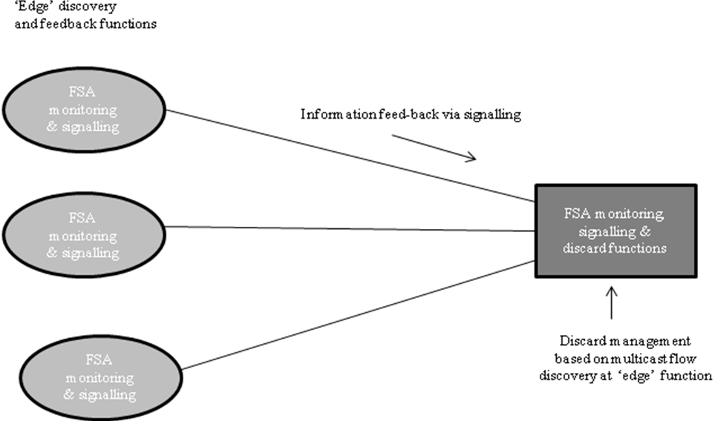

Figure III-2: Co-operating functions to aid discard management upstream of the DSLAMs

Based on the feedback received from EDFs, the FSA function at C makes appropriate packet discard decisions on other flows being passed towards AB.
Note that the QoS experience of flows passing via C towards AB is the same as for any scenario where a high preference flow is added, except in one respect. There will be a longer reaction time before appropriate discard management can be applied at C, during which time, the DSLAM will be the point of packet discard and (if it is not an FSA device) discards may be applied randomly until C has received the feedback. For this reason, the point C should be close to the DSLAMs to minimise this reaction time.

Appendix IV: A comparison of RSVP and FSA to determine how simple it would be to make FSA signalling appear as an extension of RSVP
(This appendix does not form an integral part of this Recommendation)

IV.1 A comparison of the two QoS architectures.

RSVP | FSA
RSVP provides receiver-initiated setup of resource reservations for multicast or unicast data flows | FSA provides sender- intiated setup of state values associated with the QoS treatment of unicast flows. This achieves the rapid response of FSA-managed network links directed towards “on-demand” service support for senders. There is an assumption that, prior to FSA sender-initiated setup requests, there may be an out-of-band receiver-initiated request for service that triggers the sender to respond.
RSVP operates on top of IPv4 or IPv6, occupying the place of a transport protocol in the protocol stack. However, RSVP does not transport application data. | FSA signalling operates on top of IPv4 or IPv6, occupying the place of a transport protocol in the protocol stack. However, FSA signalling does not transport application data.
Like the implementations of routing and management protocols, an implementation of RSVP will typically execute in the background, not in the data forwarding path, | FSA signalling is designed to execute and manage flow state values in the data forwarding path.
RSVP is not itself a routing protocol. Routing protocols determine where packets get forwarded; RSVP is only concerned with the QoS of those packets that are forwarded in accordance with routing. | FSA signalling is not itself a routing protocol. Routing protocols determine where packets get forwarded; FSA signalling is only concerned with the QoS of those packets that are forwarded in accordance with routing.  However, it may be noted that FSA provides the support for the avoidance of route flapping through the use of flow state. Flow state includes next hop that can be applied to all packets of a flow after the first.
During reservation setup, an RSVP QoS request is passed to two local decision modules, "admission control" and "policy control". Admission control determines whether the node has sufficient  available resources to supply the requested QoS. Policy control determines whether the user has administrative permission to make the reservation. If both checks succeed, parameters are set in the packet classifier and in the link layer interface (e.g., in the  packet scheduler) to obtain the desired QoS. If either check fails, the RSVP program returns an error notification to the application process that originated the request. | FSA signalling includes a token that indicates administrative permission to make the reservation. Failure to include a valid token may not necessarily terminate the forwarding of the flow but is likely to, at least, downgrade the QoS support applied to that flow and to cause changes in signalled values of the QoS request as would be read by downstream FSA-managed links.
RSVP is simplex, i.e., it makes reservations for unidirectional data flows | FSA signalling is simplex, i.e., it makes reservations for unidirectional data flows
RSVP establishes "soft" state; that is, RSVP sends periodic refresh messages to maintain the state along the reserved path(s). In the absence of refresh messages, the state automatically times out and is deleted. | FSA signalling establishes "soft" state; but, being an in-band process does not require periodic signalling refresh messages to maintain the state along the reserved path(s). Instead it is the absence of data packets that causes the state to automatically time out and be deleted.
According to RFC 2205, an RSVP session is defined by the triple: (DestAddress, ProtocolId [, DstPort]).  Here DestAddress is the IP destination address of the  data packets. ProtocolId is the IP protocol ID. The optional DstPort parameter is a "generalized destination port", i.e., some further demultiplexing point in the transport or application protocol layer. DstPort could be defined by a UDP/TCP destination port field, by an equivalent field in another transport protocol, or by some application-specific information.  However it is noted in RFC 2205 that an RSVP reservation request consists of a "flowspec" together with a "filter spec" and that the filter specs may select arbitrary subsets of the packets in a given session. Such subsets might be defined in terms of senders (i.e., sender IP address and generalized source port), in  terms of a higher-level protocol, or generally in terms of any fields in any protocol headers in the packet. For example, filter specs might be used to select different sub flows of a hierarchically-encoded video stream by selecting on fields. | FSA sessions include RSVP parameters and additional parameters. These additional parameters are the source IP address and source port number. Whilst RSVP extends to the inclusion of source parameters in its filter spec, the use of the filter spec is to manage the packet classifier, not the scheduler.
RSVP supports an enhancement to one-pass service known as "One Pass With Advertising" (OPWA) [OPWA95]. With OPWA, RSVP control packets are sent downstream, following the data paths, to gather information that may be used to predict the end-to-end QoS. The results ("advertisements") are delivered by RSVP to the receiver hosts and perhaps to the receiver applications. The advertisements may then be used by the receiver to construct, or to dynamically adjust, an appropriate reservation request. | FSA signalling packets are sent downstream following the path of the data packets and downstream FSA-managed links may reduce the QoS that will be applied to the flow. The receiving end forwards the QoS request (modified or not) back to the source.
Each receiver host sends RSVP reservation request (Resv) messages upstream towards the senders. These messages must follow exactly the reverse of the path(s) the data packets will use, upstream to all the sender hosts included in the sender selection. They  create and maintain "reservation state" in each node along the path(s). | It is not required that upstream FSA signalling packets follow the same route as the downstream packets. In practice this is a simplification compared to RSVP.
Each RSVP sender host transmits RSVP "Path" messages downstream along the uni-/multicast routes provided by the routing protocol(s), following the paths of the data. These Path messages store "path state" in each node along the way. This path state includes at least the unicast IP address of the previous hop node, which is used to route the Resv messages hop-by-hop in the reverse direction. | The RSVP Path message has similarities to the FSA downstream signal, which is also designed to store state in each node controlling a FSA-managed link. There is no need for the inclusion of previous hop node address information.
A Path message is required to carry a Sender Template, which describes the format of data packets that the sender will originate. This template is in the form of a filter spec that could be used to select this sender's packets from others in the same session on the same link.  A Sender Template may specify only the sender IP address and optionally the UDP/TCP sender port, and it assumes the protocol Id specified for the session. | The equivalent FSA message specifies more parameters defining the session (see above).

Table IV.1 Comparisons of RSVP and FSA signalling principles

IV.2 Ability to merge FSA as a new extension of RSVP
Table IV.1 shows major differences that do not make FSA easy to be added as a simple extension of RSVP. In particular:
- FSA is sender-initiated, not receiver-initiated
- FSA reservation requests are in-band (following the path of data packets) as opposed to RSVP where they execute “in background”, ie not in the forwarding path. For equipment to track the signal and then the flow at high speed, they both should be in the same flow. Different flows cause a significantly harder and slower implementation and may not be feasible at higher speeds like 40 and 100 Gbps.
- The RSVP Path message and the RSVP OPWA have some similarities with FSA. However the Path message would need to be modified to support FSA soft state plus session parameters, and a message returned to the source showing any modifications that FSA nodes made to the support of the requested QoS. That “advertisement” to both receiver and source is a feature of FSA.
- The initial receiver-initiated sequence would be out-of-band signalling that commenced prior to the first FSA sender-intiated signal. It may be possible to join the receiver-initiated RSVP signalling phase with the sender-intiated FSA signalling phase. Such a merge of these two phases should nevertheless aim to exploit rather than hinder the transport services of FSA, especially:
  - The FSA Available Rate service, which should not require new upstream out-of-band signalling for each available rate update cycle (which are typically very frequent, of the order of 100 packets).
  - The FSA Maximum Rate Immediate Transfer service which should not require upstream out-of-band requests to cause rejection of the flow if insufficient resources are not immediately available (but, however, can cause rejection of the flow for other reasons including severe overload).
- More fundamentally, there is no requirement for a RSVP receiver-initiated phase prior to to the FSA phase, and the receiver initiation may be performed by other means, such as clicking “download now” on some web content. This implies
  - There is no requirement for receiver-initiated signals to follow the reverse route of the sender FSA signals.
  - The use of options, as indicated in the RSVP receiver-initiated signals, could be noted and applied only by the sender during the FSA phase and not by intermediate nodes prior to the FSA phase.
  - Flow identity and associated flow state are created and retained only during the FSA phase, as nothing is assumed about the routing of receiver-initiated signals.

These represent significant issues for the inclusion of FSA as an extension of RSVP. This, in turn, raises the need to consider other options that allow standards-based FSA control messages to alert intermediate nodes and end equipment, for example through the use of an EXP code-point in the packet header that indicates an FSA control message.
__________________

