INTERNATIONAL TELECOMMUNICATION UNION |  | STUDY GROUP 15
TELECOMMUNICATION  STANDARDIZATION SECTOR  STUDY PERIOD 2013-2016 |  | WD1014-14r1 (WP 3/15)
English only
Original: English
Question(s): | 14/15 | Munich, 17-20 May 2016
TD
Source: | ITU-T SG15 Q10 and Q14 Munich Joint Interim Meeting
Title: | YANG mapping of the G.874.1 v2.11 Information Model

1. Introduction
This document contains in section 2 below the YANG mapping of the UML information model defined in Recommendation G.874.1 “Optical transport network (OTN): Protocol neutral management information model for the network element view”.
The mapping is done automatically using the open source UML to YANG mapping tool《xmi2yang tool-v2.0》 (https://github.com/OpenNetworkingFoundation/EAGLE-Open-Model-Profile-and-Tools/tree/UmlYangTools). This version of the mapping tool is a beta version, which is still under development and thus further improvement is expected.
The output Yang module from the mapping tool has been validated by using the YANG tool at http://www.yangvalidator.com/.
Note that the G.874.1 UML model is a base model consisting of model constructs for constructing interface specific UML models. Thus some validation issues, such as related to containment/naming trees, can only be addressed at the interface design stage. The purpose of mapping the base UML model is to demonstrate the feasibility of UML-to-YANG automatic mapping and also to identify and resolve UML to YANG mapping issues.

2. YANG Mapping of G.874.1

2.1 G.874.1 UML Model
The inforce published version of Recommendation G.874.1 v2.0 (10/2012) is available on the ITU-T site at http://www.itu.int/rec/T-REC-G.874.1/en. The editor version of the UML file v2.11.01 is embedded here below. This is the one used to translate into YANG.
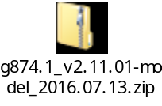

2.2 G.874.1 YANG Mapping

2.2.1 G.874.1 YANG Module
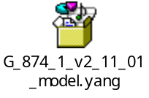

2.2.2 G.874.1 YANG Tree
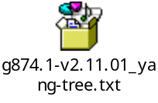

3. References
[ITU-T G.874.1] ITU-T Recommendation G.874.1 “Optical transport network (OTN): Protocol neutral management information model for the network element view” v2.11
[xmi2yang tool] Open Source UML to YANG Translation Tool, https://github.com/OpenNetworkingFoundation/EAGLE-Open-Model-Profile-and-Tools/tree/UmlYangTools
[YANG Validation] YANG Validation Tool, http://www.yangvalidator.com/

_________________

