 | INTERNATIONAL TELECOMMUNICATION UNION  TELECOMMUNICATION  STANDARDIZATION SECTOR  STUDY PERIOD 2017-2020 |  | TD 26 (WP2/13)
 |  |  | STUDY GROUP 13
 |  |  | Original: English
Question(s): |  | 19/13 | 6-17 February 2017
TD 26
Source: |  | Editors
Title: |  | Proposed NWI - “Metadata framework for cloud service lifecycle management” (Y.cslm-metadata)
Contact: |  | Ying Cheng  China Unicom  P.R.China |  | Tel: +86-10-66259394  Fax:+86-10-66259154  Email: chengying10@chinaunicom.cn
Contact: |  | Yan Lei  Datang Software Technologies CO.,LTD.  P.R.China |  | Tel: +86 10 59139021  Fax: +86 10 59139100  Email: yanlei@cattsoft.com
This document is the initial draft recommendation of “Metadata framework for cloud service lifecycle management"(Y.cslm-metadata), which was agreed to initiated at this meeting. This document includes the results of discussion on the Q19/SG13 Meeting which was held on 6-17 February, 2017.
The A.1 justification required for new work items proposed draft Recommendation Y.cslm-metadata is presented in Annex I.

The following table shows discussion results for contributions.
Document  Number | Source | Title | Meeting results
[ C - 161 ] | China Unicom , DaTang Telecommunication Technology & Industry Holding Co. Ltd | Proposal for initiating a new work item on functional requirements of cloud service lifecycle metadata | Agreed with modifications.  The scope was agreed as the metadata framework of common cloud service lifecycle management during the meeting in February 2017. The initial skeleton starts with NaaS service lifecycle management metadata aspect in closed-loop automation environment. Other XaaS service lifecycle management metadata related content is invited.

During this meeting, it was agreed as follows.
- Initial skeleton of draft Y.cslm-metadata.
- Initial content of general description and metadata functions in cloud service.

Contributions are invited in the following aspects.
- Non-NaaS service metadata description and function.
- Further addition and modification on general description.

Annex I

A.1 justification for proposed draft new Recommendation Y.cslm-metadata
Question: | 19 | /13 | Proposed new ITU-T Recommendation | 6 - 17 February 2017
Reference and title: | Recommendation ITU-T < Y.cslm-metadata> " Metadata framework for cloud service lifecycle management "
Base text: | TD26(WP2/13) |  |  | Timing: | Q1 2019
Editor(s): | Ying Cheng, China Unicom, chengying10@chinaunicom.cn  Yan Lei, Datang Software Technologies CO.,LTD., yanlei@cattsoft.com |  |  | Approval process: | AAP
Scope (defines the intent or object of the Recommendation and the aspects covered, thereby indicating the limits of its applicability):
This Recommendation provides metadata framework for closed-loop automation lifecycle management of cloud service, especially in the environments of DevOps and CI/CD.
This Recommendation covers the following aspects:
- General description of metadata for cloud service lifecycle management;
- Metadata functions in cloud service;
- Metadata framework for cloud service lifecycle management;
- Metadata applicability in cloud service lifecycle management.
Summary (provides a brief overview of the purpose and contents of the Recommendation, thus permitting readers to judge its usefulness for their work):

This Recommendation specifies the metadata framework for cloud service lifecycle management in the closed-loop automation environment.

Relations to ITU-T Recommendations or to other standards (approved or under development):
- Relationship with ITU-T Y.3522
Recommendation ITU-T Y.3522 provides an overview of end-to-end (E2E) cloud service lifecycle management by specifying cloud service lifecycle metadata, the cloud service lifecycle management framework, cloud service lifecycle management stages and the relationship with cloud computing reference architecture. This Recommendation also provides E2E cloud service lifecycle management functional requirements derived from the corresponding typical use cases.
Cloud service lifecycle is specified in [ITU-T Y.3522] via the corresponding metadata description in different stages, which is regarded as a major model linking the whole lifecycle of a cloud service, from design, deployment, operation, to retirement. But there are lacks of metadata description in specific service lifecycle management especially on DevOps and CI/CD.
- Relationship with ITU-T Y.3512 and Y.CCNaaS-arch
Draft Recommendation Y.CCNaaS-arch provides NaaS functional architecture by specifying functionalities, functional components, and reference points, based on the functional requirements specified in ITU-T Y.3512.
Several kinds of models, including network service model, network operational policy model, and network resource model, are mentioned in draft Y.CCNaaS-arch, in the description of NaaS service instantiation functionality and functional components. Actually, modelled resource, service, and policy can be managed in DevOps and CI/CD environment, taking cloud service lifecycle metadata as a linkage, from design time to execution time.
Liaisons with other study groups or with other standards bodies:
MEF, ETSI, TMF, ISO/IEC JTC 1/SC 32, IETF
Supporting members that are committing to contributing actively to the work item:
China Unicom, DaTang Telecommunication Technology & Industry Holding Co. Ltd, Orange, ZTE, ETRI

Draft ITU-T Recommendation Y.cslm-metadata
Metadata framework for cloud service lifecycle management

Summary
This Recommendation specifies the metadata framework for cloud service lifecycle management in the closed-loop automation environment.

Keywords
cloud service, lifecycle management, metadata framework, closed-loop automation
Introduction
<Optional - This clause should appear only if it contains information different from Scope and Summary>
Table of Contents
1 Scope 7
2 References 7
3 Definitions 8
3.1 Terms defined elsewhere 8
3.2 Terms defined in this Recommendation 8
4 Abbreviations and acronyms 8
5 Conventions 8
6 General description 9
7 Metadata functions in cloud service 9
7.1 Network service data model 10
7.2 Network policy data model 10
7.3 Network resource data model 10
8 Metadata framework for cloud service lifecycle management 10
9 Security consideration 10
Appendix I 11
II.1 VPC 11
Bibliography 12

Scope
This Recommendation provides metadata framework for closed-loop automation lifecycle management of cloud service, especially in the environments of DevOps and CI/CD.
This Recommendation covers the following aspects:
- General description of metadata for cloud service lifecycle management;
- Metadata functions in cloud service;
- Metadata framework for cloud service lifecycle management;
- Metadata applicability in cloud service lifecycle management.
NOTE 1 – The scope was agreed as the metadata framework of common cloud service lifecycle management during the meeting in February 2017. The initial skeleton starts with NaaS service lifecycle management metadata aspect in closed-loop automation environment. Other XaaS service lifecycle management metadata related content is invited.
NOTE 2 – The objective in defining the metadata framework of NaaS service lifecycle management is not to invent new metadata, but to make the existing metadata interoperable and integrated in the closed loop automation management of NaaS service, especially in the environments of DevOps and CI/CD.

2 References
The following ITU-T Recommendations and other references contain provisions which, through reference in this text, constitute provisions of this Recommendation. At the time of publication, the editions indicated were valid. All Recommendations and other references are subject to revision; users of this Recommendation are therefore encouraged to investigate the possibility of applying the most recent edition of the Recommendations and other references listed below. A list of the currently valid ITU-T Recommendations is regularly published.
The reference to a document within this Recommendation does not give it, as a stand-alone document, the status of a Recommendation.
[ITU-T X.1601] Recommendation ITU-T X.1601 (2015), Security framework for cloud computing.
[ITU-T Y.3500] Recommendation ITU-T Y.3500 (2014) | ISO/IEC 17788:2014, Information technology – Cloud computing – Overview and vocabulary.
[ITU-T Y.3502] Recommendation ITU-T Y.3502 (2014) | ISO/IEC 17789:2014, Information technology – Cloud computing – Reference architecture.
[ITU-T Y.3512] Recommendation ITU-T Y.3512 (2014), Cloud computing – Functional requirements of Network as a Service.
[ITU-T Y.3520] Recommendation ITU-T Y.3520 (2015), Cloud computing framework for end to end resource management.
[ITU-T Y.3521] Recommendation ITU-T Y.3521/M.3070 (2016), Overview of end-to-end cloud computing management.
[ITU-T Y.3522] Recommendation ITU-T Y.3522 (2016), End-to-end cloud service lifecycle management requirements.

3 Definitions
<Check in the ITU-T Terms and definitions database on the public website whether the term is already defined in another Recommendation. It may be more consistent to refer to such a definition rather than redefine it>

3.1 Terms defined elsewhere
<Normally terms defined elsewhere will simply refer to the defining document. In certain cases, it may be desirable to quote the definition to allow for a stand-alone document>
This Recommendation uses the following terms defined elsewhere:
3.1.1 <Term 1> [Reference]: <optional quoted definition>
3.1.2 <Term 2> [Reference]: <optional quoted definition>

3.2 Terms defined in this Recommendation
This Recommendation defines the following terms:
3.2.1 metadata: "Metadata" in NaaS service lifecycle management in this Recommendation refers to the network service model, network resource model, and network policy model.

4 Abbreviations and acronyms
This Recommendation uses the following abbreviations and acronyms:
CI Continuous Integration
CD Continuous Delivery
DevOps Development and Operation
NaaS Network as a Service

5 Conventions
<Describe any particular notation, style, presentation, etc. used within the Recommendation, if any>
The keywords "is required to" indicate a requirement which must be strictly followed and from which no deviation is permitted if conformance to this Recommendation is to be claimed.
The keywords "is recommended" indicate a requirement which is recommended but which is not absolutely required. Thus this requirement need not be present to claim conformance.
The keywords "can optionally" indicate an optional requirement which is permissible, without implying any sense of being recommended. This term is not intended to imply that the vendor's implementation must provide the option and the feature can be optionally enabled by the network operator/service provider. Rather, it means the vendor may optionally provide the feature and still claim conformance with the specification.
In the body of this Recommendation and its annexes, the words shall, shall not, should, and may sometimes appear, in which case they are to be interpreted, respectively, as is required to, is prohibited from, is recommended, and can optionally. The appearance of such phrases or keywords in an appendix or in material explicitly marked as informative is to be interpreted as having no normative intent.

6 General description
[Editor’s notes in February 2017] This clause aims to provide the general description of metadata for cloud service lifecycle management, including metadata types, challenges of automated closed loop management especially in the environments of DevOps and CI/CD, etc..
With the increasing demands on the closed loop automation management of cloud service, DevOps and CI/CD (continuous integration / continuous delivery) are widely considered and adopted in the real world environment, e.g. ECOMP, whose implementation has also been launched recently, as an open source project OpenEcomp by Linux Foundation. According to [ITU-T Y.3522], the complicated re-design, re-configuration and re-deployment problems can be addressed through the cloud service lifecycle management metadata, which represents all of the lifecycle aspects of the virtualized elements, as expressed in the form of logical objects within a defined model space. A new service can be created with changes only in metadata and minimal modifications. Therefore, the lifecycle management metadata can be regarded as the linkage between design time and execution time.
[ITU-T Y.3522] describes the functions of metadata in different stages of cloud service lifecycle management in general and doesn’t cover the detailed position and function of metadata in the context of whole lifecycle management of the specific XaaS use cases, whose dependencies and constraints vary unavoidably. Taking NaaS as a specific example, whose detailed use cases and functional requirements, functionalities, functional components have been developed in [ITU-T Y.3512] and draft Recommendation Y.CCNaaS-arch, flexible and extended VPN and Bandwidth on demand require dynamic and automatic addition and reduction on VPN sites and bandwidth capacity according to the pre-designed conditions, and the modelling for network service, network policy, network resource and their interoperability and integration are needed in the whole closed-loop automation management environment.
One of the focuses in this Recommendation is to specify the interoperability and integration of the existing NaaS related data models, including network service data model, network policy data model, and network resource data model.

7 Metadata functions in cloud service
[Editor’s notes in February 2017] This following initial content aims to specify the positions and functions of NaaS service metadata in the whole lifecycle management. The following illustrated figure is proposed for better understanding. Other XaaS related content is invited.
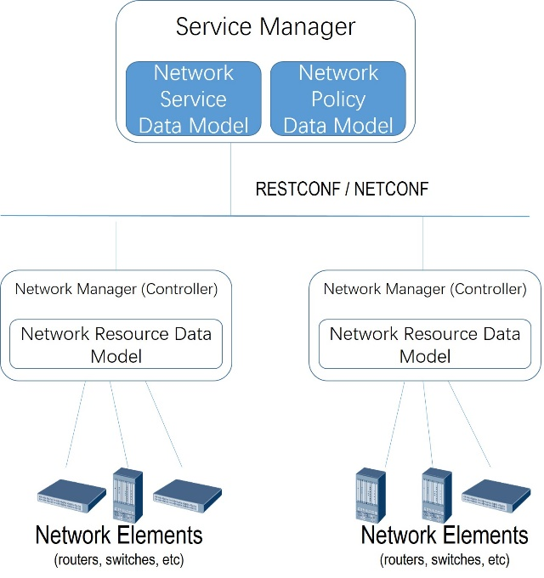
Figure 7-1 Illustration of metadata functions in NaaS service

7.1 Network service data model
Network service data model describes the specific network service based on the characteristic of the service and can be used for service delivery, e.g, L3VPN and L2VPN data models using YANG as the modelling language under development of the working groups L3SM and L2SM of IETF.

7.2 Network policy data model
Network policy data model describe high-level network-wide polices, which can be input to a network management function (within a SDN controller, an orchestrator, or a network element), and always combined with network service data model and mapped into a target configuration of network elements, e.g., generic policy data model using YANG as the modelling language under development of the working group SUPA of IETF.

7.3 Network resource data model
Network resource data model describes network topology across different layers. Network resources include physical and/or virtual network nodes and links.

8 Metadata framework for cloud service lifecycle management
[Editor’s notes in February 2017] This clause aims to specify the metadata framework in cloud service lifecycle management by reflecting the interoperability and integration of the cloud service metadata , especially in the environments of DevOps and CI/CD.

9 Security consideration

Appendix I
Metadata applicability in cloud service lifecycle management
(This appendix does not form an integral part of this Recommendation.)
[Editor’s notes in February 2017] This clause aims to provide the applicability examples of cloud service lifecycle management metadata.

II.1 VPC
The manipulation of the virtualized VPC network may also affect the configuration of physical networks. For example, when two new VMs associated to a given VPC are deployed in two different data centres, the VPC control mechanism needs to generate a VPN between these two data centres for the internal VPC communications. Therefore, the control mechanism for a VPC should be able to adjust the underlying network at run time when the CSC requests changes to the VPC network or service deployment.
When the CSC moves from one location to another, which is near to another CSP’s data centre, and in the case the network load between these two data centres is low, the CSC’s VM(s) should be migrated to the new data centre in order to allow for a better user experience.
As illustrated by Figure I.1, a virtual private cloud (VPC) corresponds to a combination of cloud computing resources with a VPN infrastructure to give cloud service customers the abstraction of a private set of cloud resources that are transparently and securely connected to their own infrastructure. VPCs are created by taking dynamically configurable pools of cloud resources and connecting them to enterprise sites with VPNs.
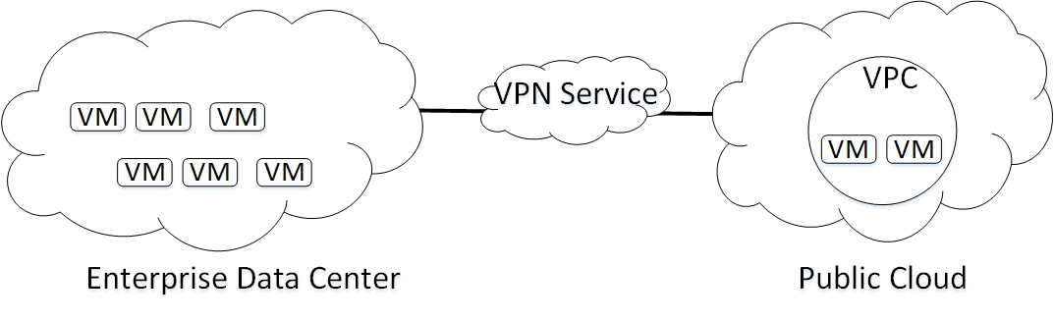
Figure I.1 Illustration of VPC
Network resource data model needs to be used in this scenario for modelling the physical nodes and links.
Network service data model, specifically for L3VPN, is needed to model the L3VPN attributes, including, but not limited to, tenant ID, VPN site IDs, VPN type, access bandwidth.
Network policy data model here can be described as follows, using ECA policy.
- Event: a VPC user's location is changed (near to another DC).
- Condition: network_load(DC_old, DC_new) < threshold.
- Action:
  - 1. Migrate the VM to the new data center (DC_new).
  - 2. Update the VPNs connecting the user's services.

Bibliography

_______________________

