O-RAN WG9 to IETF S-2023003

Title: LS on O-RAN Transport Network Slicing Enhancement

Source: O-RAN WG9 - Open X-haul Transport Work Group
To: IETF-opsawg, IETF-teas
Cc:

Contact Person:

Name: Richard Roberts (Juniper Networks)

E-mail Address: rroberts@juniper.net

Name: Ivan Bykov (Ribbon)

E-mail Address: Ivan.Bykov@rbbn.com

Name: Martin Birk (Highstreet technologies)

E-mail Address: Martin.Birk@highstreet-technologies.com

Name: Jiajin Gao (China Mobile)

E-mail Address: jiajingao@chinamobile.com

Send any reply LS to: liaisons@o-ran.org

Attachments: N/A

1. Overall Description:
The O-RAN Alliance is committed to evolving radio access networks, making them more open and smarter than previous generations. The key principles of the O-RAN Alliance include:

- Lead the industry towards open, interoperable interfaces, RAN virtualization, AI/ML and big data enabled RAN intelligence.
- Specify APIs and interfaces, driving standards to adopt them as appropriate, and exploring open source where appropriate.
- Maximize the use of common-off-the-shelf hardware and merchant silicon and minimizing proprietary hardware.

O-RAN Working Group 9 (WG9) is developing O-RAN Transport Network Element (TNE) management interfaces and best practices to support transport capabilities and service demands of RAN and Core subsystems.

The O-RAN WG9 would like to follow IETF specifications to manage Transport Networks (TNs). In this context, we identify the Network Slice Service (NSS) and Attachment Circuit (AC) specifications as a key enabler to streamline the operation of connectivity services. More precisely, our objective is to provide the following for the integration of Transport Networks:

- Allow for Plug & Play TN Slice-aaS deployments based on IETF technologies.
- Rely upon standard open interfaces.
- Promote modularity and controlled complexity.
- Accommodate typical TN deployment models with clear operational perimeters (e.g., separate customer-facing interfaces vs internal/provider interfaces).
- Use extensible models/APIs to accommodate, e.g., new features, data plane, architectures, and technologies.
- Ease mapping between service and network views.
- IETF-based modelling for the description of TN attachment as external 3GPP NRM.

Figure 1 provides a high-level overview of the orchestration of IETF Network Slices:

- Use IETF-based APIs as an interface between the Transport Network Orchestration (e.g., IETF NSC as per [slice-fw]) and the Mobile Network Orchestration.
- Use NSS ([slice-service]) and AC ([ac-svc][ac-common] [ac-ntw]) data models for TN slice management.

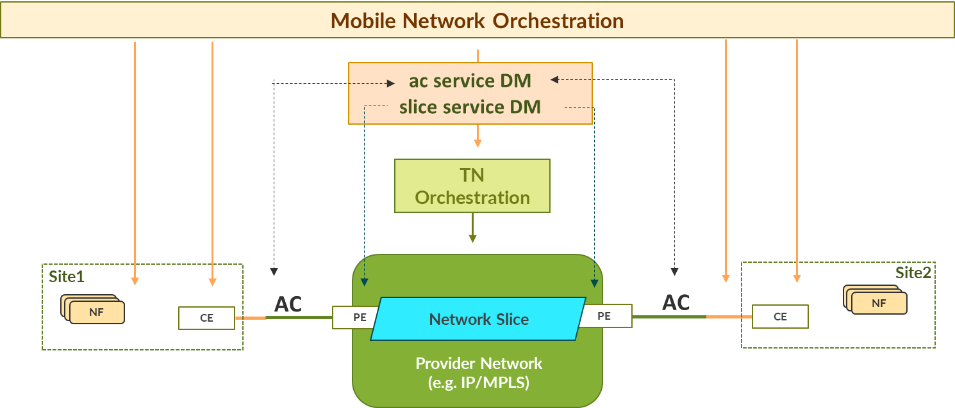
Figure 1: Orchestration of the Transport Network from Mobile Network Orchestration

References:
[ac-common]: https://datatracker.ietf.org/doc/draft-boro-opsawg-teas-common-ac/
[ac-ntw]: https://datatracker.ietf.org/doc/draft-boro-opsawg-ntw-attachment-circuit/
[ac-svc]: https://datatracker.ietf.org/doc/html/draft-boro-opsawg-teas-attachment-circuit
[slice-fw]: https://datatracker.ietf.org/doc/draft-ietf-teas-ietf-network-slices/
[slice-service]: https://datatracker.ietf.org/doc/draft-ietf-teas-ietf-network-slice-nbi-yang/

2. Actions:
To: IETF-opsawg, IETF-teas

Since O-RAN plans to rely on IETF APIs and Data Models for the management of Attachment Circuits and Network Slices, notably [ac-svc], [ac-common], [ac-ntw], and [slice-service]. O-RAN WG9 kindly asks IETF-opsawg to take the information provided by this LS into account and provide their feedback.

3. Meeting Schedule:
O-RAN WG9 have regular weekly meetings where all contributions are considered.

O-RAN Alliance Face-to-Face Meeting June 19-23, 2023 Osaka, Japan

